DECISION

Planning (Listed Building and Conservation Areas) Act 1990

Listed Building Consent Granted

Address:
33 Ferncroft Avenue
London
Camden
NW3 7PG

Proposal:
External alterations include replacement of existing windows on the side and rear elevations, enlarging existing rear and side dormers at roof level, replacement of balustrades and doors to the rear balconies, removal of projecting pelmet on the rear elevation, removal of concrete lintels and replacement with brick arches on the rear elevation, removal of render to rear elevation at lower ground level and reinstatement of brickwork.
Drawing Nos: LP-00; EX-01; EX-02; EX-03; EX-04; EX-05; EX-06; PA-01 P-01; PA-02 P-01; PA-03 P-01; PA-04 P-01; PA-05 P-01; PA-06 P-01

The Council has considered your application and decided to grant Listed Building Consent subject to the following condition(s):

Conditions And Reasons:

1 | The works hereby permitted shall be begun not later than the end of three years from the date of this consent.  Reason: In order to comply with the provisions of Section 18 of the Planning (Listed Buildings and Conservation Areas) Act 1990.
2 | The development hereby permitted shall be carried out in accordance with the following approved plans:  LP-00; EX-01; EX-02; EX-03; EX-04; EX-05; EX-06; PA-01 P-01; PA-02 P-01; PA-03 P-01; PA-04 P-01; PA-05 P-01; PA-06 P-01  Reason: In order to safeguard the special architectural and historic interest of the building in accordance with the requirements of policy D2 of the Camden Local Plan 2017.
3 | All new work and work of making good shall be carried out to match the existing adjacent work as closely as possible in materials and detailed execution.  Reason: In order to safeguard the special architectural and historic interest of the building in accordance with the requirements of policy D2 of the Camden Local Plan 2017.

Informative(s):

You are advised that any works of alterations or upgrading not included on the approved drawings which are required to satisfy Building Regulations or Fire Certification may require a further application for listed building consent.

This approval does not authorise the use of the public highway. Any requirement to use the public highway, such as for hoardings, temporary road closures and suspension of parking bays, will be subject to approval of relevant licence from the Council's Streetworks Authorisations & Compliance Team, 5 Pancras Square c/o Town Hall, Judd Street London WC1H 9JE (Tel. No 020 7974 4444). Licences and authorisations need to be sought in advance of proposed works. Where development is subject to a Construction Management Plan (through a requirement in a S106 agreement), no licence or authorisation will be granted until the Construction Management Plan is approved by the Council.

All works should be conducted in accordance with the Camden Minimum Requirements - a copy is available on the Council's website (search for ‘Camden Minimum Requirements’ at www.camden,gov.uk) or contact the Council's Noise and Licensing Enforcement Team, 5 Pancras Square c/o Town Hall, Judd Street London WC1H 9JE (Tel. No. 020 7974 4444)

Noise from demolition and construction works is subject to control under the Control of Pollution Act 1974. You must carry out any building works that can be heard at the boundary of the site only between 08.00 and 18.00 hours Monday to Friday and 08.00 to 13.00 on Saturday and not at all on Sundays and Public Holidays. You must secure the approval of the Council's Noise and Licensing Enforcement Team prior to undertaking such activities outside these hours.

In dealing with the application, the Council has sought to work with the applicant in a positive and proactive way in accordance with paragraph 38 of the National Planning Policy Framework 2021.

You can find advice about your rights of appeal at:

http://www.planningportal.gov.uk/planning/appeals/guidance/guidancecontent

Yours faithfully

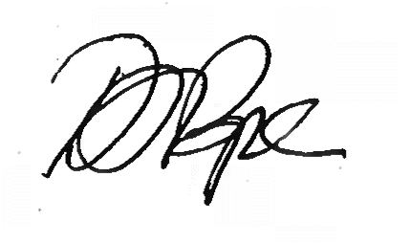
Daniel Pope
Chief Planning Officer

