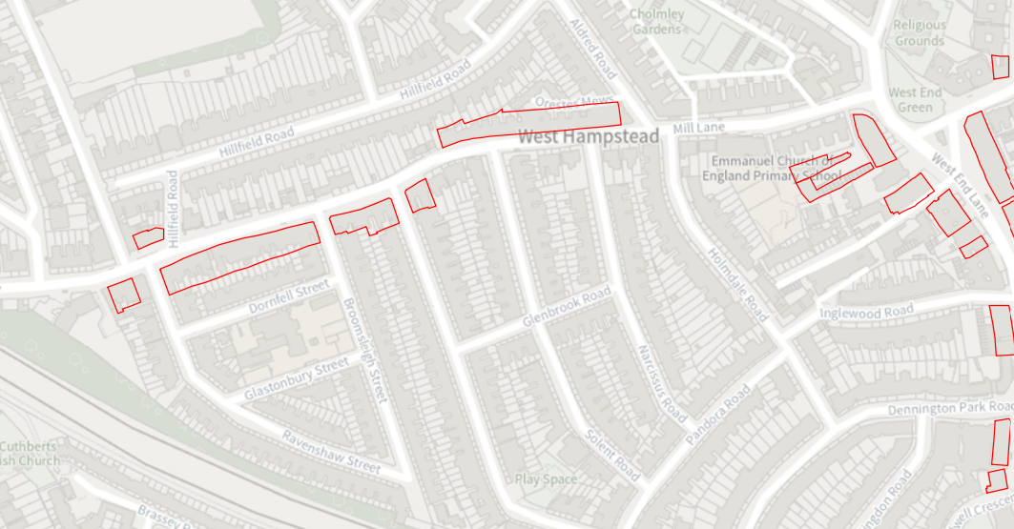

<https://www.camden.gov.uk/documents/20142/4842163/North+Map+1.pdf/a9d3953e-555c-1bb8-aa8b-6611efd2cc45?t=1677070376712>