

# To London Borough of Camden, Planning Department

**Planning Ref:** 2023/5366/P

**Address:** University College School, Frognal NW3 6XH

**Case Officer:**  Edward Hodgson

**Date**: 29.01.2024

The Heath & Hampstead Society are in general very supportive of this application that is sensitive to the setting of the grade II listed main building. We are pleased to see that more than 10% Biodiversity Net Gain is planned for the site, and that an attenuation tank is proposed below the rear car park to mitigate for significant rainfall run-off and absence of significant permeability of the soils.

We do have some reservations however and would like to propose a few changes that consider local and site-specific knowledge and to make this application up-to-date with Camden’s current draft Local Plan, the Camden Flood Risk Management Strategy 2022-7 and the Camden Strategic Flood Risk Assessment, 2024.

**Hydrogeological investigation**

The BIA’s hydrogeology desktop investigation picks up that the proposed basement will be below the groundwater table at the top of the Claygate Member, and that the Claygate Member will contain relatively permeable material with impermeable bands. However, there is little to no acknowledgement of the old river running through the site as shown in the Arup report (2010) ‘Camden geological, hydrogeological and hydrological study. Guidance for subterranean development’ (CGHHS) figure 2 BGS 1920 geology 1 in 10560 map, though more clearly shown in a section below and publicly available. The rivers here were drawn onto the 1920 map from the 1870 published Ordnance Survey map, a highly accurate map for boundaries, ponds and rivers on the survey date of 1866.

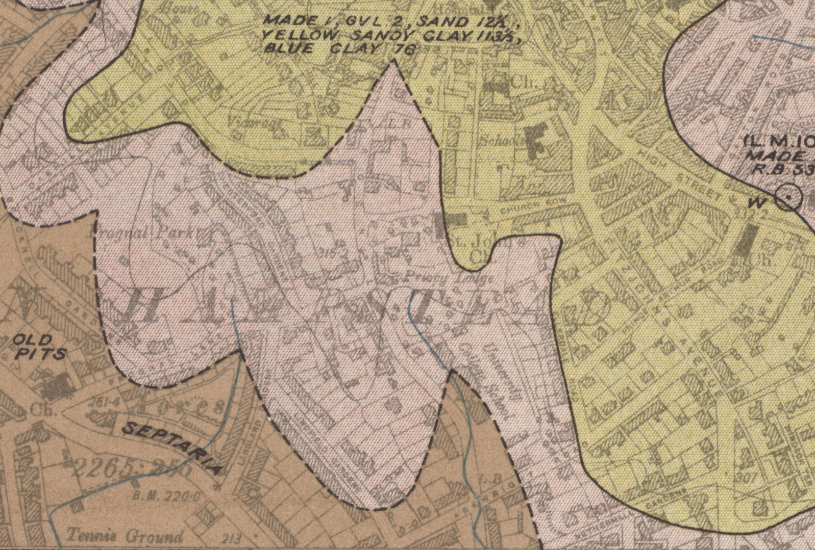

**from BGS 6-inch series geology 1920** available <https://maps.nls.uk/geo/explore/#zoom=15.5&lat=51.56317&lon=-0.17119&layers=197&b=1>

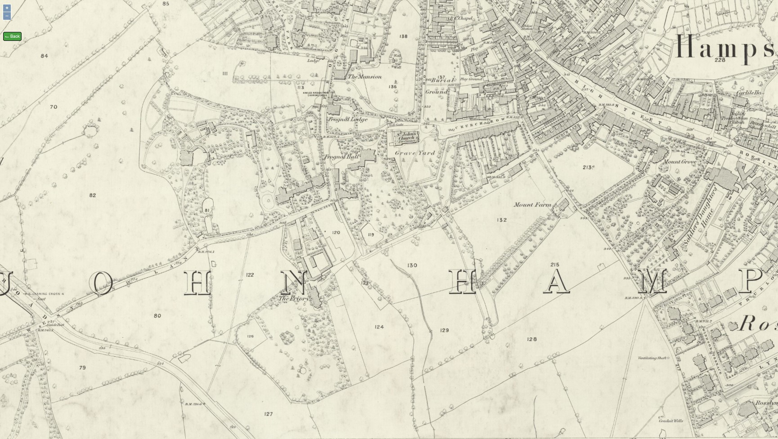

**from Ordnance Survey 25-inch 1st edition map Surveyed: 1866, Published: 1870** <https://maps.nls.uk/view/103312952>

While the river itself is now mainly within the sewer that can be heard through a grating in the Frognal roadway, immediately to the north of the school, contemporary maps show the river’s previous course is essentially along the length of the Edwardian part of the school. This means that the silty sandy courses of the old river and the tributaries feeding will still exist, will be carrying groundwater and are capable of carrying significantly larger quantities of water during storm surges. This is borne out by the need for 9 pumps within the main building’s basement to keep groundwater out of the basement at all times and during normal rainfall. However, the basement floods from time to time despite these 9 pumps, with water entering the school Library. We understand this occurred not only in 1975 and 2002 but at other times, and in July 2021 to a depth of approximately 2 feet in the basement.

The borehole tests found silty and sandy soil within the clay, and groundwater at various depths, particularly at the Made Ground-Claygate Beds interface, where the water table would be predicted. However, boreholes are points of measurement and do not fully capture the ability of the ground to carry intermittent and horizontal surges in groundwater. We believe there are 2 issues arising from the BIA:

1) No mention is made of the spring line along the Claygate to Band D of the London Clay Formation boundary here, and while the old pond 40m north of the school is acknowledged in the desktop study, the spring that fed it and formed the river is not clearly illustrated. The interpretation of the tests is somewhat insufficient without awareness of this and the history of on-site flooding.

2) Groundwater testing has only been performed during relatively dry periods. Only 3 measurements were taken, on 7th & 15th June and 6th July 2023. As can be seen on rainfall tables from a site within a kilometre and a roughly similar height above sea level (see below, from <http://nw3weather.co.uk/wxdataday.php?year=2023&vartype=rain>) these were dry days across a not particularly wet period and missed opportunities to assess groundwater flow during and immediately following more intense rainfall. No opinion as to the amount of groundwater that could pass through the site during an intense storm could be made or its future possible extent estimated.

The ‘Flood Risk Assessment and Drainage Strategy Report’ for UCS by Price and Myers (Price & Myers FRADSR) mentions that greenfield runoff rates were the minimum for Camden's Strategic Flood Risk Assessment (2014) but we do not consider this is sufficient to prepare for the future. It also notes that Camden’s SFRA (2014) states: ‘Developments in this flood zone do not have any restrictions, *provided they do not increase the risk of flooding elsewhere’*. This has been superseded by the Camden Strategic Flood Risk Assessment of 2024, which repeatedly emphasises protecting others: e.g. ‘The Council will continue to ensure that new developments are safe from flood risk and *wherever possible* *reduce the risk of flooding elsewhere*’. Since 1st November 2023 this guidance,

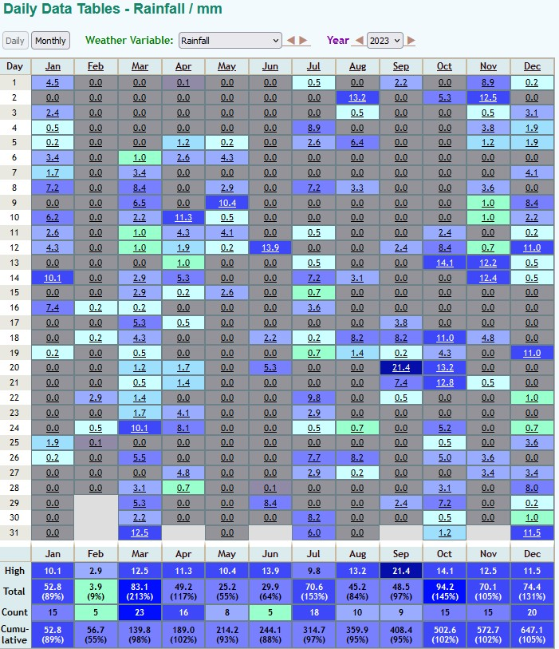

**Rainfall in 2023, ‘nw3weather’ station**

along with the NPPF (2021) and the new Camden Local plan is now subject to the Environmental Principles Policy Statement, part of the Environment Act 2021. This means that such documents that require interpretation must perform this interpretation with the EPPS and its principles in mind. We consider the EPPS adds weight to our argument that groundwater moved directly into the sewer system should be attenuated to protect those receiving it and the environment in general.

**Extending the scope of the Price & Myers’ FRADSR**

Price & Myers’FRADSR limits the scope of SUDs calculations to the northern development area, not the whole site. Thus, while focussing on the setting of the listed building, the building itself is ignored, despite being already subject to flooding during more severe storms. This is understandable since this planning application does not involve changes to this building, but we consider a wider view would be in UCS’s interest, due to several concerns.

The main building has flood warning electronic monitors within the basement and is well looked after, however we have concerns about the effects of climate change on this important building and its contents if the present degree of storm surges are not quantified and the future increase of these not prepared for. We believe that such testing done now – as is normally required by the CGHHS – would assist in establishing the timing and flow of water beneath the whole site, including the main building, associated with rainstorms.

The site of the attenuation tank however is, we believe, key to a potential solution to both the on-site situation and a contribution to those areas at risk of flooding *elsewhere* ‘downstream’. The 9 pumps below the main building are sending groundwater directly into the sewer, and are increasing the risk of flooding through sewer surcharging during storm surges. This particular sewer contributes to the Goldhurst Local Flood Risk Zone of South Hampstead and surcharges in South Hampstead, including Belsize Road, during flood events. There are records and personal memory of a man drowning in a basement in Belsize Road as a direct result of this in 1975, and another would have drowned on 12th July 2021 were it not for the quick thinking of a neighbour who happened to be there at the right time, thought to check and then rescued him.

We would suggest UCS and its experts quantify the likely volumes required to prevent future on-site groundwater as well as surface water flooding during rainstorms, with additional volume allowed for to take climate change into account. Also to consider a few adjustments to the area set aside in the Price & Myers’ FRADSR for an attenuation tank. This proposed tank is across a large area beneath a car park, but it is only 1 metre in depth.

Two much deeper and larger structures could be fitted into this space, though this must of course be done in a safe manner that does not cause ground pressure changes prompting building movement. This site is just within the area at high to very high risk of landslide due to the likely presence of Head solifluction superficial deposits, the slope of the hill and the spring line lubricating it (see map, over). The two structures we recommend for consideration include:

1. A large deep well (perhaps a smaller version of the vortex drop built in Westminster at Formosa Street that is successfully protecting Maida Vale from flooding) to
   1. divert groundwater away from sand partings below the main building and providing future protection for flood damage to the entire site;
   2. act as a significant attenuation tank for holding back storm water, contributing to the slowing of water to the sewer going to the Goldhurst Local Flood Risk Zone downstream. (We believe Thames Water should consider whether the current situation where groundwater is pumped into the sewer system can continue, and if they can give their support for more attenuation here.)
2. A grey water tank to store rainwater
   1. for watering green spaces, and watering trees during drought;
   2. reducing mains water consumption and cost for such uses as cleaning floors and flushing on-site toilet cisterns, etc.

(We are in early discussion with West Hampstead Fire Brigade about adapting London Fire Brigade pumps with filters so that locally stored grey water can be used to re-charge their fire engines in case of need.)

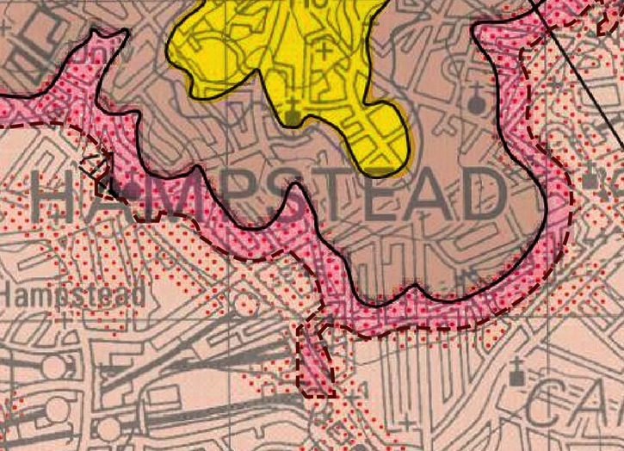

UCS site

Areas of high & very high

risk of landslide

Map adapted from ‘BGS Areas of greatest potential for slop instability’

( <https://largeimages.bgs.ac.uk/iip/mapsportal.html?id=1001750> )

We hope these tests and the adjustments to the attenuation tank area would have a minimal impact on timing to get the project prepared for planning consent. This would however have the potential to protect the whole site much more effectively in the future, and to be of significant benefit to those affected by the water passing through and across the site to the Flood Zones downstream.

David Castle, Chair, Planning Sub-Committee Dr Vicki Harding, Planning Sub-Committee