**How to take payments for annual fee invoices.**

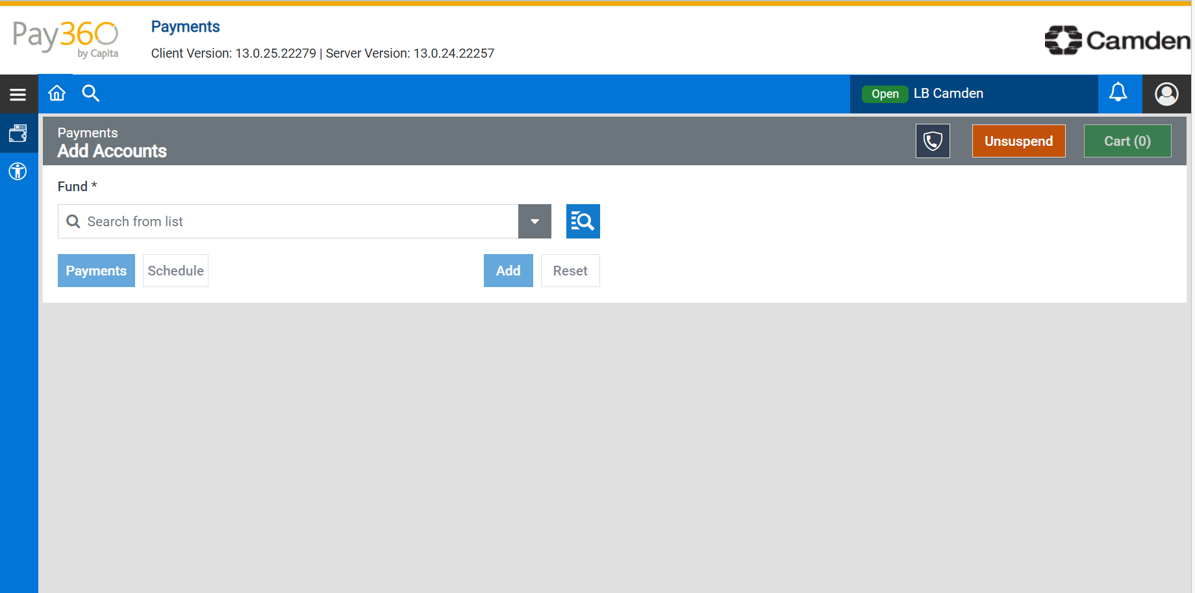

Click on the drop down (search from list)

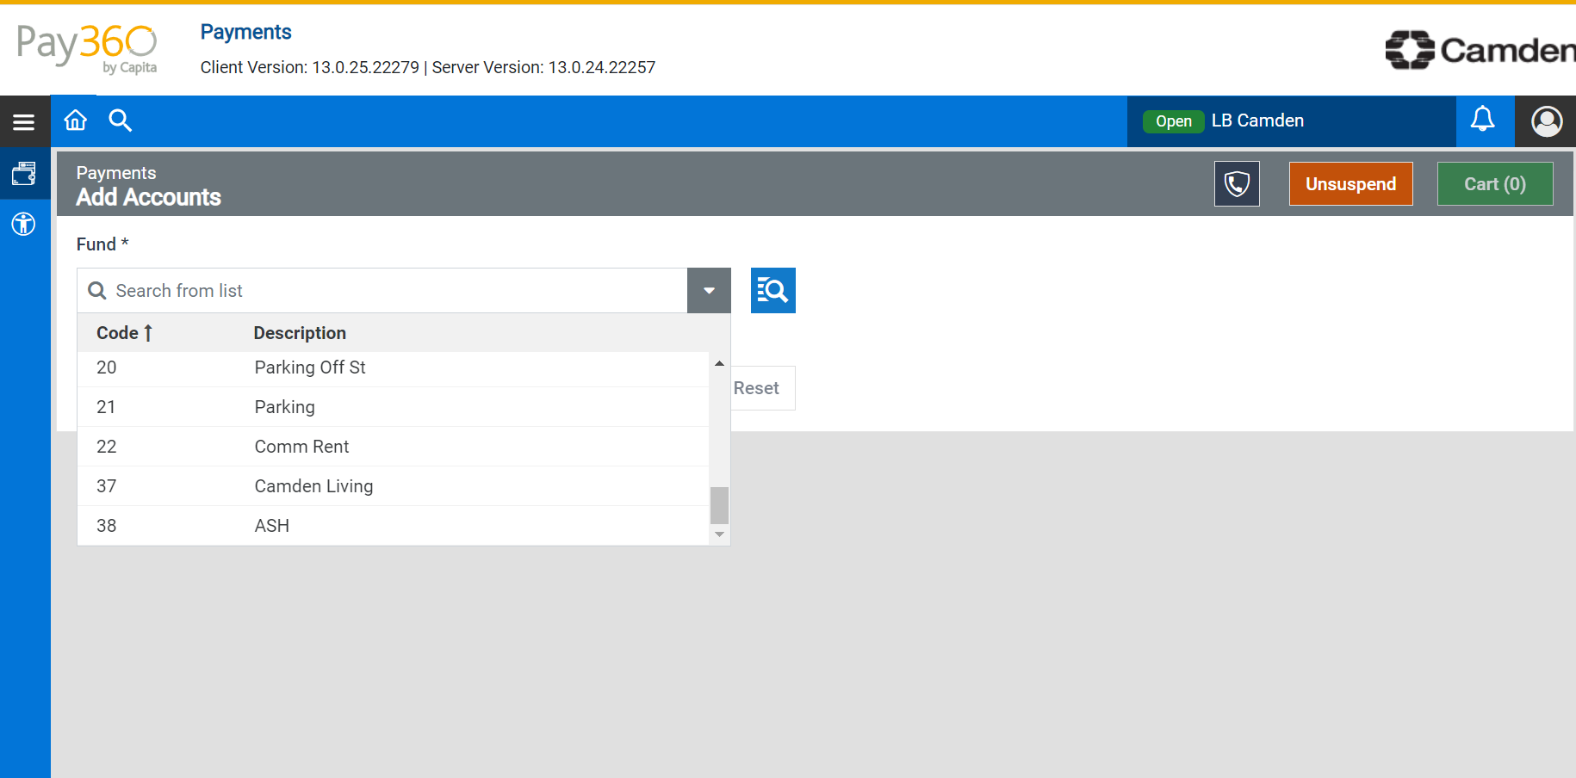

Scroll right to the bottom and click on ASH (code 38)

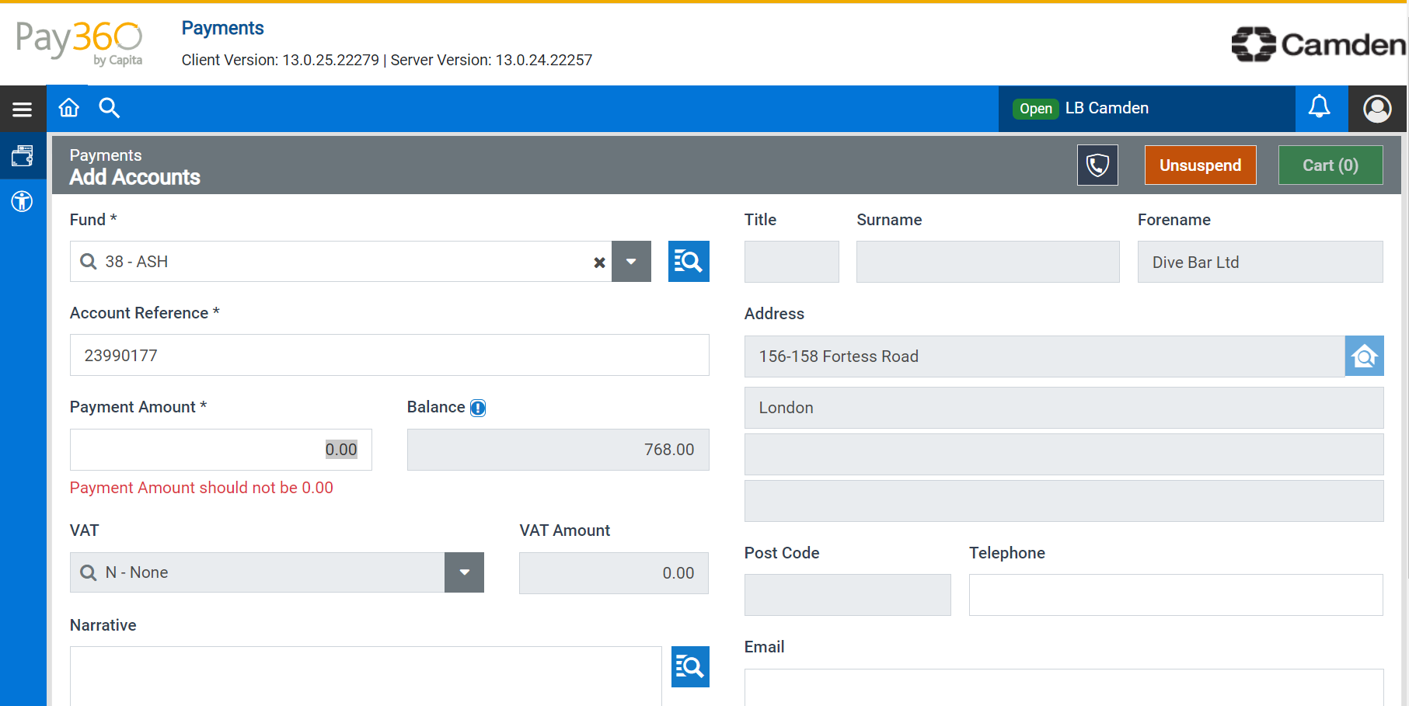

In the Account Reference*, put in the invoice number, the outstanding balance will show on the right hand side.

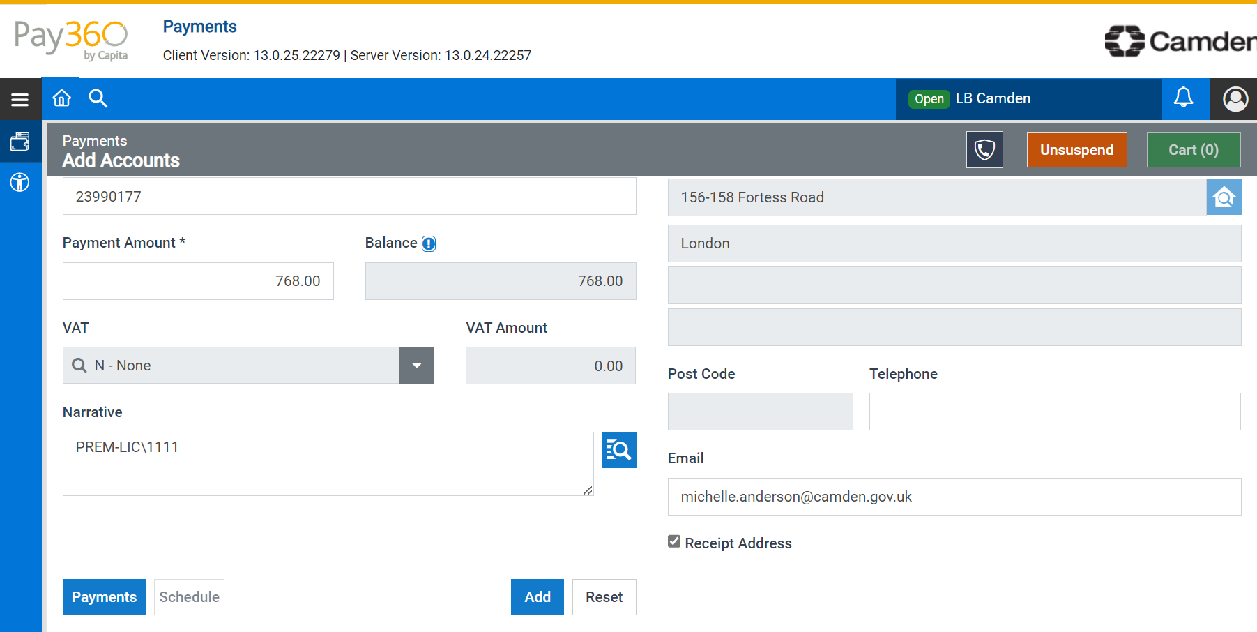

* In the Narrative enter the premises licence number.
* At this screen, always add an email address for the customer for a receipt to be emailed as you won’t be able to enter on the next screen.
* If you have more than one invoice, press add and repeat the above step.
* Once you have completed this screen, press payments.

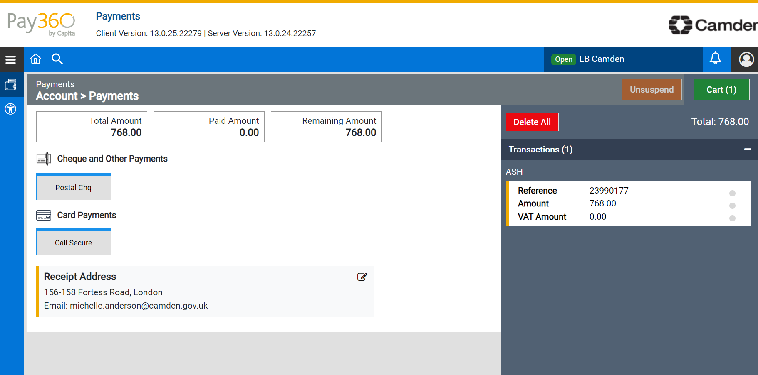

Click on call secure.

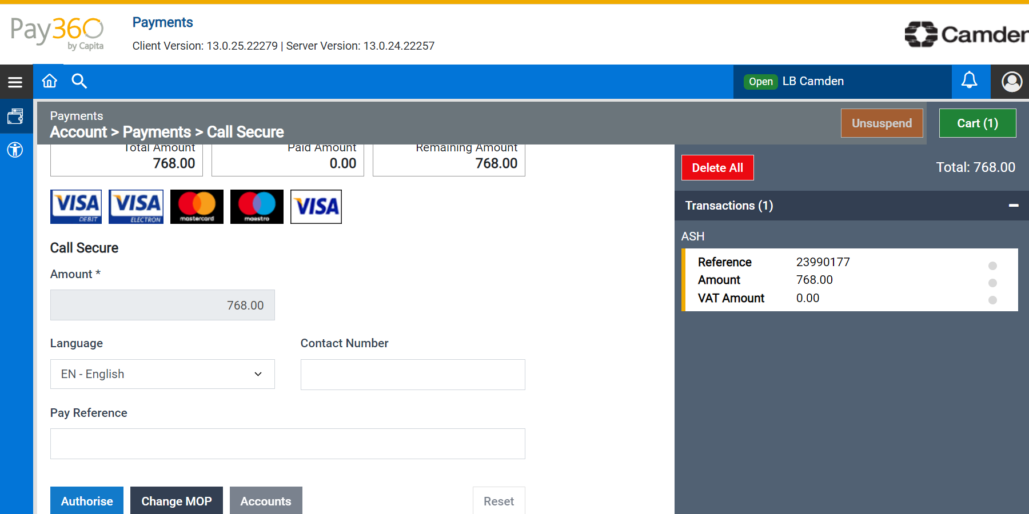

Click on authorise.

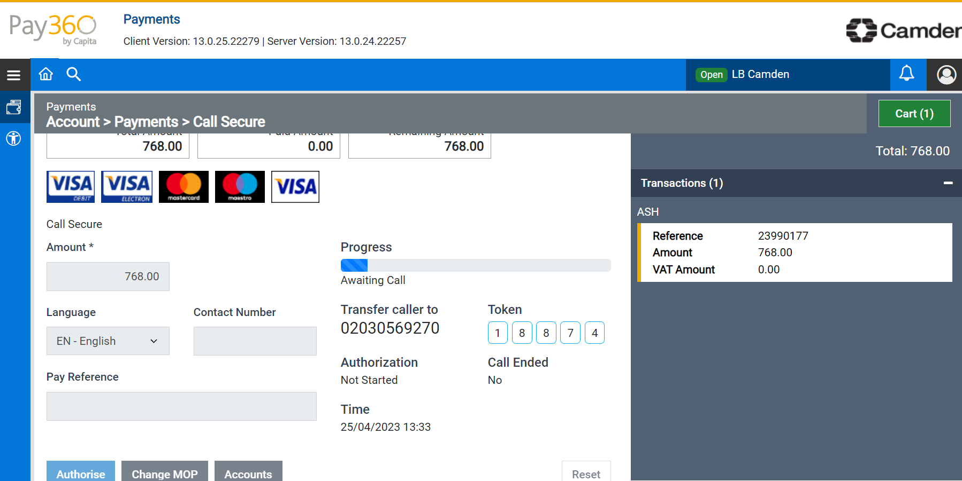

Give the customer the token number and transfer the customer to the telephone number (02030569270)