Tree works: 19 Arlington Road: Rear Garden Site Plan

Total Garden Area: 17ft wide x 80 ft long.

 | Raised Patio Area
 |  | Ash Tree  (1)  * |  | Lawn Area |  | Olive Tree  * | Flower Bed  Fig*  shrub
 | Flower Bed
 | Patio Area
 | House extension
17 Arlington road | 19 Arlington Road |  |  |  |  |  |  | 21 Arlington Road

Photos below
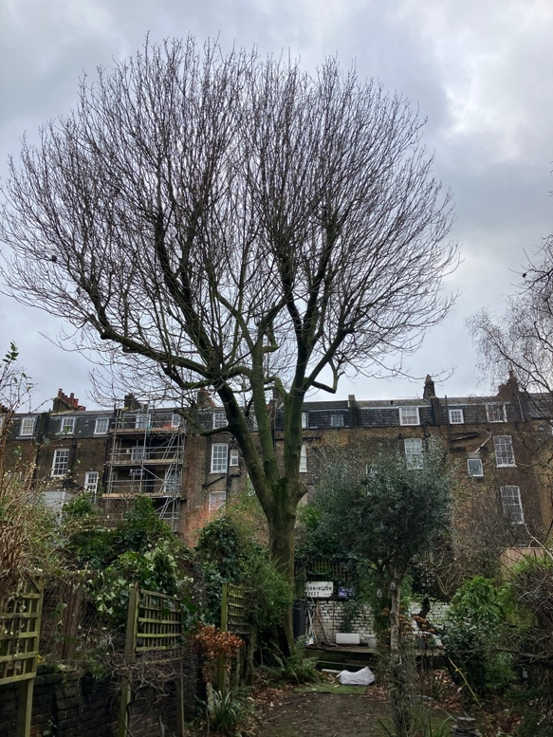 | 