DECISION

Planning (Listed Building and Conservation Areas) Act 1990

Listed Building Consent Granted

Address:
18 Dunboyne Road
London
NW3 2YY

Proposal:
Installation of steel riser pipe on east elevaton of upper maisonette (retrospective).
Drawing Nos: Site Location Plan; 20230915_23009725_PLN_EL_1.1 - Pre-Existing & Existing East Elevations; 20230915_23009725_PLN_SI_3.1 - Site Plan; 20230915_23009725_PLN_SI_4.1 - Network Plan; Design and Heritage & Access Statement.

The Council has considered your application and decided to grant Listed Building Consent subject to the following condition(s):

Conditions And Reasons:

1 | The development hereby permitted shall be carried out in accordance with the following approved plans:  Site Location Plan; 20230915_23009725_PLN_EL_1.1 - Pre-Existing & Existing East Elevations; 20230915_23009725_PLN_SI_3.1 - Site Plan; 20230915_23009725_PLN_SI_4.1 - Network Plan; Design and Heritage & Access Statement.  Reason: In order to safeguard the special architectural and historic interest of the building in accordance with the requirements of policy D2 of the Camden Local Plan 2017.
2 | All new work and work of making good shall be carried out to match the existing adjacent work as closely as possible in materials and detailed execution.  Reason: In order to safeguard the special architectural and historic interest of the building in accordance with the requirements of policy D2 of the Camden Local Plan 2017.

Informative(s):

Reasons for granting listed building consent:

The application property is an upper maisonette situated in the western block of the grade II listed Dunboyne Road Estate. The Estate was designed by Neave Brown and the Borough Architect's Department for Camden Housing Department in 1965, and built from 1971-77. The buildings are constructed from concrete blocks with a rendered external finish.

Approval is sought retrospectively for the installation of a steel riser pipe on the soffit of the east elevation of an upper maisonette in the westernmost block of the Estate, which has been installed as a one-off due to the failure of the existing gas installation to the property in question. The current applications are pursuant to extant planning and listed building consent applications ref 2019/3376/P and 2019/3981/L, which were approved on 16/10/2019 for the installation of external gas pipe apparatus on the front elevations of properties in the Dunboyne Road Estate.

It is considered that the proposed works have been installed in a discreet manner and are consistent with the extant approved scheme for the installation of external gas pipes. As such, the works cause no harm to the special interest of the grade II listed building.

Public consultation was undertaken for this application by means of a site notice and a press notice, but no responses were received. The site's planning history was taken into account when arriving at this decision.

Special regard has been attached to the desirability of preserving the listed building and its features of special architectural or historic interest, under s.16 of the Planning (Listed Buildings and Conservation Areas) Act 1990 as amended by the Enterprise and Regulatory Reform Act (ERR) 2013.

As such, the proposal is in general accordance with policies D1 and D2 of the Camden Local Plan 2017. The proposed development also accords with the London Plan 2016 and the National Planning Policy Framework 2021.

You are advised that any works of alterations or upgrading not included on the approved drawings which are required to satisfy Building Regulations or Fire Certification may require a further application for listed building consent.

In dealing with the application, the Council has sought to work with the applicant in a positive and proactive way in accordance with paragraph 38 of the National Planning Policy Framework 2021.

You can find advice about your rights of appeal at:

http://www.planningportal.gov.uk/planning/appeals/guidance/guidancecontent

Yours faithfully

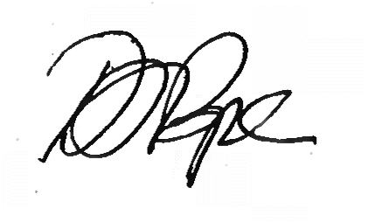
Daniel Pope
Chief Planning Officer

