Email: Brendan.Versluys@camden.gov.uk

06 December 2023

Dear Brendan Versluys

**Brunswick Centre,** **London, WC1N 1BS**

**REF:** 2023/3870/P & 2023/3901/L

The Twentieth Century Society has been notified of the above Listed Building Consent application to repurpose part of the two-storey carpark beneath the Brunswick Centre as a (207 bedroom) hotel with associated reception and food and beverage (F&B) facilities. This would involve lowering the existing basement slab currently separating the upper and lower basement levels. An entrance to the hotel would be provided within a retail unit (unit 38a) at ground floor level, and ASHPs and PV panels located at roof level. The Society has concerns about the application which are outlined below.

Significance

Designs for the Brunswick Centre developed from 1959, initially by Patrick Hodgkinson and Sir Leslie Martin before Martin left and Hodgkinson became sole architect from 1963. It was built between 1968 and 1972 to modified designs. The Brunswick is a hugely important example of post-war low-rise, high-density housing, designed as a ‘megastructure’ consisting of two A-framed blocks, linked by a raised podium accommodating shops and a cinema, over a basement carpark. It is an architectural landmark and highly significant piece of post-war urban planning.

Policy

The Brunswick Centre is Grade II listed and located within the Bloomsbury Conservation Area. As a listed building, the local authority should be mindful of Section 66(1) of the Planning (Listed Buildings and Conservation Areas) Act 1990: “In considering whether to grant planning permission […] for development which affects a listed building or its setting, the local planning authority […] shall have special regard to the desirability of preserving the building or its setting or any features of special architectural or historic interest which it possesses.” The local authority should also note Section 71(1) of the Act which relates to conservation areas: “In the exercise, with respect to any buildings or other land in a conservation area […] special attention shall be paid to the desirability of preserving or enhancing the character or appearance of that area.”

Section 16 of the National Planning Policy Framework (NPPF) on the historic environment should also be consulted, particularly paragraphs

199: “When considering the impact of a proposed development on the significance of a designated heritage asset, great weight should be given to the asset’s conservation […] This is irrespective of whether any potential harm amounts to substantial harm, total loss or less than substantial harm to its significance.”

And 200: “Any harm to, or loss of, the significance of a designated heritage asset (from its alteration or destruction, or from development within its setting), should require clear and convincing justification.”

Comments

The Society was consulted on the proposals at pre-application stage and attended a site visit in early June 2023. The case was reviewed by the Society’s advisory Casework Committee on 12 June and an official written response provided on 30 June.

In our pre-application response, we stated that we had no objections to proposals to repurpose the carpark as a hotel in principle. The carpark is currently an underutilised space and the basement levels are largely of neutral heritage significance. However, the potential detrimental impact of lowering the floor slab on the building’s structure was raised in our earlier response and does not seem to have been adequately addressed by the applicant. Our deep concerns on this aspect are shared by Stuart Tappin, a Brunswick resident and a very well established structural engineer and expert on 20th-century concrete structures (we refer to Tappin’s letter dated 21 October 2023). We recommend that Stuart Tappin is engaged in the project and his expertise sought. In our previous letter, we also highlighted the impact that the hotel use could have on the building’s existing services, which we remain concerned about.

In our June response, we raised serious concerns about the condition of the Brunswick Centre. We note that a condition survey is being undertaken covering the Brunswick’s ‘most significant elevations and structural components’ to identify their condition. A schedule of defects and repairs will be produced to accompany the survey which will identify defects, their priority level and recommendations for their repair. Officers will decide what and how much repair work will be undertaken and these will be agreed by way of a section 106 agreement. Our view is that all the exposed concrete, including the internal A-frames to the residential areas should be inspected for damage and then repaired as part of any development works. We are pleased that the estate’s condition is being addressed in this application. It was evident on site that previous repairs have not been wholly successful – old patch repairs do not match the original concrete finish and some are failing. Any new repair work needs to be informed by thorough research and investigation and needs to be tested off-site and in a discreet location on-site before it is implemented. Repairs should be durable but also reversible if necessary and an aesthetic match (in texture and colour). A maintenance plan should also be produced. It is vital that this conservation work goes ahead and is carried out to a high standard.

We do not wish to comment on the remaining proposed interventions.

We hope that these comments are of use to you. We would be grateful if you could please inform us of your decision on this application.

Yours sincerely,

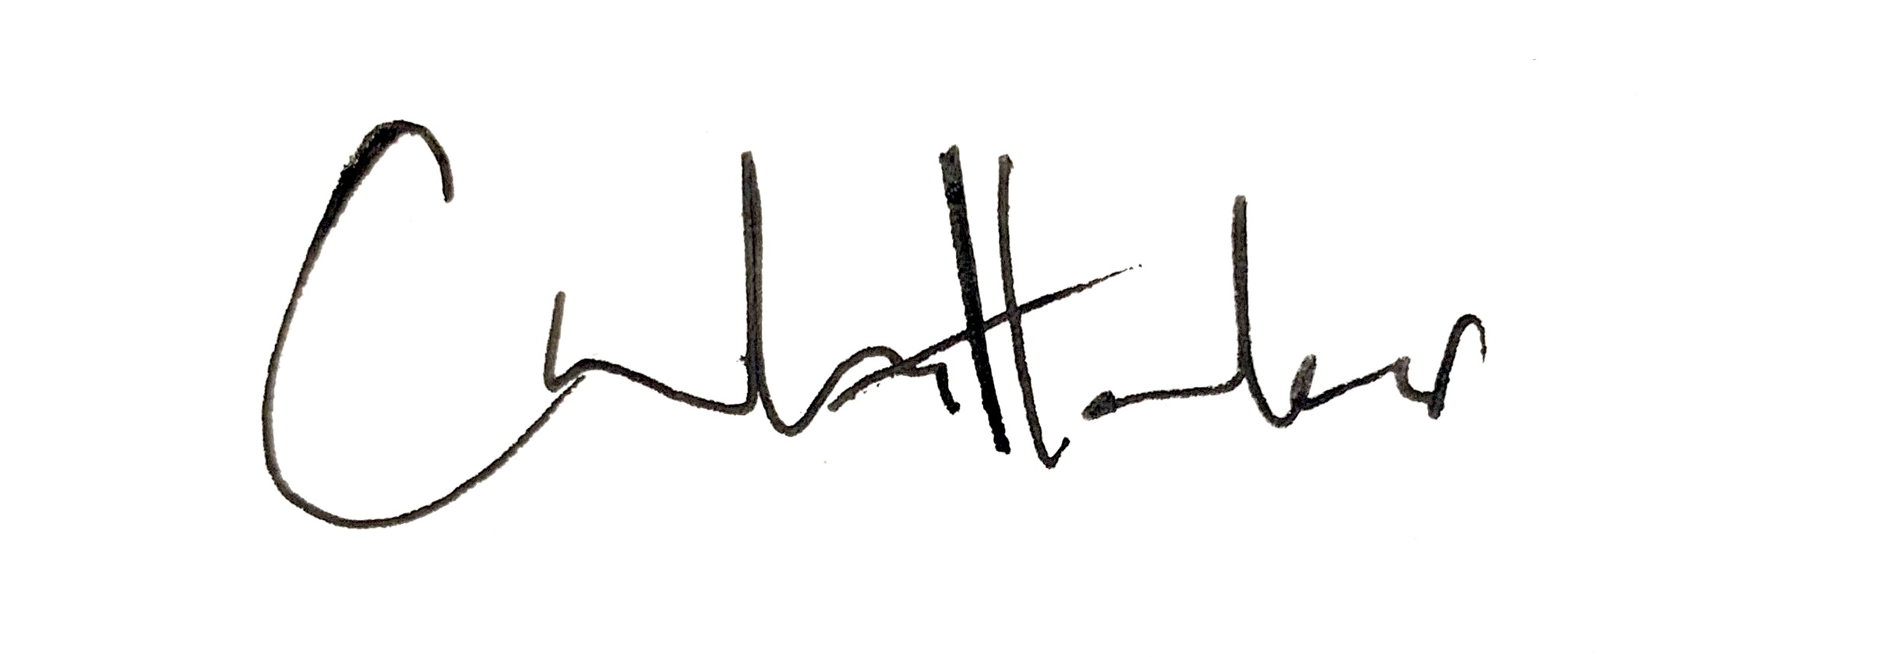

Coco Whittaker

**Senior Caseworker**

The Twentieth Century Society  
70 Cowcross Street  
London, EC1M 6EJ  
Tel 020 7250 3857  
[coco@c20society.org.uk](mailto:coco@c20society.org.uk)

**Remit:** The Twentieth Century Society was founded in 1979 and is the national amenity society concerned with the protection, appreciation, and study of post-1914 architecture, townscape and design. The Society is acknowledged in national planning guidance as the key organisation concerned with the modern period and is a constituent member of the Joint Committee of the National Amenity Societies. Under the procedures set out in *ODPM Circular 09/2005,* all English local planning authorities must inform the Twentieth Century Society when an application for listed building consent involving partial or total demolition is received, and they must notify us of the decisions taken on these applications.