**7 Percy Street**

**London**



**Historic Building Assessment**

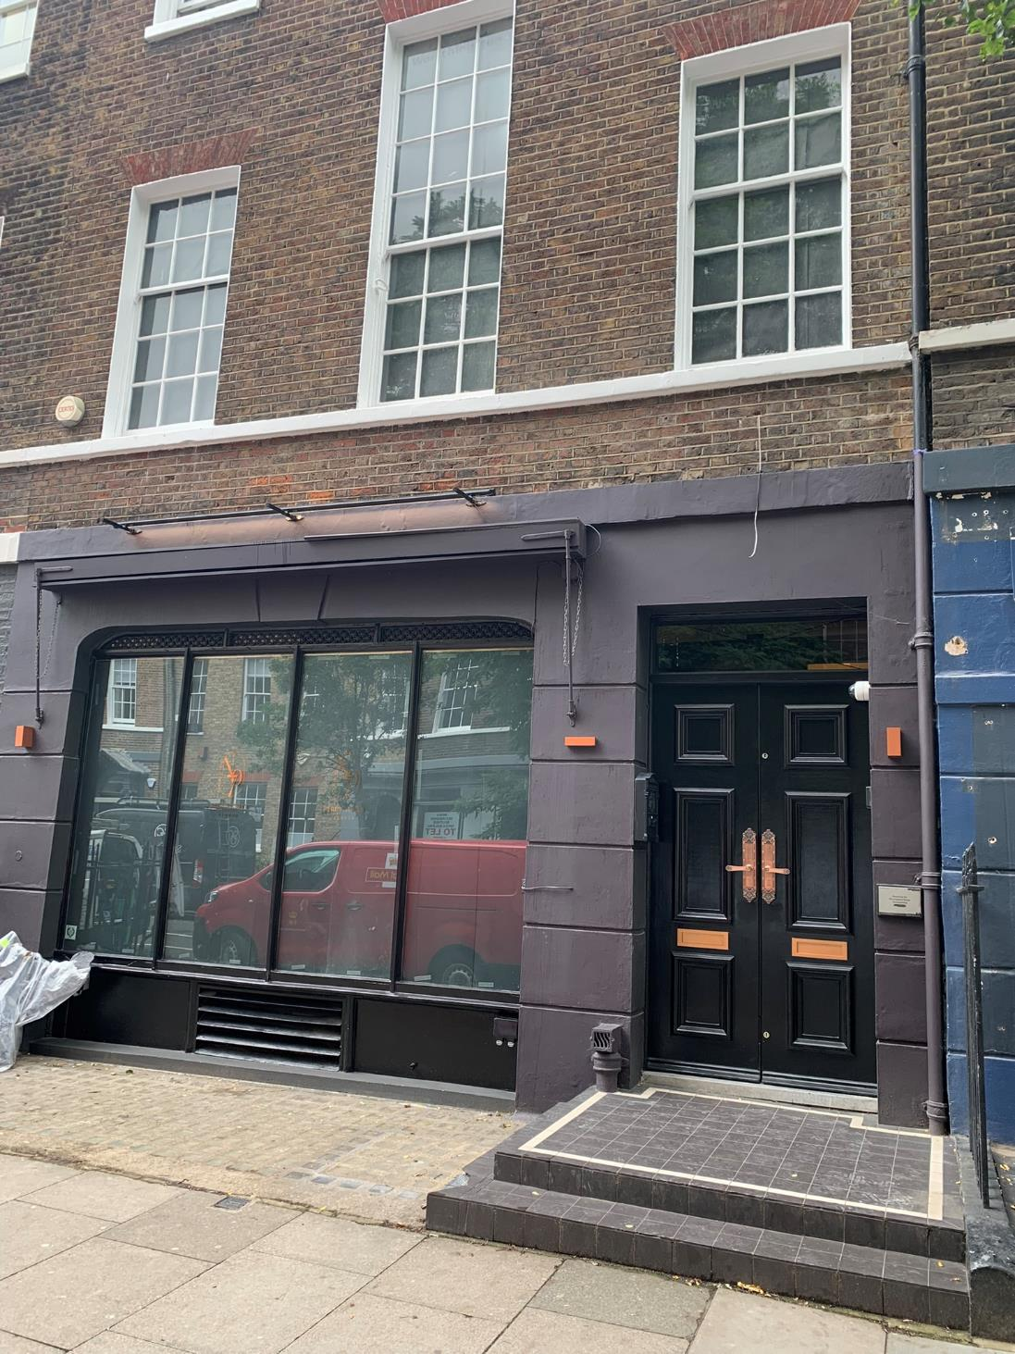**Version history**

Project name: 7 Percy Street (inc.6 Percy Street Basement)

Project number: 065

Client: Seven Percy Street Limited

|  |  |  |  |  |
| --- | --- | --- | --- | --- |
| Rev: | Date: | Status | Name | Description |
|  |  |  |  |  |
| 2 | Sept 23 | APPROVAL | Stephen Wardle | Heritage Consultant | Final Issue |
| 1 | Sept 23 | APPROVAL | Stephen Wardle | Heritage Consultant | First Issue |

This document has been prepared for the titled project or named part thereof and should not be relied upon or used for any other project without an independent check being carried out as to its suitability and prior written authority of *SDW architectural design* being obtained. *SDW architectural design* accepts no responsibility or liability for the consequences of this document being used for a purpose other than the purposes for which it was commissioned. Any person using or relying on the document for such other purpose agrees and will by such use or reliance be taken to confirm his agreement to indemnify *SDW architectural design* for all loss or damage resulting, therefore. *SDW architectural design* accepts no responsibility or liability for this document to any party other than the person by whom it was commissioned.

**SDW architectural design**

34 Twisse Road

Bolton

BL2 6NZ

T: 07519 190 770

E: [s.d.wardle@gmail.com](http://www.buttress.net/)

**Contents**

* 1. Introduction 6
  2. Background 6
  3. Methodology 6
  4. Authorship & Ownership 6
  5. Heritage Policy and Guidance 7
  6. Location & Description 10
  7. Current Land Use & Management 10
  8. Designations 10
  9. Understanding the Heritage 12
  10. Historic Overview 12
  11. No.7 Percy Street 13
  12. Charlotte Street Conservation Area 17
  13. History & Development 19
  14. Relevant Planning History 21
  15. Assessment of Significance 23
  16. Archaeological Interest 24
  17. Architectural & Artistic Interest 24
  18. Historic Interest 24
  19. Summary of Proposed Works 26
  20. Ground Floor 26
  21. Basement Floor 28
  22. Heritage Impact Assessment 22
  23. Methodology 31
  24. Impact on no.7 Percy Street 32
  25. Conclusion 33
  26. Bibliography 35
  27. Architectural Drawings 36

**Project Summary**

**Project Summary**

SITE NAME: 7 Percy Street (inc. 6 Percy Street basement)

ADDRESS: 7 Percy Street Fitzrovia, London, W1T 1DH

SITE OWNERS: Seven Percy Street Limited

LOCAL PLANNING AUTHORITY: London Borough of Camden

DESIGNATIONS: Grade II

CONSERVATION AREA: Charlotte Street Conservation Area

DATE OF PROPERTY: Georgian

PROJECT TYPE: Heritage Statement

PREPARED BY: Stephen Wardle

QA BY: Hanif Darvesh / Frank De Lacey

DATE: September 2023

**1.0 Introduction**

# Introduction

## Background

The following report presents a Historic Building Assessment has been prepared to inform the application process in relation to proposals to carry out internal alterations to the grade II listed no.7 Percy Street, Fitzrovia, London, W1T 1DH, henceforth referred to as ‘The Site’. This report sets out the historic development and significance of the site and its context and considers the potential and scope for change and alteration.

The site is situated on the south side of Percy Street and forms part of a listed group of terraced town houses with later shops at numbers 5-9 including attached railings to no.8. The buildings are grouped together in this way presumably because all were originally constructed during the 1760s. The group is listed as grade II and sits within the boundary of Charlotte Street Conservation Area.

The proposed scheme is intended to upgrade the existing Class A1 provision at ground floor and basement floor, making alterations to areas of comparatively lesser significance. The proposals involve the reconfiguration of existing modern partitions within the basement area, and relocation of the modern staircase to the rear room of the ground floor level.

No works to the exterior are proposed.

This report is to supplement a retrospective Listed Building Consent application for works already carried out. Any works that are deemed to be insensitive or detrimental to the significance of the building are to be removed and restored through the advice of the conservation officer at Camden Council.

## 1.2 Methodology

This assessment sets out the historic development of no.7 Percy Street and provides an overview of the building’s significance and heritage value. The report also assesses the impact the proposal will have on the Charlotte Street Conservation Area and the setting of the adjoining listed buildings. The document is intended to support the submission of a Planning application.

The document surveys the heritage, providing an overview of important information to foster a better understanding of the asset and its significance. It does this through assessment of the surviving building fabric and its wider context. Significance is assessed in relation to heritage interests outlined by Historic England. The aim of this assessment is to understand the site to provide a baseline against which to assess heritage impacts. This document has been written in accordance with National.

Planning Policy Framework (2021), Historic England’s Statements of Heritage Significance (2019), Conservation Principles, Policies & Management for the Sustainable Management of the Historic Environment (2008), and BS7913 - British Standards Guide to the Conservation of Historic Buildings.

The report is divided into four main sections. The first (section 2) describes the historic development of the site and the second (section 3) considers its significance together with an assessment of its surviving historic fabric. The final two sections (section 4 and section 5) describe the proposed scheme and its effects.

It should be noted that in common with many historic buildings, sites, and places, it is not possible to provide a truly comprehensive analysis of the site’s historic development. The research and analysis set out in this document is as thorough as possible given the type and number of archival resources available. Research has been undertaken using the London Metropolitan Archives, Ordnance Survey mapping, the Camden Local Archives Centre, LB Camden planning website; and Historic England’s Archive.

## Authorship & Ownership

This document has been prepared by Stephen Wardle,

BSc (Hons), MCIAT, Accredited Conservationist.

## Heritage Policy and Guidance Summary

## Legislation

The primary legislation relating to Listed Buildings and Conservation Areas is set out in the Planning (Listed Buildings & Conservation Areas) Act 1990. Section 66(1) reads:

*“In considering whether to grant planning permission for development which affects a listed building or its setting, the local planning authority or, as the case may be, the Secretary of State shall have special regard to the desirability of preserving the building or its setting or any features of special architectural or historic interest which it possesses.”*

In relation to development within Conservation Areas, Section 72(1) reads:

*“Special attention shall be paid to the desirability of preserving or enhancing the character or appearance of that area.”*

The Courts have determined that “preserve” in the context of the Planning Acts, means the minimum requirements of the Act would be met if there is an absence of harm. This statutory requirement relates to designated heritage assets.

The NPPF and Historic England’s Good Practice Guide in Planning No. 3 – The Setting of Heritage Assets (Historic England) [GPA3] makes it clear that the setting of a heritage asset in the surroundings in which a heritage asset is experienced, is a material consideration.

*“The Courts have held that it is legitimate in appropriate circumstances to include within a conservation area the setting of buildings that form the heart of that area (R v Canterbury City Council ex parte David Halford, February 1992; CO/2794/1991) and NPPF paragraph 80, for example, makes it clear that historic towns are regarded as having a setting.” [1]*

And

*“In primary legislation, the setting of conservation areas is not a statutory duty. However, the NPPF states that the setting of a designated heritage asset can contribute to its*

*significance.” [2]*

**Revised National Planning Policy Framework**

The National Planning Policy Framework (NPPF) was published on July 2018, revised in February 2019, and revoked all past Planning Policy Guidance and Statements and now embodies national policies and objectives.

Under the heading ‘Achieving sustainable development’ we are advised in paragraph 8 that:

“*Achieving sustainable development means that the planning system has three overarching objectives, which are interdependent and need to be pursued in mutually supportive ways.”*

Under an “*economic objective*” this is defined as:

*“to help build a strong, responsive and competitive economy, by ensuring that sufficient land of the right types is available in the right places and at the right time to support growth, innovation and improved productivity; and by identifying and coordinating the provision of infrastructure.’’*

Under “*a social objective*” we are advised that this involves:

*“to support strong, vibrant and healthy communities, by ensuring that a sufficient number and range of homes can be provided to meet the needs of present and future generations; and by fostering a well-designed and safe built environment, with accessible services and open spaces that reflect current and future needs and support communities’ health, social and cultural well-being;”*

Under “*an environmental objective*” this is referred to as:

*“to contribute to protecting and enhancing our natural, built and historic environment; including making effective use of land, helping to improve biodiversity, using natural resources prudently, minimising waste and pollution, and mitigating and adapting to climate change, including moving to a low carbon economy.”*

Although there is a presumption in favour of sustainable development, footnote 6 makes it clear that it is not an automatic presumption where designated heritage assets are concerned. Paragraph 124 sets out that “*good design is a key aspect of sustainable development” and that planning policies and decisions should ensure that developments*:

1. *will function well and add to the overall quality of the area, not just for the short term but over the lifetime of the development;*
2. *are visually attractive as a result of good architecture, layout and appropriate and effective landscaping;*
3. *are sympathetic to local character and history, including the surrounding built environment and landscape setting, while not preventing or discouraging appropriate innovation or change (such as increased densities);*
4. *establish or maintain a strong sense of place, using the arrangement of streets, spaces, building types and materials to create attractive, welcoming and distinctive places to live, work and visit; encourage the effective use of land by re-using land that has been previously developed (brownfield), provided it is not of high environmental value, conserve heritage assets in a manner appropriate to their significance, so that they can be enjoyed for their contribution to the quality of life of this and future generations.*

Chapter 16 relates specifically to ‘Conserving and enhancing the historic environment’ with paragraphs 184 – 202 being relevant to the consideration of proposals affecting heritage assets. Paragraph 189 indicates that:

*“ …. local planning authorities should require an applicant to describe the significance of any heritage assets affected, including any contribution made by their setting. The level of detail should be proportionate to the assets’ importance and no more than is sufficient to understand the potential impact of the proposal on their significance.*

The definition of a heritage asset as set out in the NPPF Glossary includes:

*“A building, monument, site, place, area or landscape identified as having a degree of significance meriting consideration in planning decisions, because of its*

*heritage interest. Heritage asset includes designated*

*heritage assets and assets identified by the local planning authority (including local listing).”*

Attention is drawn to paragraph 192 which requires, inter alia:

*“the desirability of sustaining and enhancing the significance of heritage assets …*

*the wider social, cultural, economic, and environmental benefits that conservation of the historic environment can bring;*

*the desirability of new development making a positive contribution to local character and distinctiveness; and opportunities to draw on the contribution made by the historic environment to the character of place.”*

Paragraph 193 states that:

“When considering the impact of a proposed development on the significance of a designated heritage asset, great weight should be given to the asset’s conservation (and the more important the asset, the greater the weight should be). This is irrespective of whether any potential harm amounts to substantial harm, total loss or less than substantial harm to its significance.”

Paragraph 195 indicates that where a development

*“will lead to substantial harm to (or total loss of significance of) a designated heritage asset, local planning authorities should refuse consent, unless it can be demonstrated that the substantial harm or total loss is necessary to achieve substantial public benefits that outweigh that harm or loss, or all of the following apply:*

1. *the nature of the heritage asset prevents all reasonable uses of the site; and*
2. *no viable use of the heritage asset itself can be found in the medium term through appropriate marketing that will enable its conservation; and*
3. *conservation by grant-funding or some form of not for profit, charitable or public ownership is demonstrably not possible; and*
4. *the harm or loss is outweighed by the benefit of bringing the site back into use. “*

Paragraph 196 refers to cases that will lead to less than substantial harm to the significance of a designated heritage asset, this harm is to be weighed against the public benefits of the proposal including where appropriate securing its optimum viable use.

Paragraph 197 requires that consideration be given to the impact of development proposals, directly or indirectly on non-designated heritage assets. This would include unlisted buildings in conservation areas. Again, a balanced judgement will be required having regard to the scale of any harm or loss and the significance of the heritage asset.

Paragraph 198 specifically states that LPAs should not permit the loss of the whole or part of a heritage asset without taking all reasonable steps to ensure the new development will proceed after the loss has occurred.

It is noted that Paragraph 200 indicates development is not prohibited within the setting of heritage assets where proposals would enhance or better reveal their significance. Proposals that preserve those elements of the setting that make a positive contribution to, or better reveal the significance of the asset are to be treated favourably.

The NPPF therefore recognizes the need to clearly identify relative significance at an early stage and then to assess the impact of development proposals in that context.

**Planning Practice Guidance (PPG)**

The Planning Practice Guidance (PPG) was published in March 2014 as a companion to the NPPF, replacing many foregoing Circulars and other supplementary guidance. In respect of heritage decision-making, the PPG stresses the importance of determining applications on the basis of significance and explains how the tests of harm and impact within the NPPF are to be interpreted.

The PPG also notes the following in relation to the setting of heritage asset:

*“A thorough assessment of the impact on setting needs to take into account, and be proportionate to, the significance of the heritage asset under consideration and the degree to which proposed changes enhance or detract from that significance and the ability to appreciate it.”*

*(Ref I D: 18a-014-20140306)*

**Historic England Conservation Principles:**

**Policies and Guidance 2008**

Historic England sets out in this document a logical approach to making decisions and offering guidance about all aspects of the historic environment, including changes affecting significant places. It states that:

*“New work or alteration to a significant place should normally be acceptable if:*

1. *there is sufficient information comprehensively to understand the impacts of the proposal on the significance of the place;*
2. *the proposal would not materially harm the values of the place, which, where appropriate, would be reinforced or further revealed;*
3. *the proposals aspire to a quality of design and execution which may be valued now and in the future;*
4. *the long-term consequences of the proposals can, from experience, be demonstrated to be benign, or the proposals are designed not to prejudice alternative solutions in the future.”*

(page 59).

**Historic England Making Changes to Heritage Assets Advice Note 2 (February 2016)**

This advice note provides information on repair, restoration, addition, and alteration works to heritage assets. It advises that:

*"The main issues to consider in proposals for additions to heritage assets, including new development in conservation areas, aside from NPPF requirements, such as social and*

*economic activity and sustainability, are proportion, height, massing, bulk, use of materials, durability and adaptability, use, enclosure, relationship with adjacent assets and definition of spaces and streets, alignment, active frontages, permeability and treatment of setting."* (page 10)

**Historic England Managing Significance in Decision Taking in the Historic Environment Good Practice Advice (GPA) in Planning Note 2 (March 2015)**

This advice note sets out clear information to assist all relevant stake holders in implementing historic environment policy in the National Planning Policy Framework (NPPF) and the related guidance given in the Planning Practice Guidance (PPG). These include:

*“assessing the significance of heritage assets, using appropriate expertise, historic environment records, recording and furthering understanding, neglect and unauthorised works, marketing and design and distinctiveness.”* (page 1)

**Historic England The Setting of Heritage Assets Historic Environment Good Practice Advice (GPA3) in Planning Note 3 (July 2015)**

This document presents guidance on managing change within the settings of heritage assets, including archaeological remains and historic buildings, sites, areas and landscapes. Bullet point 4 on page 2 of GPA3 states that:

*“Setting in urban areas, given the potential numbers and proximity of heritage assets, is therefore intimately linked to consideration of townscape and urban design and of the character and appearance of conservation areas. The character of the conservation area, and of the surrounding area, and the cumulative impact of proposed development adjacent, would suggest how much impact on the setting should be taken into account.”*

Under the heading ‘Views and setting’ we note that the contribution of setting to the significance of a heritage asset is often expressed by reference to views which can be static, dynamic, include a variety of views across

or including that asset, and views of the surroundings from or through the asset. [3] At the same time it is noted that one does not need to be in direct view of a heritage asset to be within its setting. It does not depend on public rights or the ability to access it. [4]

GPA3 sets out a stepped approach to assessing setting and the role that it plays in contributing to the significance of a heritage asset/s. This process requires one to have an understanding about the significance of the asset/s in order to be able to determine if harm would arise. It is advised that the following steps are undertaken:

Step 1 – identify which heritage assets and their settings are affected;

Step 2 – assess whether, how and to what degree these settings make a contribution to the significance of the heritage asset(s);

Step 3 – assess the effects of the proposed development, whether beneficial or harmful, on that significance;

Step 4 – explore the way of maximizing enhancement and avoiding or minimizing harm;

Step 5 – make and document the decision and monitor outcomes.

It is acknowledged that this is not the only method of assessing setting, the role that it plays and if a site falls within that setting. It has however stood the test of time and has been accepted by Inspectors at appeal and public inquiries.

## 1.4.2 Local Policy

**The London Plan, 2016**

**Policy 7.8 Heritage Assets and Archaeology**

This strategic policy seeks to identify the various forms of heritage assets and the historic environment within London, to ensure that these assets are sustained and enhanced, and the positive role assets can make in place shaping is fully utilised. Development within London should identify, value, conserve, restore, re-use and incorporate heritage assets, and development affecting heritage assets and their setting should conserve their significance, by being sympathetic to their form, scale, materials, and architectural detail.

**The London Plan, 2021**

**Policy HC1**

This strategic policy retains the conservation principles of the 2016 Plan, however there is a new emphasis on the need for the London Boroughs’ to provide evidence that demonstrates a clear understanding of the historic environment. This is combined with the requirement to provide plans and strategies which will inform the effective integration of London’s heritage in regenerative change.

**Camden Local Plan, 2017**

**Policy D2: Heritage**

This extensive policy relates all aspects of the historic environment. The policy states:

*The Council will preserve and, where appropriate, enhance Camden’s rich and diverse heritage assets and their settings, including conservation areas, listed buildings, archaeological remains, scheduled ancient monuments and historic parks and gardens and locally listed heritage assets.*

Designated Heritage Assets

Designed heritage assets include conservation areas and listed buildings. The Council will not permit the loss of or substantial harm to a

designated heritage asset, including conservation areas and Listed Buildings, unless it can be demonstrated that the substantial harm or loss is necessary to achieve substantial public benefits that outweigh that harm or loss, or all of the following apply:

1. the nature of the heritage asset prevents all reasonable uses of the site;
2. no viable use of the heritage asset itself can be found in the medium term through appropriate marketing that will enable its conservation;
3. conservation by grant-funding or some form of charitable or public ownership is demonstrably not possible; and
4. the harm or loss is outweighed by the benefit of bringing the site back into use.

The Council will not permit development that results in harm that is less than substantial to the significance of a designated heritage asset unless the public benefits of the proposal convincingly outweigh that harm.

Conservation Areas

Conservation areas are designated heritage assets, and this section should be read in conjunction with the section above headed ‘designated heritage assets.’ In order to maintain the character of Camden’s conservation areas, the Council will take account of conservation area statements, appraisals and management strategies when assessing applications within conservation areas.

The Council will:

1. require that development within conservation areas preserves or, where possible, enhances the character or appearance of the area;
2. resist the total or substantial demolition of an unlisted building that makes a positive contribution to the character or appearance of a conservation area;
3. resist development outside of a conservation area that causes harm to the character or appearance of that

conservation area; and

1. preserve trees and garden spaces which contribute to the character and appearance of a conservation area, or which provide a setting for Camden’s architectural heritage.

Listed Buildings

Listed buildings are designated heritage assets, and this section should be read in conjunction with the section above headed ‘designated heritage assets.’ To preserve or enhance the borough’s listed buildings, the Council will:

1. resist the total or substantial demolition of a listed building;
2. resist proposals for a change of use or alterations and extensions to a listed building where this would cause harm to the special architectural and historic interest of the building; and
3. resist development that would cause harm to significance of a listed building through an effect on its setting.

Archaeology

The Council will protect remains of archaeological importance by ensuring acceptable measures are taken proportionate to the significance of the heritage asset to preserve them and their setting, including physical preservation, where appropriate.

Other Heritage Assets and Non-Designated Heritage Assets

The Council will seek to protect other heritage assets including non-designated heritage assets (including those on and off the local list), Registered Parks and Gardens and London Squares. The effect of a proposal on the significance of a non-designated heritage asset will be weighed against the public benefits of the proposal, balancing the scale of any harm or loss and the significance of the heritage asset.

## Aerial view of a city Description automatically generatedLocation & Description

The site is a three-storey Georgian terraced townhouse located within Fitzrovia, Central London. The site forms part of a single terrace encompassing the south side of Percy Street and is considered to form a group with numbers 5-9. The property is also included within the Charlotte Street Conservation Area.

## Current Land Use & Management

At ground floor and basement level, these areas are currently vacant with the previous occupation being one of London’s top award-winning hair salons

– *Charles Worthington*. This existing use class is designated **Class E** (old Class A1).

The proposed scheme is intended to change the use into a Private Members Lounge which would change the former designated use to **Sui-Generis**.

## Designations

As noted above, no.7 Percy Street is a **grade II listed** building. The building was listed in 1974 and forms one of a group of 5 terraced houses with later shops to ground level. The terrace is situated within the **Charlotte Street Conservation Area**.

**2.0 Understanding the Heritage**

* 1. **Understanding the Heritage**

## 2.1 Historic Overview

Prior to the mid-eighteenth Century, Percy Street and the land within the Charlotte Street Conservation Area formed agricultural land on the edge of London and was within the Manor of Tottenhall (Figure 01). The area of land was recorded in the Domesday Book as being owned by the Canons of St Paul’s Cathedral but changed hands several times in the following centuries. After the Restoration, the land was leased in 1667 to the Earl of Arlington, who then passed it onto his daughter and her husband, Henry Fitzroy Earl of Euston, and Duke of Grafton. [5]

During the early C18, areas surrounding the conservation area were developed, with the establishment of the formally planned Cavendish Estate to the west and Bloomsbury Estate to the east. However, with the construction of New Road (now known as Euston Road) as a bypass to Oxford Street in the 1750s, suburban development spread rapidly between Oxford Street, to New Road in the north. In the space of 20 years, the existing urban grain was established and whilst due to numerous landowners and developers, the quality and architectural finishes vary within the streets, the four-storey townhouse was the predominate building form.

Whilst the development of the land occurred rapidly, the decline in the popularity of the area was also rapid. By the turn of the C19, the wealthy were moving to more fashionable areas in west London. This led to a change in the character of the area during the C19: the Camden Conservation Area Appraisal for Charlotte Streets states that *“the large grand houses were subdivided and rented out. The large rooms made good studios and as a result, the area attracted many artists. The area continued to become poorer during the C19 and a range of artists, artisans and craftsmen established businesses in the area, attracted by low rents” [6].* It was also during this time that the area became popular with migrant communities from Europe, particularly France and Italy, who established businesses, shops, and restaurants in the area.

**Figure 02:** Extract of Ordnance Survey 25 Inch Map: London XXXIV.

Surveyed 1870. Published 1875

By the C20, Tottenham Court Road became a focus for the development of large, purpose-built shops for furniture and other goods being made locally. The name “**Fitzrovia**” for which the area is still known, is believed to have been coined in the 1930s as a result of gatherings of writers and other talented people at the Fitzroy Tavern.

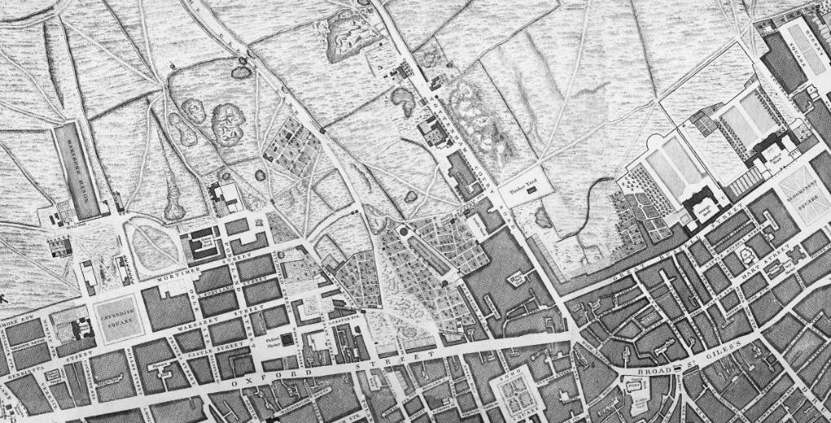

**Figure 01:** John Roque’s Map of London, 1746.

- approximate position of Percy Street

## No.7 Percy Street

No.7 Percy Street was listed in a group with numbers

5-9 Percy Street at Grade II on the 14th May 1974. The list description succinctly describes the architectural features of the front facades. It states:

*NUMBERS 5-9 AND ATTACHED RAILINGS TO NUMBER 8, 5-9 PERCY STREET*

*National Grid Ref: TQ 29598 81566*

CAMDEN

TQ2981NE PERCY STREET 789-1/99/1294 (south side)

14/05/75 Nos.5-9 (Consecutive) and attached railings to No.8

GVII

*5 terraced houses with later shops. 1764-1770, altered. Built by W Franks and W Reeves. Multi-coloured stock brick with slated mansard roofs and dormers. Stucco 1st floor sill and floor bands, except No.5 Stone cornices. EXTERIOR: 3 storeys, attics, and basements. 3 windows each; No.6, 2 windows. Gauged brick flat arches (mostly reddened) to recessed sash windows, most with original glazing bars. Parapets. No.7: rusticated stucco ground floor, now painted. C20 shop window with C19 filigree ironwork head. Square-headed doorway with fanlight and panelled double-doors. 1st floor centre window elongated. INTERIORS: not inspected*

*(Survey of London: Vol XXI, Tottenham Court Road and* *Neighbourhood, St Pancras III: London: 1949:*

*7-11).*

Despite the list description being written over 40 years ago, there appears to be very few changes to the architectural features of the 5 townhouses. The only element of renewal to the exterior would appear to be the shop front to no.7 Percy Street.

* + 1. 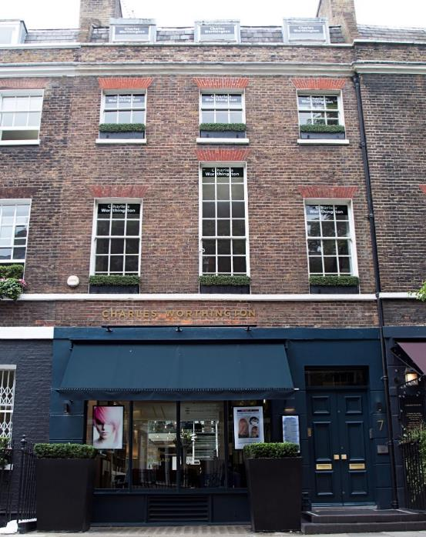Exterior

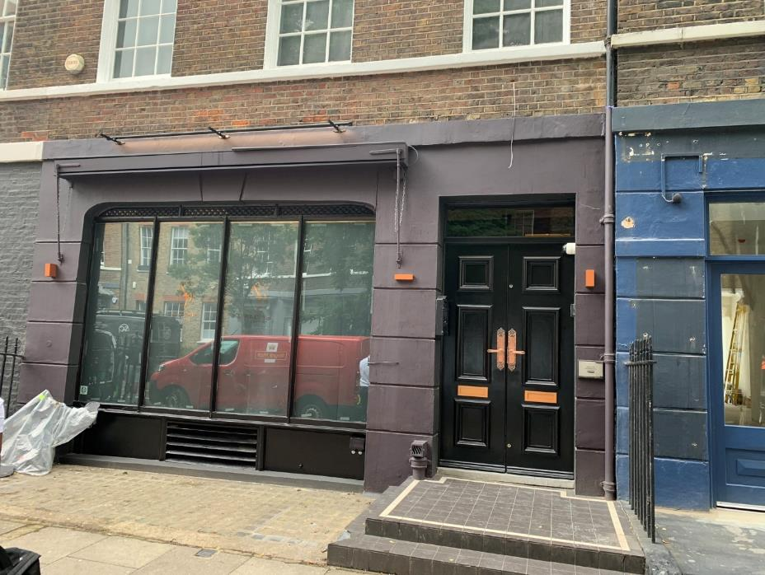

**Figure 03, *Left:*** no.7 Percy Street – Front Elevation, 2022

**Figure 04, *Right:*** no.7 Percy Street – Front Elevation, 2023

Built in the Georgian period between 1794 and 1770, no.7 Percy Street is three-storeys in height and is constructed primarily of multi-coloured London stock brick with slated mansard roof. Rusticated stucco is at the ground floor level and is now painted.

There is a large shop window at ground floor level with a timber framed windows replaced during the 1990s. The window retains C19 filigree ironwork to the head. The ground floor main entrance is a square-headed doorway with fanlight and a pair of painted timber panelled double-doors. There is a retractable canopy that sits above the shop window.

There are 3no. windows to each of the upper floors with the first-floor central window elongated in height compared to the two windows either side. The sash windows retain the original glazing bars. The mansard roof has 3no. timber dormer windows, with all windows aligned.

The rear of the property contrasts greatly in character with the front elevation, displaying a functional character with differing styles of windows. The main roof maintains its original M-shape roof form, with 2no. 3 bayed dormer windows facing to the rear onto Percy Mews.

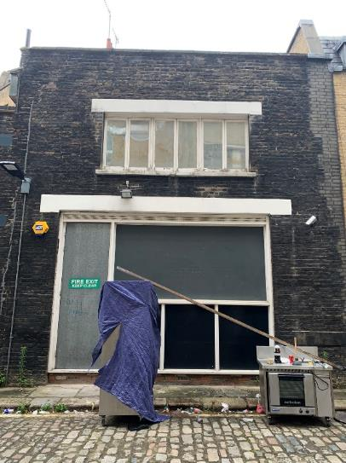To rear of the site is no.7 Percy Mews, a two-storey former mews house. This is constructed in London stock brick with a clay pantile hipped roof. Air-conditioning units sit on the roof level. The rear elevation has a large window at ground floor (incorporating fire exit door) and at first floor (6 bayed window).

The two buildings (no.7 Percy Street and no.7 Percy Mews) are now combined as one property with a glazed infill structure installed between, presumably during the 1990s.

**Figure 05:** no.5 Percy Mews – Rear Elevation, 2023

**5**

* + 1. **Interior – Ground Floor**

**3**

**2**

The plan form of all the houses in Percy Street seem to have been alike: the ground floor having a room at the front and an entrance hall, east or west of it with an archway leading to the staircase behind and a back room narrower than that in front. [7]

**1**

**4**

0No.7 Percy Streets entrance hall is to the west (facing the building this is to the right). This is accessed from the square-headed doorway with fanlight and a pair of painted timber panelled double-doors. The entrance archway leading to the staircase behind has been concealed by modern stud partitioning when the ground floor and upper floors was sub-divided during the C20.

**Top, *left*** – view looking into reception room from entrance hall (2013) (1)

**Top, *right*** – view looking towards rear wall of reception room (2005) (2)

**Bottom, *left*** – view looking towards rear wall of reception room (2013) (3)

**Bottom, c*entre*** – view looking up C20 glass staircase within mews townhouse (2013) (4)

**Bottom, *right*** – view looking towards rear extension between no.7 Percy Street and no.7 Percy Mews (2005) (5)

The ground floor reception rooms to the left of the entrance hall has been knocked through into the rear room, now read as one. This adaptation was implemented during the mid-C19 when the ground floor was converted into a shop. The room retains the original moulded cornices around the perimeter of each room. Timber profiled panelling sits above a dado that runs around the perimeter of the room.

There are 2no. chimney breasts (one serving each room) on the adjoining wall with no.6 Percy Street. The original fireplaces which would have consisted of a mantelpiece with side supports, hearth and firebox have been replaced with modern C20 marble fireplaces.

There is a timber partition between the reception room and entrance hall that has been adapted with glass panels inserted within the timber panelling (*date unknown*). A room with a staircase and a table

The rear wall of no.7 Percy Street has been removed, opening out onto what would have been the courtyard between no.7 Percy Street and no.7 Percy Mews. This has been infilled with a glass lean-too roof during the 1990s, when the property saw most of the internal alterations.

The mews property to the rear has a mezzanine floor accessed by a modern C20 glass staircase.

* + 1. **Interior – Basement Floor**

**1**

The basement floor covers both no.6 Percy Street and no.7 Percy Street, connected by 2no. openings within the party wall. The floor is accessed via a staircase from the ground floor of no.7 Percy Street.

This floor has seen the most adaptation over the years, with modern stud partitions having been installed to divide the spaces into smaller rooms.

To the front of the property are brick arched vaults which sit underneath the pavement above.

The ceiling throughout has been underdrawn to provide a void for services and ducting to run.

These spaces retain little or no original features of historical merit.

**3**

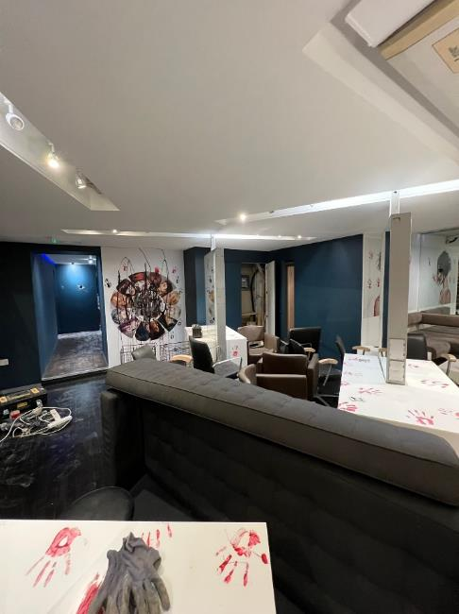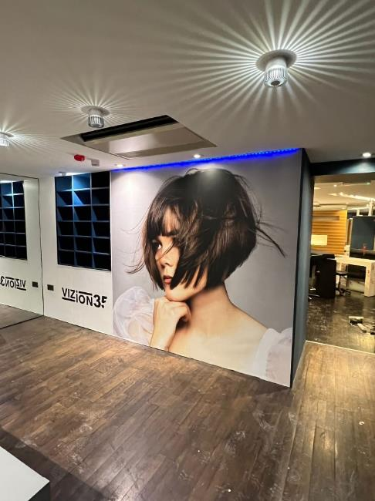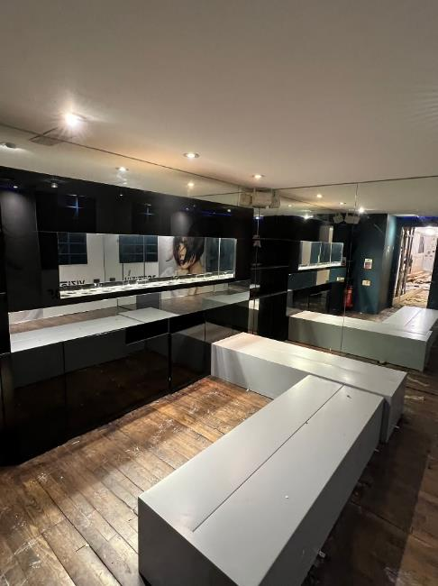

**2**

**Bottom, *left*** – view looking towards front of no.7 Percy Street (2023) (1)

**Bottom, *centre*** – view looking towards party wall within no.6 Percy Street (2023) (2)

**Bottom, *right***– view looking towards front of no.6 Percy Street (2023) (3)

## Charlotte Street Conservation Area

The Charlotte Street Conservation Area was designated on the 26th March 1974, and subsequently extended in 1981, 1985 and 1999 to form its current extent. The conservation area covers 8.9ha from Tottenham Court Road in the east, to Cleveland Street in the west, and Gresse Street in the south and Chitty Street in the north. Both the south and west boundaries of the conservation area adjoins the London Borough of Westminster.

The Charlotte Street Conservation Area is situated within an area known as Fitzrovia. The Conservation Area Appraisal, which was adopted in 2006, encapsulates the significance of the area in its origins as a speculatively developed residential area of Georgian townhouses which was constructed within 20 years from 1750. However, by the late C18 and into the C19, the area declined in popularity for the wealthy, and as a result artists, craftsmen and immigrant communities took up residence in the large houses which were subdivided and charged at low rents. Furthermore, shops, businesses and public houses were developed or inserted into older properties at ground level. It is the varied, mixed use of the area which gives it a distinct character and appearance.

No.7 Percy Street is typical of the conservation area, as it is a typical Georgian townhouse with a mix of residential and business use, incorporating a retail unit at ground and basement.

* + 1. **Designated Heritage Assets within the Setting**

As Figure 06 demonstrates, the majority of the terraces on both the north and south side of Percy Street are listed Grade II. This includes:

* + no.4 Percy Street
  + nos.5-9 Percy Street (consecutive)
  + no.12 and 13 Percy Street
  + nos.32 and 33 Percy Street

Whilst the outlined designated assets are considered to create a formal street scene and as such, have a shared urban setting, the proposed scheme at No.2 is considered to have a nil to negligible impact on the setting of the adjacent listed buildings. This is due to the fact that there will be no change to the existing use of the building and no material alterations are proposed to the external elevations. As such, the

**Figure 06:** Extract of Map produced by LB Camden: Built Heritage

Audit Plan for Charlotte Street Conservation Area

existing character and use of the terrace will remain as existing, as well as the external appearance and therefore the appearance of the street scene will be preserved.

* + 1. **Setting**

Situated within inner London in the Borough of Camden, Percy Street runs from Rathbone Street in the west to Tottenham Court Road in the east. At its western end it is joined by Rathbone Place and Charlotte Street. Percy Mews, a redeveloped and cobbled cul-de-sac with original surviving Mews properties, runs parallel with Percy Street and is approached through an entrance under a building on Rathbone Place.

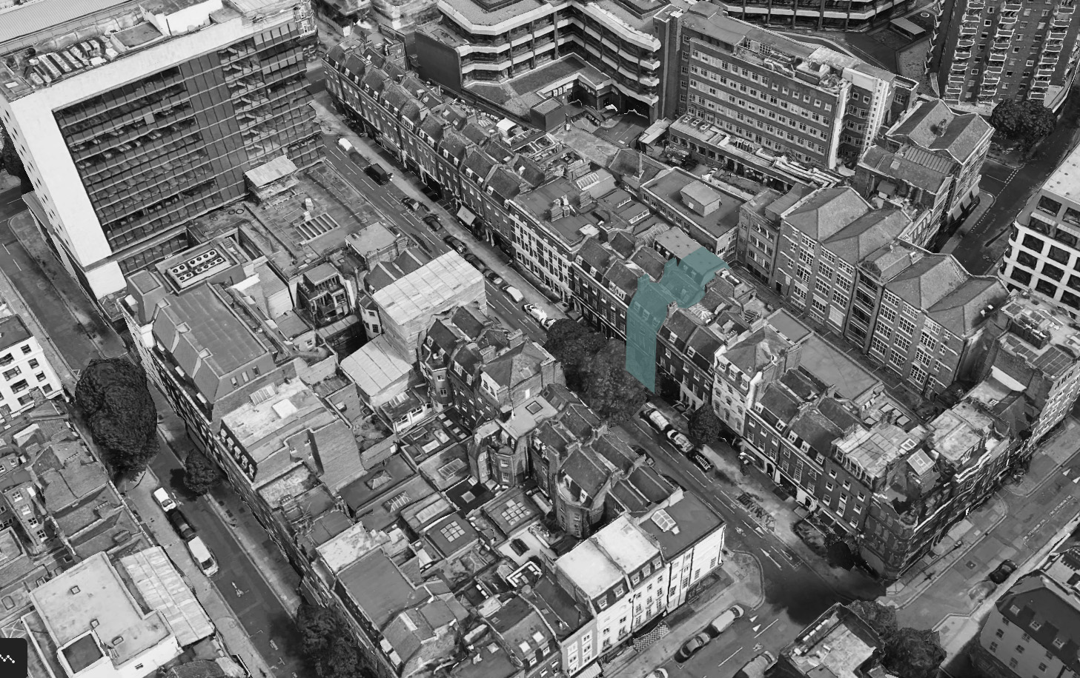

Figure 07: View South of Percy Street Setting

The route of Tottenham Court Road existed as a major link between London and the northern villages such as Camden Town, Hampstead and beyond. In the 1750s, the construction of the New Road (now Euston Road) to the north, roughly parallel to the ancient Oxford Street, kick-started a planned development in the area between these two roads. This area - known since the 1930s as “**Fitzrovia**” – was speculatively developed between c.1750 and c.1770. Percy Street is in the southern portion of this new development.

## History & Development

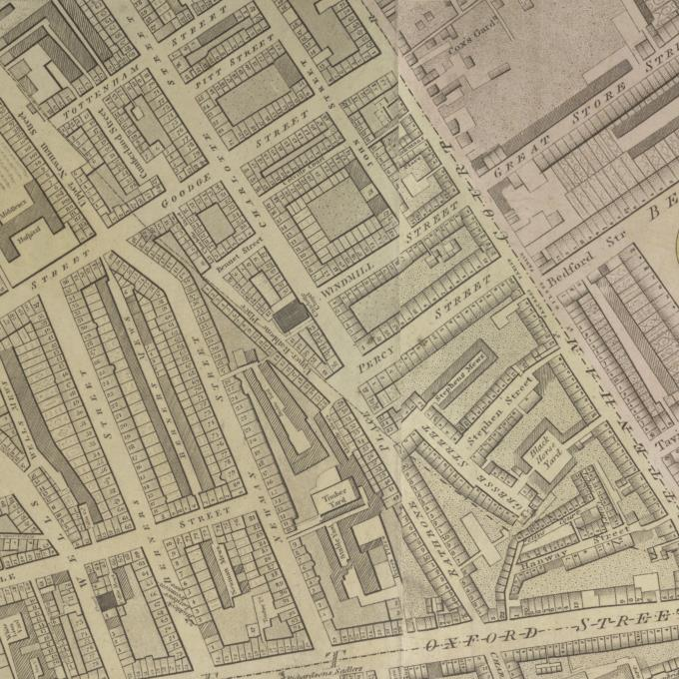

**Figure 08:** Percy Street in Richard Horwood’s ‘PLAN of the Cities of LONDON and WESTMINSTER the Borough of SOUTHWARK, and PARTS adjoining Shewing every HOUSE’, 1792-99

In 1764, landowners Francis and William Goodge granted leases on the south side of what is now Percy Street, and in 1766 on the north side. By 1770, 28 grand terraced town houses and their associated service mews had been completed. [8]

These can be seen on Horwood’s map of London

1792-99 (see figure 08 [9]). There are 37 properties now built, the south side being numbered consecutively from no.1 near the corner of Rathbone Street to no. 20 where it meets Tottenham Court Road and the north side from no. 21 next the Crab Tree in Tottenham Court Road to no.37 which adjoins no.2 Charlotte Street. Both sides exhibit (with two exceptions only) an unbroken uniform design, three storeys high in stock brick with red brick flat arches to the sash windows, of which there are three to each of the upper floors. Each house has a basement, with two windows, lit by an open area and its façade terminates in a stone molded cornice and brick parapet, above which is a mansard roof with two attic windows, and plain brick chimneys.

The architecture of Percy Street is undistinguished. Most of the buildings are generic three-storey Georgian town houses with standard interior features. The ground floors of around half of the houses on the street have been converted to retail use, and on the north side a large modern office block is situated on the corner of Tottenham Court Road.

The first edition OS Map surveyed in 1870 shows the courtyard to rear of the property, with a connecting link building between no.7 Percy Street and no.7 Percy Mews (see figure 09) [10].

The architectural historian Dan Cruikshank describes Percy Street as one of the most important streets built in Georgian London, *“for it is one of the earliest realisations of that Classical urban ideal – the uniform and symmetrically composed street”.* [11]

A handful of regular palace-fronted streets predate Percy Street (e.g. nos.54-64 Strand (1738), Great George Street, Westminster (1755) and John Street, Bloomsbury (1759-mid-1760s) however, Percy Street was a much longer uniform terrace, which was duplicated on both sides to form a *‘monumental street of unprecedented scale’*. It was started a year before the Adam brothers began the Adelphi in 1768, often regarded as heralding London’s age of large-scale and uniform urban developments. [12]

No architect has been identified for Percy Street, but research of the surviving building leases reveals the name of William Franks [13] who made an agreement with Francis and William Goodge in 1764 for a 63 -year lease on the south side of Percy Street made up of *‘a parcel of ground fronting toward the north of an intended street called, or intended to be called, Percy Street’’.* Franks probably sub-let to craftsmen who were partners in the scheme, and he is likely to have designed as well as built the houses in Percy Street. He took out further leases for the south side in 1764, and for the north side in 1766. Franks himself lived at no.5 Percy Street until 1788, two years before his death. [14]

Evidence from the Sun Fire Insurance records[15] show that for at least the first 50 years of occupation many of the houses in Percy Street were occupied by gentlemen, widows, and well-heeled spinsters, as well as the better sort of professional such as apothecaries, medical doctors, professors and a goldsmith.

The substantial terraced houses were not only stylish externally, but their interiors were impressive in a modest way, with wide stone halls to the ground floor, and a main front and back room on the principal floors. The second and garret floors were generally sub-divided to form dressing rooms and extra bedrooms. A variety of internal details survive or are recorded as existing earlier in the C20.

Today many of the houses in Percy Street have had shopfronts inserted into their ground floors, an adaptation that occurred from the mid-C19 onwards and many have lost a proportion of their original internal decoration. However, no.7 Percy Street retains some important internal and external features of a house built when Neo-Classicism was starting to become fashionable in the London townhouse.

Fitzrovia suffered bombing during the Second World War, with no.7 receiving blast-damage and other houses close by were badly damaged. [16]

After the War, a number of houses on the north-eastern end of Percy Street, towards the corner with Tottenham Court Road, were demolished. A modern office tower – Metropolitan House; was built here in 1965. This was refurbished in the early 2000s and is now known as the Met Building.

During the early 1910s to 1920s, The B Pulkra Company was occupier of the ground floor and part of the basement floor, sellers of women’s fashionwear. [17]

From 1920s, The Crompton Dancing Academy[18] was based at no.7 Percy Street; one of several academies based around the Borough of London established by Robert Morris Crompton (1845-1926). In late Victorian England, dance teachers lacked national representation and means of communication among themselves to address professional concerns. Crompton was London-based dancing master who was a key figure in contemporaneous efforts in developing a national organisation devoted to both social and stage dancing, The Imperial Society of Teachers of Dancing, who are still active today. Choreographer, writer, and founder-editor of the first periodical devoted to dance in England (Dancing, 1891–1893), Crompton finally succeeded in establishing a national organisation that was devoted to both social and stage dancing in 1904. As the first president of the Imperial Society of Teachers of Dancing, his visionary ideals of an annual technical congress, improvements in the status of the profession, and the future enhancement of dance as an art were placed on a firm institutional footing. [19]

From the late 1920s to early 1940s, the ground floor was occupied by The Standard Health Appliance Company[20] later becoming The Lewis Institute of Physical Culture [21], practitioners of Homeopathy. This was a pseudoscientific system of alternative medicine.

In the 1950s, Peter Stuyvesant Travel [22], a travel agent was based on the ground floor.

In 1966, the ground floor and first floor was converted as an architect’s offices[23]. Frederick Gibberd Partnership was based at no.7 Percy Street until the 1981. The practice was established in 1935 by the late Sir Frederick Gibberd, who was one of the most significant British Modernist designers of the late C20,

whose work covered architecture, town planning and landscape design[24]. Gibberd’s most notable commissions include the new Town of Harlow (1947), Liverpool Metropolitan Cathedral, (1967), Didcot Power Station (1967), and London Central Mosque (1977).

In 1981, the ground floor and the basement was refurbished and converted back to retail and workshop purposes. [25]

In 1998, Charles Worthington, one of the most iconic names in British hairdressing, converted the ground floor, basement, and upper floors into a hairdressing salon [26]. This was occupied as a hairdressing salon until January 2023.

**Figure 09:** London XXXIV (City of Westminster) 1875

**Figure 10:** OS Map, 1895

**Figure 11:** OS Map, 1836

## Relevant Planning History

There are a number of applications that relate to the site. These include the following:

* + - 2013 (reference 2003/1799/L): *The installation of 1 x retractable canopy at ground floor front elevation in connection with existing retail unit (Class A1)* – GRANTED
    - 2005 (reference 2005/1178/L): *The demolition of internal walls at basement level* – GRANTED
    - 1999 (reference LS9805172 and PS9904061): *Retention of internal and external works, comprising, repair and refurbishment of the interior of the building, a new shopfront, a new roof, and air handling units to the rear mews building and the installation of an extract duct to the rear elevation* – GRANTED
    - 1998 (reference PS9804841): *Change of use of the basement of No.6 and the basement and ground floors of No.7 from offices within Class B1 to use as a hairdressing salon within Class A1* – GRANTED
    - 1992 (reference 9270033): *Refurbishment and alterations* – GRANTED
    - 1985 (reference 8500640): *Change of use of the ground floor and basement from offices to a private members club* – REFUSED
    - 1981 (reference 32210(R1)): *Works of refurbishment and the change of use to offices of 7 Percy Street, and the use of the basement and ground floors of 6 Percy Street for retail and workshop purposes, with a self-contained maisonette on the upper floors* – GRANTED
    - 1976 (reference 23342): *The continued use, for a further limited period, of the ground floor and first floor rear as an architect’s offices* – GRANTED
    - 1966 (reference 1928): *The use for a limited period of the ground floor and rear first floor at 7 Percy Street, Camden, as an architect’s offices* – GRANTED

**3.0 Assessment of**

**Significance**

# Assessment of Significance

Following guidance outlined in Historic England’s Conservation Principles, Policies and Guidance (2008), along with the more recent Historic England Advice Note 12 Statements of Heritage Significance: Analysing Significance in Heritage Assets, the following section will aim to assess any heritage interest(s) that the site might hold.

The level of significance will be assessed based on the

scale below:

**Exceptional:** Heritage interests having national or international importance, usually found where assets are designated at grade II*, grade I, scheduled monuments, and UNESCO World Heritage sites.

**High:** Heritage interests having national importance, usually found where assets are designated at grade II*.

**Medium:** Heritage interests having regional importance, usually found where assets are designated grade II. Also, generally applies to Conservation Areas.

**Low:** Heritage interests that make a positive contribution to their area, group or setting. Usually, non-designated heritage assets and historic townscapes.

**Neutral:** Historically unimportant. These ratings are intended to address the heritage values outlined below, and do not relate to the significance of specific buildings, spaces, or areas of fabric.

## Archaeological Interest

#### There will be archaeological interest in a heritage asset if it holds, or potentially holds, evidence of past human activity worthy

#### of expert investigation at some point.

The condition of any potential remains on the site is likely to be poor due to high levels of disruption from urban development and the introduction of a basement to the terrace.

With regard to any potential building’s archaeology, interest is also limited due to lack of any early material within the buildings itself.

The archaeological value of 7 Percy Street is **low**.

## 3.2 Architectural & Artistic Interest

#### These are interests in the design and general aesthetics of a place. They can arise from conscious design or fortuitously from the way the heritage asset has evolved.

#### More specifically, architectural interest is an interest in the art or science of the design, construction, craftsmanship and

#### decoration of buildings and structures of all types. Artistic interest is an interest in other human creative skills, like sculpture.

No.7 Percy Street holds architectural interest as an undistinguished Georgian town house of modest merit and design value, constructed of multi-coloured stock brick with slate mansard roof and dormers; materials historically used widely across the borough of London.

The architectural interest of the building is increased by its position within Percy Street and the wider context of the Charlotte Street Conservation Area. The building is framed by similar buildings.

The architectural and artistic interest of 7 Percy Street is **medium.**

## 3.3 Historic Interest

#### An interest in past lives and events (including pre-historic). Heritage assets can illustrate

#### or be associated with them. Heritage assets with historic interest not only provide a material record of our nation’s history, but can also provide meaning for communities derived from their collective experience

#### of a place and can symbolise wider values such as faith and cultural identity.

No.7 Percy Street holds historic value in relation to the development of Percy Street within the wider context and setting of the Charlotte Street Conservation Area. The building forms part of a group of generic three-storey Georgian town houses known for the number of artists that have lived there, however non are known to have resided at 7 Percy Street.

The historic value of 7 Percy Street is **medium.**

**4.0 Summary of Proposed Work**

## 4.0 Summary of Proposed Works

The following scheme has been designed by Si&CO architectural designers; the following assessment responds to information provided by the client.

The proposed works are for the internal ground floor and basement refit and refurbishment of a former hairdressing salon, converting the spacing into a Private Members Club serving licenced alcohol and food.

The proposed interior included a number of changes to existing C20 stud partitions walls at ground and basement level and the relocation of the C20 modern rear staircase.

## 4.1 Ground Floor

Internal alterations to the ground floor seek to remove modern interventions approved by planning applications 1999 (reference LS9805172 and PS9904061), with the fundamental key changing being the relocation of the moder glass staircase to the rear of the Mews property.

**Demolition & Alteration - Ground Floor Plan**

Fixed cabinetry is to be limited to the easter party wall between the chimney breast within no.7 Percy Street. This is in the position of former display cabinetry as the previous occupant.

Fixed cabinetry is also to be installed along the eastern wall within the glazed infill extension between no.7 Percy Street and no.7 Percy Mews at the rear, along with a bar and backbar installed along the western wall. These are in the position of former hair styling stations of the former occupant.

To the rear, the steps to the lowered floor area are to be rationalised with a balustrade installed to the remainder.

The C20 staircase which services the mezzanine floor within he rear mews property is to be relocated from the centre of the room to the western wall.

Previous locations of fixed hardwired speakers to the alcoves either side of the chimney breasts within no.7 Percy Street are to be retained.

**Proposed Ground Floor Plan**

Wireless CCTV cameras are to utilise existing positions where possible. Light fittings are to be replaced, utilising existing positions.

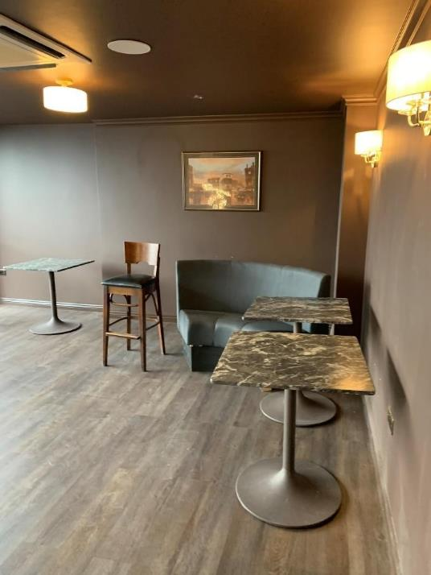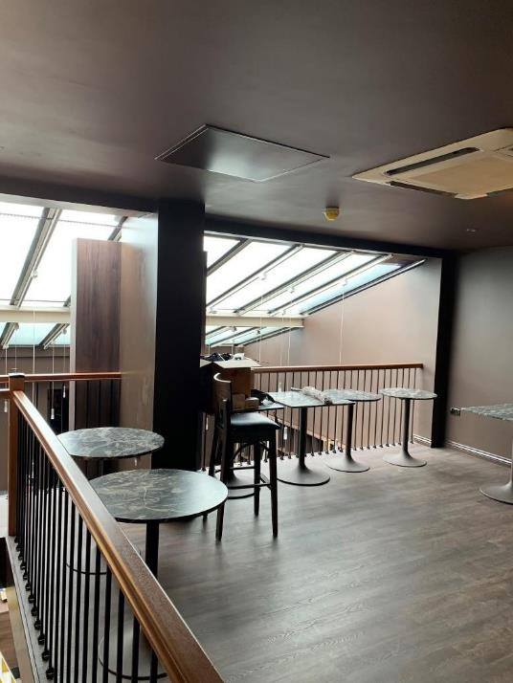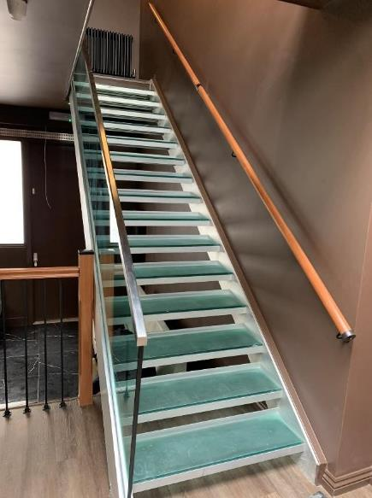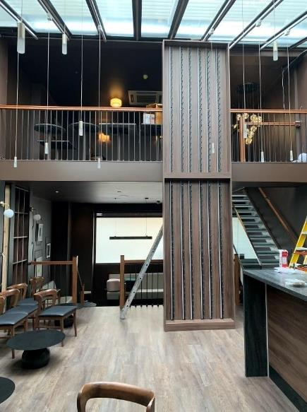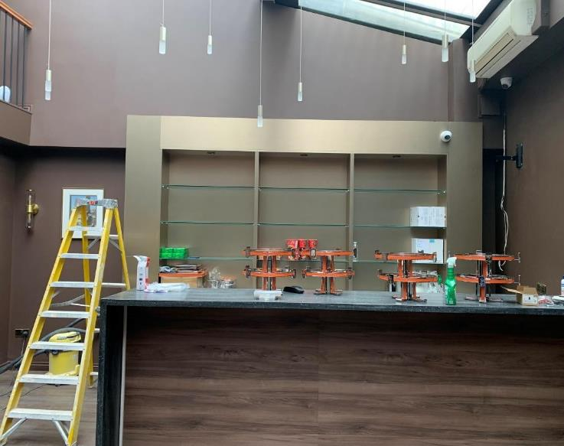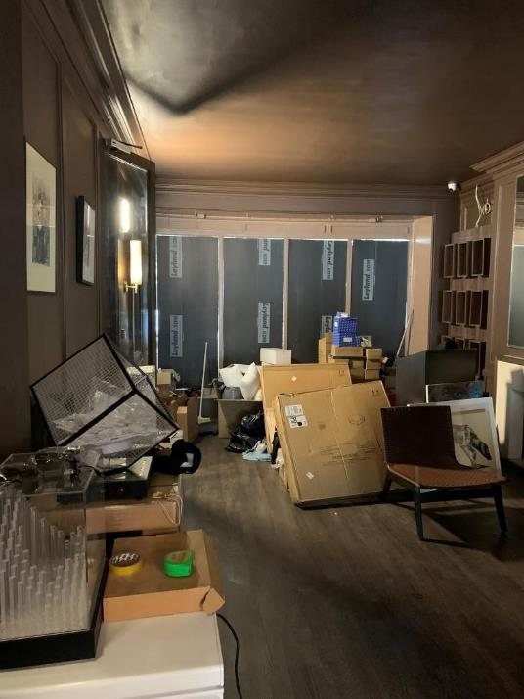

**Top, *far left***– view looking towards front of no.7 Percy Street

**Top, *left centre***– alcove within no.7 Percy Street

**Top, *right centre***– view on mezzanine within no.7 Percy Mews

**Top, *far right***– view on mezzanine within no.7 Percy Mews

**Bottom, *left*** *–* new bar area within glazed infill extension

**Bottom, *centre***– view looking to mezzanine within glazed infill extension

**Bottom, *right***– relocation of modern C20 glass staircase within glazed infill extension

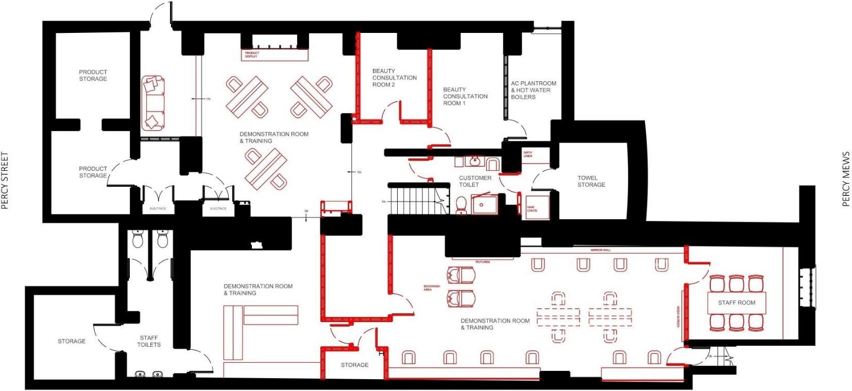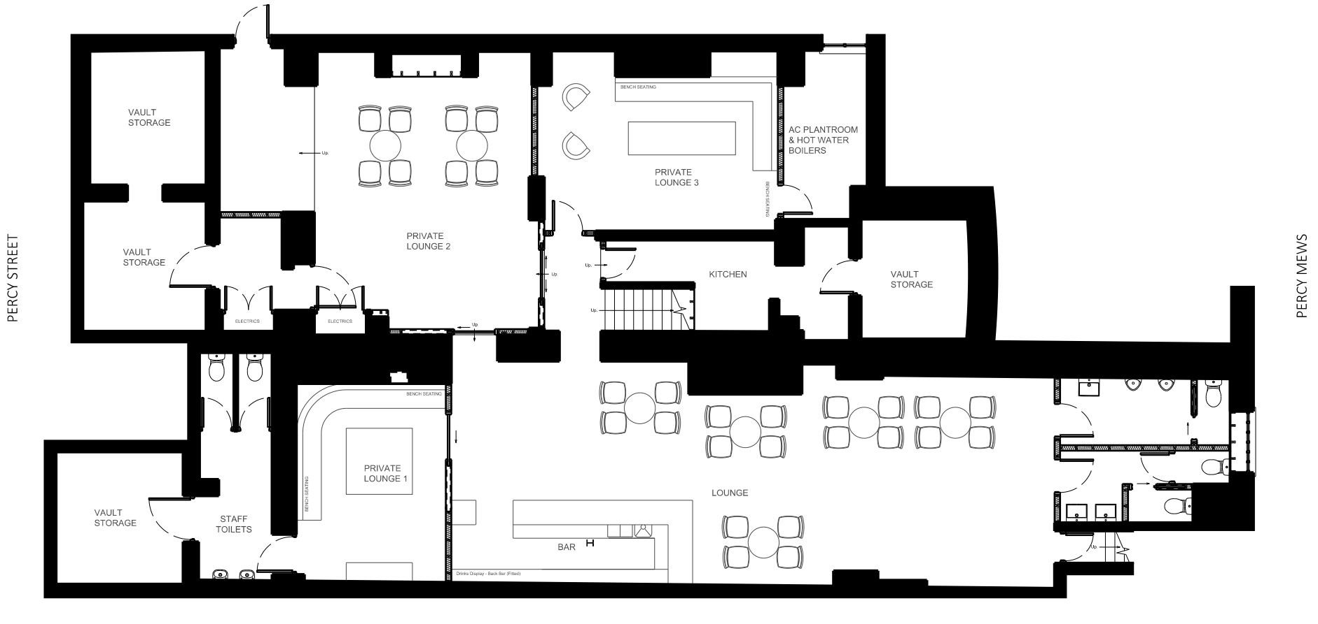

## 4.2 Basement Floor

Internal alterations to the basement floor seek to remove modern interventions approved by planning applications in 1999 (reference LS9805172 and PS9904061) and 2005 (reference 2005/1178.L).

The existing basements are largely devoid of historic or architectural features which are of significance and has previously been adapted largely through the use of stud walls and has modern plasterboard ceilings throughout.

**4.2.1 no.7 Percy Street Basement**

Within no.7 Percy Street basement, the modern stud partitions sub-dividing the rear room is proposed to be removed, opening up this space for the use as a Private Lounge area. The metal plasterboard ceiling is to be removed to increase the floor to ceiling height.

A new stud partition is to be installed between the front and rear room, along with a new metal frame plasterboard ceiling that is installed at a reduced depth. A plaster cornice is to be installed around the perimeter of each room.

**Demolition & Alteration - Basement Floor Plan**

No works are proposed to be undertaken within the barrel vaults which sit underneath the pavement of Percy Street.

**4.2.1 no.6 Percy Street Basement**

Within no.6 Percy Street basement, the proposals seeks to remove the modern stud partitions that subdivide the space, creating a larger bar and lounge area. The metal frame plasterboard ceiling is to be removed to increase the floor to ceiling height.

A new stud partition is proposed to be installed to the right of the front chimney breast towards the front of the basement to create a smaller Private Lounge area.

To the rear of the basement, the former staff room area is to be sub-divided into separate male and female toilets.

A new stud partition is to be installed between the front and rear room, along with a new metal frame plasterboard down stand coffered ceiling incorporating LED perimeter lighting.

**Proposed Basement Floor Plan**

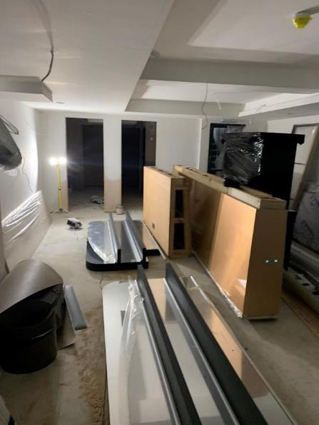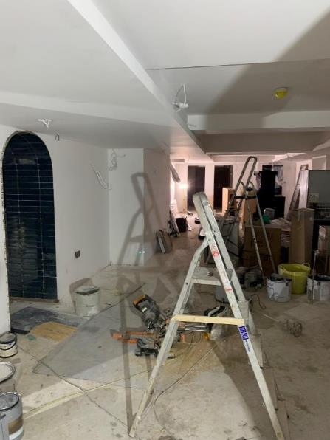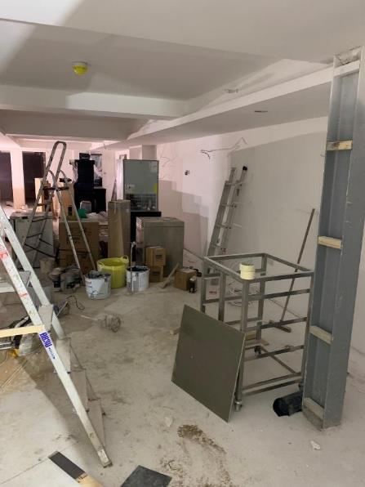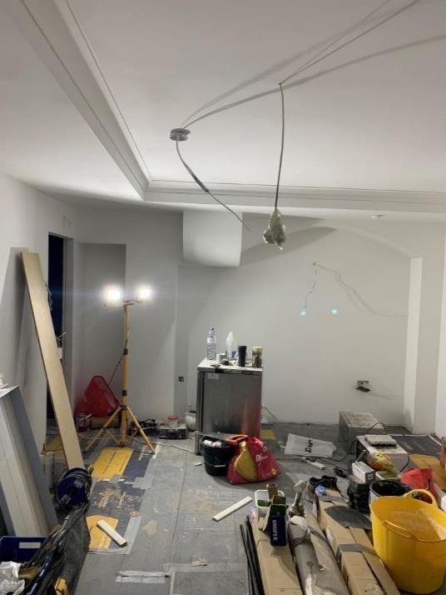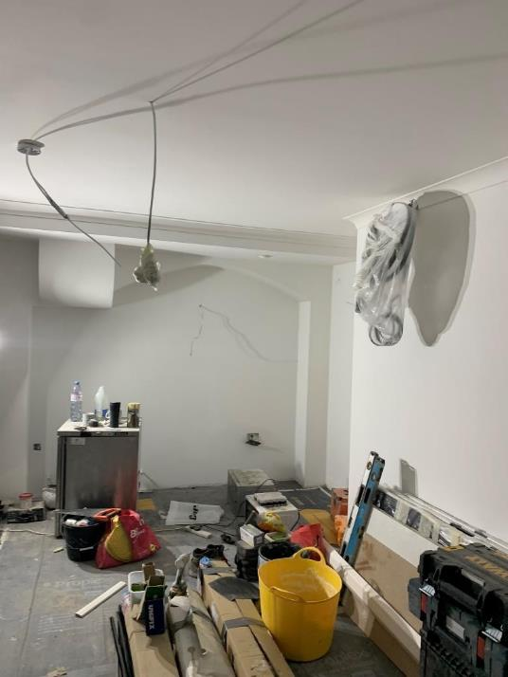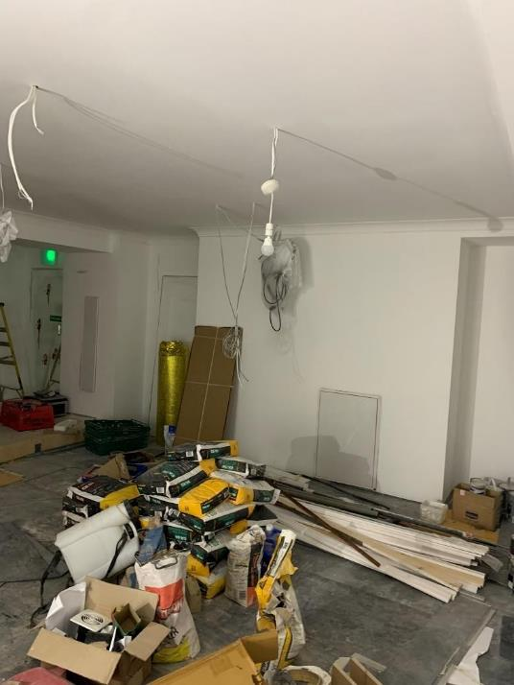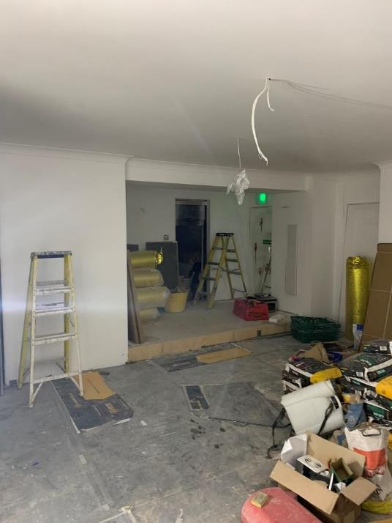

**Top, *far left***– view looking towards front of no.7 Percy Street

**Top, *left centre***– view looking towards front of no.7 Percy Street

**Top, *right centre***– view of rear room within no.7 Percy Street

**Top, *far right***– view of rear room within no.7 Percy Street

**Bottom, *left*** *–* view looking to rear of no.6 Percy Street

**Bottom, *centre***– view looking to rear of no.6 Percy Street

**Bottom, *right***– view looking to rear of no.6 Percy Street

**5.0 Heritage Impact Assessment**

# 5.0 Heritage Impact Assessment

## 5.1 Methodology

Impacts will be assessed and scaled per British Standards BS7913 guidance for the scale of impacts, which correlates with the ICOMOS Guidance on Heritage Impact Assessments. ICOMOS suggest a 9-point scale spectrum for defining the impacts of

proposed changes, which is included here in **Figure 13**. This scale is a useful tool within the context of the benefit and harm dichotomy of the NPPF. The scale provides the opportunity for beneficial outcomes to be quantified, balanced, and considered alongside the

NPPF outcomes of: no harm, less than substantial harm, and substantial harm. Together they create a holistic approach to assessment.

**Assessment of Scale of Specific Impact and Change**

The **scale of change i**s based on the level of proposed intervention and how much potential the intervention has to alter fundamental principles of significance of the asset. The scale of impact relates this to the significance of the asset in question. It is important to note that impacts can be both direct and indirect, and do not only relate to the physical fabric. Change and impact can also be primary or secondary; temporary or permanent; reversible or irreversible; and may arise as a consequence of construction or operation of the proposed development. For the purpose of this assessment, the following definitions have been applied:

**Direct impacts** are those that arise as a primary consequence of the Scheme. Direct impacts can result in the physical loss of part or all of an asset, and/or changes to its setting. Setting is, *‘the surroundings in which a place is experienced, its local context, embracing present and past relationships to the adjacent landscape.’*

**Direct impacts** resulting in physical loss are usually permanent and irreversible; normally occur as a consequence of construction; and are confined within the development footprint. The magnitude of these impacts will depend on the proportion of the asset affected, and whether its key characteristics would be affected.

**Direct impacts** that affect the setting of an asset can occur as a consequence of construction or operation of the scheme and can affect assets some distance from the development. Assessment of impacts on setting refers to perceptible visual and aural effects that can be appreciated at a given time. Such impacts may

be temporary or permanent, reversible, or irreversible depending on the extent to which the cause of the impact can be removed. Impacts may also be transient where occurrence is sporadic or of limited duration, for example related to hours of operation or the frequency of passage of vehicles.

**Indirect impacts** occur as a secondary consequence of construction or operation of the development and can result in physical loss or changes to the setting of an asset beyond the development footprint.

**Severity of impacts** has been judged taking into account their direct and indirect effects and whether they are temporary or permanent, reversible, or irreversible. The cumulative effect of separate impacts has also been considered. The magnitude of impact (summation of direct and indirect impacts) is assigned one of the descriptors; impacts may be adverse or beneficial.

|  |  |  |  |  |  |
| --- | --- | --- | --- | --- | --- |
| **VALUE OF HERITAGE ASSET** | **SCALE & SEVERITY OF CHANGE/IMPACT (EITHER ADVERSE OR BENEFICIAL)** | | | | |
| **No Change** | **Negligible Change** | **Minor Change** | **Moderate Change** | **Major Change** |
| Very High  (Grade I/Scheduled Monument) | Neutral | Slight | Moderate/  Large | Large/Very  Large | Very Large |
| High  (Grade II*) | Neutral | Slight | Moderate/ Slight | Moderate/  Large | Large/Very  Large |
| Medium  (Grade II/ Conservation Area) | Neutral | Neutral/Slight | Slight | Moderate | Moderate/  Large |
| Low  (Locally Listed) | Neutral | Neutral/Slight | Neutral/Slight | Slight | Slight/ Moderate |
| Negligible  (Non-Designated) | Neutral | Neutral | Neutral/Slight | Neutral/Slight | Slight |

**Figure 12:** Significance/Scale of Impacts Table

|  |  |  |  |  |
| --- | --- | --- | --- | --- |
| **No Change** | **Negligible Change** | **Minor Change** | **Moderate Change** | **Major Change** |
| No material change to the heritage asset or its setting. | A minor change or alteration, but unimportant.  Having no visual or indirect impacts on the asset or  its setting. Slight changes to use or access. | A minor change to an element of fabric or setting that results in  a noticeable difference. Limited indirect impacts  or changes to character. | Changes to an element, including replacement, or insertion of a new element, where the asset or its setting has clearly been modified.  Noticeable indirect  impacts. | A change of great extent, including the complete removal of an element. Changes to most or all of the asset or its setting. Total alteration of the asset. Extreme indirect impacts. |

**Figure 13:** Definition of types of change

|  |  |  |  |  |  |  |  |  |
| --- | --- | --- | --- | --- | --- | --- | --- | --- |
| Major  beneficial | Moderate beneficial | Minor  beneficial | Negligible  beneficial | Neutral | Negligible  adverse | Minor  adverse | Moderate adverse | Major  adverse |

**Figure 14:** 9-point scale of impact

## Impact on 7 Percy Street

The national and local policy requires the impact upon the significance of a designated heritage asset shall be preserved or enhanced.

It is considered that the proposed works to the ground floor and basement floor will have a **neutral impact** on the significance of the designated heritage asset.

The ground floor and basement floor are largely devoid of historic or architectural features.

The proposed relocation of the C20 staircase to the rear of the building is considered to have a **neutral impact** on the significance of the heritage asset; the rear staircase is of modern design and of no intrinsic historic or architectural interest and as such does not contribute to the distinctive character of the listed building. Its relocation, which will be in the same area between the glazed link infill extension and the mezzanine of the mews townhouse, will therefore not affect the significance of the asset, with the proposal providing an improved usable floor area.

The installation of fixed cabinetry to the eastern party wall between the chimney breasts within no.7 Percy Street is considered to have a **neutral impact**; no architectural features of note will be obscured as the wall behind is a C20 stud wall lining, whilst the works are entirely reversible. It is to be noted that this section of wall previously had fixed cabinetry for the display and sale of hair products from the previous occupant.

The installation of fixed cabinetry to the eastern party wall within the glazed infill extension is considered to have a **neutral impact**; no architectural features of note will be obscured as the wall behind is a C20 stud wall lining, whilst the works are entirely reversible. It is to be noted that this section of wall previously had fixed cabinetry of styling stations from the previous occupant.

The installation of the bar and fixed cabinetry to the western party wall within the glazed infill extension is considered to have a **neutral impact**; no architectural features of note will be obscured as the wall behind is a C20 stud wall lining, whilst the works are entirely reversible. It is to be noted that this section of wall previously had fixed cabinetry of styling stations from the previous occupant.

The replacement of the C20 flooring within the ground floor is considered to have a **neutral impact**. The proposed works are entirely reversible without impacting the original floorboards.

The replacement of fixed hard-wired speakers within the alcoves either side of the chimney breasts within no.7 Percy Street is considered to have a **neutral impact** on, as the speakers utilise existing speaker positions and cables from the previous occupant.

The replacement of the wall mounted, and ceiling mounted light fittings within no.7 Percy Street is considered to have a neutral impact on, as the light

fittings utilise existing light fitting positions from the previous occupant. The light fittings are in-keeping with the period of the property.

The installation of an applied opaque film installed to the internal face of the shopfront window facing onto Percy Street is considered to have a **negligible adverse impact** on the character and appearance of the conservation area. This is considered fully reversible.

All the changes to the existing C20 partition walls within the basement areas is considered to have a **neutral impact**. The existing fabric is of no historic or architectural interest and therefore does not contribute to the significance of the herniate asset. The proposed stud partition walls will have a **neutral impact**; as they will be inserted around the retained historic fabric, along with the proposed new doors will read as a modern intervention within the historic building. As such, the morphological development of the building will be evident and as stud walls, these works are deemed fully reversible should it be desired. As such, the significance of the heritage asset remains unaffected.

The proposed insertion of a ceiling substructure within the basement floor is considered to have a **neutral impact** on the significance of the heritage asset; the proposed works will result in no loss of historic fabric and will not affect the integrity of the structure as it has already been modified as the building has been adapted over the years. As such, there will be a **neutral impact** on the significance of the heritage asset.

**5.2.1 Summary**

The proposed works will constitute as moderate change to the setting and character of the asset, resulting in a **neutral/slight impact**. This change is considered to be **neutral** in nature and will result in

**no harm** to the significance of the asset.

## Conclusion

The proposed alterations have carefully considered the significance of the designated heritage asset and have been sensitively detailed to ensure a **neutral impact** on the historic fabric and retained features. It is considered that the proposed works, which are largely internal, will not affect the significance of the asset, the setting of the surrounding listed buildings or the contribution its makes to the Charlotte Street Conservation Area.

Overall, the proposed development will result in

**no harm** to the significance of the heritage asset.

The works, therefore, are deemed to accord with national and local policy, preserving and enhancing the significance of the designated heritage asset, and as should, there is no reason why the local authority should not favourably consider the application.

**6.0 Bibliography & Sources**

# Bibliography

Survey of London, Volume 21, The Parish of St Pancras

Part 3: Tottenham Court Road & Neighborhood. (1949),

Pages 7-11

Historic Environment Good Practice Advice in Planning: 3

(2nd Edition) – The Setting of Heritage Assets;

Historic England (2017)

Charlotte Street Conservation Area Appraisal and Management Plan; London Borough of Camden (2008)

Percy Street

London County Council Bomb Damage Maps (2015)

Country Life, Vol.185. No.47 (1991)

**Website Source:**

www.camden.gov.uk/planning-building-development

www.britishnewspaperarchive.co.uk

ww.gibberd.com

## Architectural Drawings

065 (01) 000 – Location Plan

065 (01) 001 – Existing Site Plan

065 (01) 100 – Existing Basement Floor Plan

065 (01) 101 – Existing Ground Floor Plan

065 (01) 110 – Existing Basement Floor Ceiling Plan

065 (01) 111 – Existing Ground Floor Ceiling Plan

065 (01) 200 – Demolition – Basement Floor Plan

065 (01) 201 – Demolition – Ground Floor Plan

065 (01) 210 – Demolition – Basement Floor Ceiling Plan

065 (01) 211 – Demolition – Ground Floor Ceiling Plan

065 (02) 100 – Existing External Elevations

065 (03) 100 – Existing Basement Floor Internal Elevations

065 (03) 101 – Existing Ground Floor Internal Elevations – Furnished

065 (03) 102 – Existing Ground Floor Internal Elevations

065 (03) 100 – Demolition – Basement Floor Internal Elevations

065 (03) 101 – Demolition Ground Floor Internal Elevations – Furnished

065 (03) 102 – Demolition Ground Floor Internal Elevations

065 (04) 001 – Proposed Site Plan

065 (04) 100 – Proposed Basement Floor Plan

065 (04) 101 – Proposed Ground Floor Plan

065 (04) 110 – Proposed Basement Floor Ceiling Plan

065 (04) 111 – Proposed Ground Floor Ceiling Plan

065 (05) 100 – Proposed External Elevations

065 (06) 100 – Proposed Basement Floor Internal Elevations

065 (06) 101 – Proposed Ground Floor Internal Elevations – Furnished

1. GPA3, *‘The extent of setting’ Box 1, page 2*
2. GPA3, *‘The extent of setting’ Box 2*, *page 2*
3. Appendix 3: GPA3*, ‘Views and setting’ paragraph 5, page 3*
4. Appendix 3: GPA3*, ‘Setting and the significance of heritage assets’ , page 4*
5. LBC, *‘Charlotte Street CA Appraisal & MP 2008, page 14*
6. LBC, *‘Charlotte Street CA Appraisal & MP 2008, page 15*

  
7. Op. cit. Roberts, JRH & Godfrey, WH (1949).
8. Survey of London, Volume 21, The Parish of St Pancras Part 3:

   Tottenham Court Road & Neighborhood. (1949), pages 7-11
9. Source: http://www.romanticlondon.org
10. London (First Editions c1850s) XXXIV (City of Westminster; St Marylebone;

    St Pancras), Surveyed: 1870, Published: 1875
11. Dan Cruickshank, C. *’29 Percy Street, London’, Country Lift, Vol. 185,*

    *No.47* (1991)
12. *Ibid*
13. William Franks (d.1790) was an early English ‘Gentleman’ property

    developer who was instrumental in the development of Percy Street,

    Rathbone Street and Charlotte Street.
14. Op.cit Cruickshank (1991)
15. London Metropolitan Archives, Sun Fire Insurance Records
16. Ward, L., *London County Council Bomb Damage Maps*. (2015)
17. The Sketch, 16 November 1921. British Library,

    British Newspaper Archive.
18. Picturegoers, 01 January 1924. British Library,

    British Newspaper Archive.
19. Crompton’s Campaign: The Professionalisation of

    Dance Pedagogy in Late Victorian England (2007)
20. The Graphic, Saturday 13 July 1929. British Library,

    British Newspaper Archive.
21. Weekly Dispatch (London), Sunday 08 July 1936. British Library,

    British Newspaper Archive.
22. Sunday Mirror, Sunday 02 March 1986. British Library,

    British Newspaper Archive.
23. LB Camden Planning – ref: 1928
24. Source: http://www.gibberd.com
25. LB Camden Planning – ref: 32210(R1)
26. LB Camden Planning – ref: PS9804841