4SUPPLEMENTARY INFORMATION
- Site Details

Site Name: | Aviation House | Site Address: | Kingsway  London  WC2B 6NH
National Grid Reference: | E: 530502 N: 181481
Site Ref Number: | Cornerstone 24531220 | Site Type: | Macro- NTQ Replacement

- Pre Application Check List

Site Selection

Was a local planning authority mast register available to check for suitable sites by the operator or the local planning authority? |  | No
If no explain why:

After a phone call to the LPA it was established the council do not hold this information.

Were industry site databases checked for suitable sites by the operator: | Yes
If no explain why:

Site Specific Pre-application consultation with local planning authority

Was there pre-application contact: | Yes
Date of pre-application contact: | 12th October 2023
Name of contact: | The Director of Planning
Summary of outcome/Main issues raised:

Prior to the submission of this application the applicant-initiated pre-consultation discussions with the local planning authority. This provides an opportunity for the LPA to discuss development proposals and identify site specific issues.

No comments were received in respect to the consultation submitted at the time of submission.

Strategic level pre-rollout meetings are held with the LPA to discuss the necessities of the project, benefits and best practice going forward.

Annual area wide information to planning authority

Has annual area wide information been provided? | No
If no explain why:
Summary issues raised:

Cornerstones commercial relationship with VMO2 has changed, effectively increasing our independence to work with other companies in the deployment of mobile infrastructure. It means we no longer have visibility of VMO2’s full update plan. However, Cornerstone is fully committed to working closely with Local Planning Authorities and following best practice guidance.

We aim to engage and work with the planning department at the earliest opportunity from when we are instructed to deliver new infrastructure within your Local Authority area and often conduct strategic pre-rollout engagement meetings to discuss our wider rollout. If your Local Authority would like a meeting to discuss wider Cornerstone rollout plans then please advise. We recognise the importance of developing long term partnerships and will always work with you to deliver improved mobile connectivity.

Community Consultation

Rating of Site under Traffic Light Model: |  | Amber
Outline of consultation carried out:

Consultation with the local Ward Councillors for Holborn & Covent Garden Ward (Councillors Awale Olad, Julian Fulbrook and Sue Vincent).

Summary of outcome/main issues raised:

No site-specific responses had been received at the time of submission.

School/College

Location of site in relation to school/college:

St Joseph’s Catholic Primary School is in relatively close proximity to the site.

Outline of consultation carried out with school/college:

The headteacher of St Joseph’s Catholic Primary School has been consulted prior to submission.

Summary of outcome/main issues raised:

There has been no response from the St Joseph’s Catholic Primary School at the time of submission.

Civil Aviation Authority/Secretary of State for Defence or the operator of the civil safeguarding area or defence safeguarding area notification.

Will the proposed development be on a civil safeguarding area or a defence safeguarding area? |  | No
Has the Civil Aviation Authority/Secretary of State for Defence/operator of the civil safeguarding area or defence safeguarding area been notified? |  | No
Details of response:

N/A

Site Provider Letter

Copy of Site Provider Letter enclosed? |  | Yes
Date served: | 15/11/2023

- Proposed Development

The proposed site:
It is imperative to consider that this proposal is to replace an existing installation and is not a new additional telecommunications installation. The need for this rooftop site stems from an NTQ (Notice to Quit). The existing NTQ site is at Kingsway House which has been decommissioned due to redevelopment.

The proposed development consists of the installation of rooftop telecommunications equipment at Aviation House, Kingsway, London, WC2B 6NH, which can be seen from figures 1 & 2 below. The proposed rooftop installation allows the coverage from Kingsway House to be mirrored and replicated following decommission.

The proposed site is set on the rooftop of Aviation House, set in the lively Holborn district of London. Renowned for its central position and historical importance, Holborn is a bustling area that seamlessly blends businesses, shopping, entertainment, and cultural attractions. Positioned northeast of Covent Garden and a short stroll away from the British Museum, home to an extensive collection of global art and artifacts, this locale offers an array of high-end and boutique shops, along with diverse dining options. With its vibrant atmosphere and proximity to notable landmarks, this part of London naturally draws in visitors.

It is extremely important for the functionality of the local businesses for a robust and reliable telecommunication infrastructure, with a wide range of telecommunication services. It is also extremely important for Local residents and visitors to the area to have a reliable telecommunication infrastructure. The proposed installation will ensure this infrastructure is upheld.

High Holborn, Kingsway and surrounding streets benefit from tall buildings which would provide screening of the installation on street level. Existing semi-mature trees along Kingsway will also help to screen the proposal from street view. The area hosts existing telecommunications equipment, which provides a president for rooftop telecommunications equipment within the area.

Aviation House is 9 storey building set to the Northwest of Lincoln’s Inn Fields Park area, Southeast of Bloomsbury Square Garden and Southwest of Red Lion Square Gardens. Trees within the parks, together with the surrounding tall buildings, the installation will be shielded from view from the parks.

Prior to the submission of this application, discounted options were put forward , investigated and assessed and this site was deemed to be the most appropriate location. Please refer to section 5 below to see discounted locations. The optimum solution from a planning and technical perspective has been proposed.
As previously stated, this is not a new additional installation but is a replacement for an existing installation that is to be removed. The proposed installation is necessary for the continued wireless connectivity and capacity for local businesses, residents and visitors to this busy area of Camden.

Figure 1:
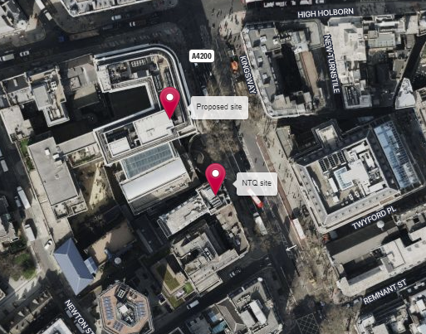

Figure 2:
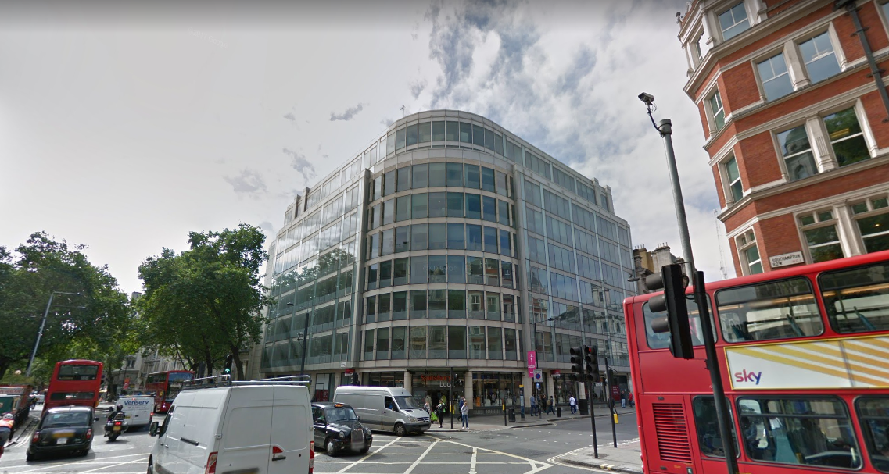

Heritage Information

This heritage section has been prepared as part of the planning application for Aviation House which includes the installation of proposed 6No. Antennas on new climbable support poles, 1No. GPS Module, 2No. 300ø Dishes, 3No. Cabinets, 1No. sub meter (inside plantroom) and associated ancillary works.

The purpose of this section is to provide an assessment of the heritage significance of the site and its surroundings, and to demonstrate how the proposed development will respond to and preserve this significance. The site is located within Kingsway Conservation Area and has a rich and varied history dating back to 1981. As such, it is an important part of the local heritage and cultural fabric, with features and characteristics that contribute to the unique and distinct character of the area.

This heritage section will provide a detailed overview of the site's historical and cultural significance, including a description of its architectural features and design elements. It will also assess the potential impact of the proposed development on the site's heritage significance and set out the measures that will be taken to mitigate any negative impacts and ensure that the site's heritage value is preserved. Finally, this section will demonstrate how the proposed development will contribute to the ongoing preservation and enhancement of the area's heritage significance, and how it will align with relevant local and national heritage policies and guidelines."
In particular:

- Considerations of design and layout are informed by the context, having regard not just to any immediate neighbouring buildings but the townscape and landscape of the wider locality. The local pattern of streets and spaces, building traditions, materials and ecology all help to determine the character and identity of the development.

- The scale, massing and height of proposed development have been considered in relation to that of adjoining buildings; the topography, the general pattern of heights in the area; and views, vistas and landmarks.

The following general design principles have been taken into account in respect of this proposed telecommunications development:

- A proper assessment of the character of the area concerned.
- That the design shows an appreciation of context.

Site Conditions, Technical Constraints, Landscape Features and Capacity Requirements

Introduction

It needs to be borne in mind that the proposed development is for a mobile telecommunications installation. Hence, access is deliberately restricted, where appropriate, for the security of the installation.

The Kingsway Conservation Area

The Kingsway Conservation Area is a designated conservation area located in the Holborn district of London and covers all of Kingsway and its associated buildings within the London Borough of Camden. Designated to protect and preserve the special architectural and historic interest of the area. The area initially comprised of earlier buildings arranged along east-west medieval streets connecting the City and Westminster. A significant portion of this area deteriorated, and coupled with traffic issues, the approval for the Kingsway scheme was granted. This initiative aimed to establish a north-south access route, effectively addressing and clearing a substantial portion of the slums in the vicinity. The conservation area is known for its distinctive architectural character, which often includes a mix of Victorian and Edwardian buildings. The architecture reflects the historical development of the area.

Design Component

The proposed rooftop installation is a replacement site for an existing site share installation, the proposed installation needs to replicate the existing site that is to be decommissioned in order to provide continued coverage and wireless connectivity to this area of London.

Whilst it is appreciated that the installation will be visible from some viewpoints within the locality, the proposed design is considered to be the least visually intrusive option. The antennas and support poles are proposed to be located set back from the rooftop edge in order to preserve the character of this conservation area by minimalizing the visual impact. The height of the proposed antennas will remain in keeping with the existing rooftop furniture. The rooftop telecommunication site will avoid street scene clutter and minimalize visual disruption in the streetscape, whilst providing optimum coverage for the area. The height of Aviation House being 9 storeys allows the installation to be set away from street view. Surrounding tall buildings and existing trees also help to minimalize visual impact from street level. This installation will allow for the Continuation of wireless connectivity and telecommunication infrastructure, following the decommissioning of the installation at Kingsway House, preserving and enhancing this Conservation Area.

It is recognised that these works may be considered to cause some harm to the character of Kingsway Conservation Area, but this harm is considered to be less than substantial and is outweighed by public benefit that will be derived by the provision of a reliable telecoms infrastructure.

Conclusion

When considering the installation of a mobile phone installation in a Conservation Area, it is important to ensure that the proposed infrastructure does not negatively impact the area's heritage significance. This can be achieved by following some key guidelines: 1. Siting and design: The mobile phone installation should be sited in a location that has minimal impact on the surrounding historic fabric, and the design of the installation should be sympathetic to the character of the area. 2. Disguising or camouflaging the installation: To minimize the visual impact of the installation, it may be possible to disguise it or incorporate it into surroundings. This could include painting it a colour that matches surrounding buildings, or adopting a design that mimics the form and character of nearby structures. 3. Engaging with the local community: Engaging with the local community can help to ensure that the proposed installation is sensitive to the area's unique character and heritage. This could involve consulting with local residents, heritage groups, and other stakeholders to gain their input and feedback on the proposed design and location of the installation. 4. Providing information and education: Providing information and education about the

proposed installation and its benefits can help to alleviate concerns and foster greater understanding and acceptance among local residents. This could involve hosting public meetings, providing educational materials, or engaging with local schools and community organizations. Overall, by following these guidelines, it is possible for a mobile phone installation to be installed in a Conservation Area while still preserving the area's heritage significance. The key is to ensure that the installation is sited and designed in a way that is sensitive to the unique character of the area and that the local community is engaged and informed throughout the process. All of the above key areas have been undertaken and thus we believe the proposal both preserves and enhances the area.

We consider the development complies with both central government and local planning policy guidance where the underlying aim is to provide an efficient and competitive telecommunication system for the benefit of the community while minimising visual impact.

Taking into account the factors of technical constraints, available sites and planning constraints we consider that this site and design clearly represents the optimum environmental solution.

On the basis of a recognised need to expand and promote telecommunications networks across the region, it is considered that the proposal fully accords with the requirements of the National Planning Policy Framework and the Council’s Local Plan Policies.

Enclose map showing the cell centre and adjoining cells if appropriate:
This can be emailed to the LPA on request.

Type of Structure :
Proposed installation of 6No. Antennas on new climbable support poles, 1No. GPS Module, 2No. 300ø Dishes, 3No. Cabinets, 1No. sub meter (inside plantroom) and associated ancillary works.

Overall Height: +29.37m AGL

Height of existing building (where applicable): |  | Top of Plant Room 38.38m AGL
Equipment Housing:
Depth: tower |  | Eltek Percy Cabinet 820mm  2 x FPR 600mm
Width: |  | Eltek Percy Cabinet 700mm  2 x FPR 750mm
Height: |  | Eltek Percy Cabinet 1800mm  2 x FPR 2000mm
Materials (as applicable):
Tower/mast etc – type of material and external colour: | Galvanised – support poles
Equipment housing – type of material and external colour: | Grey

Reasons for choice of design:
Cornerstone is the UK's leading mobile infrastructure services company. We acquire, manage and own over 20,000 sites and are committed to enabling best in class mobile connectivity for over half of all the country's mobile customers. We oversee works on behalf of telecommunications providers and wherever possible aim to:

• promote shared infrastructure
• maximise opportunities to consolidate the number of base stations
• significantly reduce the environmental impact of network development

The National Planning Policy Framework advocates site sharing, as such there is future site sharing possibilities with this rooftop installation. The proposed facility will provide coverage including 2G/3G/4G services and essential 5G coverage all from the same installation for VMo2. This is fully in line with national guidance which supports the use of high-quality communications infrastructure and states that local planning authorities should support the expansion of electronic networks.

The applicant appreciates that the site lies within the Kingsway Conservation Area (Article 2(3) land) however, the alternative options to meet the required demand for wireless connectivity would result in structures that would harm the Conservation Area. The location and design of the proposed installation has been driven and carefully selected to preserve and enhance the Kingsway Conservation Area by providing significantly enhanced coverage and capacity to this busy area of Southwark, whilst being sympathetic to the area with the design of equipment proposed. The antennas for this installation will not exceed, in height, the existing rooftop furniture, they will therefore not appear incongruous or out of context. The existing rooftop furniture is not visible from ground level therefore it is not expected that the addition of the telecoms apparatus will have any further impact.

Central Government attaches great importance to the design of the built environment and outlines this within Section 12 (para. 126) of the 2021 National Planning Policy Framework. It states:

“Good design is a key aspect of sustainable development, creates better places in which to live and work and helps make development acceptable to communities.”

In keeping with the 2021 National Planning Policy Framework (NPPF) guidelines of using: “high quality communications” (Section 10), The design of the proposed equipment has been carefully selected and is considered to be the least intrusive option available, by using this sensitive design. The proposed antennas will remain in keeping with the existing rooftop furniture, with little to no height increase. The antennas are modestly positioned around the rooftop, set back from the edge to minimalize any visual impact as much as possible.

Rooftop telecommunication sites benefit from avoiding street scene clutter whilst providing optimum coverage for the area. Physical objects such as buildings and trees can obstruct radio signals causing a reduction in signal strength and coverage. Rooftop sites lend themselves to eliminating this. The optimum solution from a planning and radio perspective has been proposed.

As detailed in section 5 below a comprehensive analysis of alternative locations has been carried out and the proposed development site was found to be the most efficient and least visually intrusive solution for delivering the operators’ coverage requirements.

Health and Safety
International Commission on Non-Ionizing Radiation Protection Declaration enclosed.

International Commission on Non-Ionizing Radiation Protection public compliance is determined by mathematical calculation and implemented by careful location of antennas, access restrictions and/or barriers and signage as necessary. Members of the public cannot unknowingly enter areas close to the antennas where exposure may exceed the relevant guidelines.

When determining compliance, the emissions from all mobile phone network operators on or near to the site are taken into account.

In order to minimise interference within its own network and with other radio networks, Cornerstone’ operates its network in such a way the radio frequency power outputs are kept to the lowest levels commensurate with effective service provision

The radio base station that is the subject of this application will be configured to operate in this way.

All operators of radio transmitters are under a legal obligation to operate those transmitters in accordance with the conditions of their licence. Operation of the transmitter in accordance with the conditions of the licence fulfils the legal obligations in respect of interference to other radio systems, other electrical equipment, instrumentation, or air traffic systems. The conditions of the licence are mandated by Ofcom, an agency of national government, who are responsible for the regulation of the civilian radio spectrum. The remit of Ofcom also includes investigation and remedy of any reported significant interference.

The telecommunications infrastructure the subject of this application accords with all relevant legislation and as such will not cause significant and irremediable interference with other electrical equipment, air traffic services or instrumentation operated in the national interest.

ICNIRP Compliance

The addition of new technologies and mast sharing affects ICNIRP compliance – a higher minimum mast height is required in some cases.

- Technical Justification

Reason(s) why site required

When planning cellular telecommunications networks it is important for engineers to predict, with a high degree of confidence, the behaviour of cellular transmissions. This then enables the operator to calculate how many cell sites are needed to provide the level of coverage required by the services they offer under the terms of their licence.

The strength of radio signals detected at a receiving device naturally reduces the further away it is from the transmitter. In general the reduction (or decay) in signal power is affected by a number of variables. The main factors are: -

• frequency,
• distance (from transmitter),
• terrain (such as hills),
• clutter (such as buildings, foliage, vehicles, and water)
• and atmospheric conditions (such as rain).

A reduction in the strength of the radio signal increases the likelihood of dropped calls and reduced data rates for internet browsing, for example.

Customers will inadvertently be aware of this by finding that sometimes they need to go near windows, a higher floor of a building or even outside in order to achieve a stronger signal for their mobile devices.

Network Changes

Over time the topography and clutter in an area is subject to change. For example, building developments, housing and tree growth can all change. As a consequence, the signals received from local phone masts can degrade, as they are dependent on these factors. These reasons along with customer complaints, network consolidation (mast sharing) and new technologies (5G) require a re-evaluation of a network operator’s telecommunications infrastructure.

There is a specific requirement for a new radio base station at this location to provide 2G, 3G and 4G coverage and capacity in and around this area of London whilst also providing the latest 4G technology and new 5G service provision to the local area. This ensures high quality indoor service provision is maintained.

- Site Selection Process

Alternative sites considered and not chosen

Site Type | Site name and address | National Grid Reference | Reason for not choosing site
RT - Roof Top  D1 | Victory House  34 Kingsway  London  WC2B 6EX | Eastings  530633,  Northings  181332 | This has been discounted due to the lack of space that is needed to accommodate the required equipment.
RT - Roof Top  D2 | 65 Kingsway  London  WC2B 6TD | Eastings  530582,  Northings  181277 | This has been discounted due to the lack of space that is needed to accommodate the required equipment.
RT - Roof Top  D3 | 71 Kingsway  London  WC2B 6ST | Eastings  530574,  Northings  181317 | This has been discounted due to the lack of space that is needed to accommodate the required equipment.
RT - Roof Top  D4 | Kingsway Hall  4 Wild Court  London  WC2B 4AU | Eastings  530526,  Northings  181293 | This has been discounted due to the position of the roof not allowing for a site to be built.
RT - Roof Top  D5 | Lincoln's Inn Fields  Holborn  London  WC2A 3BP | Eastings  530659  Northings  181418 | An installation at this location would be on low ground and surrounded by tall building. This location would not deliver the required level of coverage to the target area.
RT - Roof Top  D6 | 40 Bloomsbury Way  London  WC1A 2SA | Eastings  530202  Northings  181507 | An installation at this location is located too far to the North-West to deliver the required level of coverage to the target area. This site has therefore been discounted for this reason.
RT - Roof Top  D7 | Royal Opera House  Covent Garden  London  WC2E 9DD | Eastings  530353  Northings  181008 | Discounted due to the roof and surrounding areas causing problems with designing a viable site while also being on a grade listed 1 building.
Streetworks  D8 | Lincoln's Inn Fields Netball and Tennis Courts,  Lincoln's Inn Fields, Gray's Inn,  WC2A 3PZ | Eastings  530895 , Northings  181355 | An installation at this location would be on low ground and surrounded by tall building. This location would not deliver the required level of coverage to the target area.
Greenfield  D9 | Lincoln's Inn Fields, Gray's Inn, Holborn,  London Borough of Camden,  WC2A 3PZ | Eastings  530732 , Northings  181330 | An installation at this location would be on low ground and surrounded by tall building. This location would not deliver the required level of coverage to the target area.
Rooftop  D10 | Bucknall Street, St Giles, Bloomsbury, London Borough of Camden, WC1A 1BS | Eastings  530057 , Northings  181417 | An installation at this location is located too far to the North-West to deliver the required level of coverage to the target area. This site has therefore been discounted for this reason.
Rooftop  D11 | Kingsway House  Kingsway  London  WC2B 6QU | Eastings  530524 , Northings  181447 | This is the location of the NTQ and has therefore been discounted due to redevelopment.

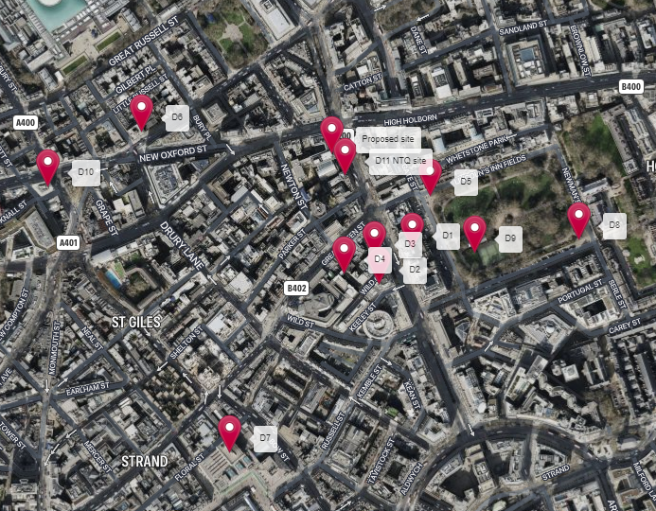

Land use planning designations:

Site Ref: | 24531220 | Site Address: | Aviation House, Kingsway, London, WC2B 6NH

Local Planning Authority: LB Camden Council

Development Plan: Camden Local Plan (2017)

Fig.1: LP Plan Extract (Reference Only):

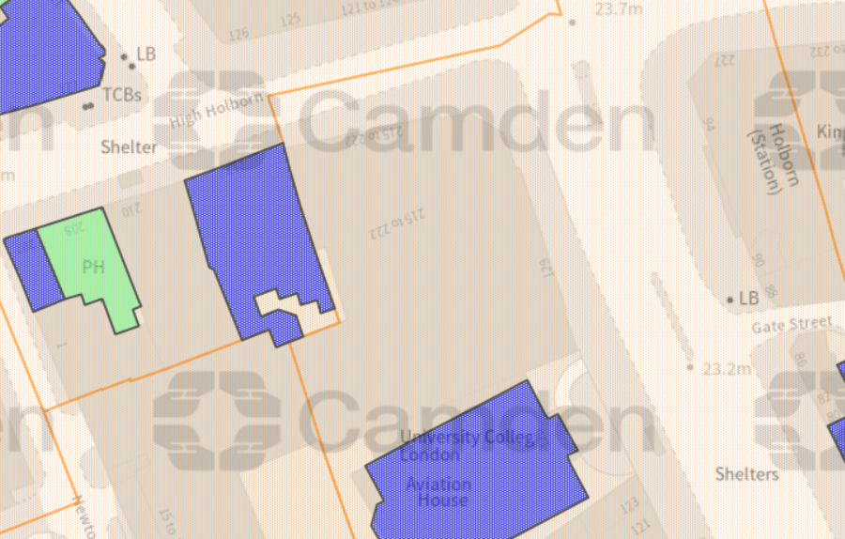

Site and its surrounds

Policy Relevant to the Development Site:

The site is designated as being within the settlement boundary, with urban uses to the north, east, south, and west. The site is in the Kingsway Conservation Area. The site designation is a material consideration.

The LB Camden Council does not have a specific telecoms policy, although para. 5.10 of the Local Plan is relevant. This, together with the NPPF is of relevance. The National Planning Policy section of this supporting statement goes into detailed analysis of why this site is in compliance with the NPPF.

Policy Analysis:

Para. 5.10 reads:

“Digital infrastructure

5.10 The Council recognises the importance of digital infrastructure in enterprise
development and expects electronic communication networks, including
telecommunications and high-speed broadband, to be provided in business
premises.”

Policy D2 reads:

“Heritage

The Council will preserve and, where appropriate, enhance Camden’s rich and diverse heritage assets and their settings, including conservation areas, listed buildings, archaeological remains, scheduled ancient monuments and historic parks and gardens and locally listed heritage assets.

Designated heritage assets

Designed heritage assets include conservation areas and listed buildings.

The Council will not permit the loss of or substantial harm to a designated heritage asset, including conservation areas and Listed Buildings, unless it can be demonstrated that the substantial harm or loss is necessary to achieve substantial public benefits that outweigh that harm or loss, or all of the following apply:

a. the nature of the heritage asset prevents all reasonable uses of the site;
b. no viable use of the heritage asset itself can be found in the medium term through appropriate marketing that will enable its conservation;
c. conservation by grant-funding or some form of charitable or public ownership is demonstrably not possible; and
d. the harm or loss is outweighed by the benefit of bringing the site back into use.

The Council will not permit development that results in harm that is less than substantial to the significance of a designated heritage asset unless the public benefits of the proposal convincingly outweigh that harm.

Conservation areas

Conservation areas are designated heritage assets and this section should be read in conjunction with the section above headed ‘designated heritage assets’. In order to maintain the character of Camden’s conservation areas, the Council will take account of conservation area statements, appraisals and management strategies when assessing applications within conservation areas.

The Council will:

e. require that development within conservation areas preserves or, where possible, enhances the character or appearance of the area;
f. resist the total or substantial demolition of an unlisted building that makes a positive contribution to the character or appearance of a conservation area;
g. resist development outside of a conservation area that causes harm to the character or appearance of that conservation area; and
h. preserve trees and garden spaces which contribute to the character and appearance of a conservation area, or which provide a setting for Camden’s architectural heritage.”

The proposed development at this site is required to deliver the requisite level of electronic communication service on a single site that is to be adapted to accommodate multiple users (so enable future site sharing opportunities), yet seeks to minimise its visual impact or change to the character of this location (the site remaining as physically distant from lines of sight from residential uses as possible in this part of the Borough / set in part behind existing shroud). The form and design of the proposed configuration would not appear out of context in this location (appearing in the comparable context of the existing roof top infrastructure / ladders etc.), so according with wider Development Plan policy and would ensure the integrity, character and setting of the area is fully maintained.

The public benefits of a greatly enhanced communications network for businesses, residents and visitors alike in this location would qualify as a substantial benefit with near benign change or impact on amenity.

Any harm to the character and setting of the wider heritage asset would qualify as less than substantial, and the public benefits would be considerable, and materially outweigh harm.

The enhanced digital service would very much accord with the objectives of the Development Plan policy.

The proposed installation fully accords with the requirements of the NPPF providing reliable communications infrastructure to ensure continued economic growth and social well-being. The proposed location of the equipment on a rooftop minimalizes visual intrusion. Mirroring the height of the existing rooftop furniture also minimalizes visual intrusion and further promotes the NPPF. The benefits of the proposed development will significantly outweigh any perceived potential harm.

The London Plan

The London Plan is a strategic planning document that sets out an integrated framework for the development of London. It is prepared by the Mayor of London and provides a long-term vision and policies for land use, transport, housing, economy, environment, and social infrastructure within the city.

The London Plan guides the spatial development of the city, taking into account factors such as population growth, housing needs, transportation requirements, and environmental sustainability. It aims to shape the city's physical and social fabric, promoting economic growth, social inclusion, and quality of life for Londoners.

The plan covers various aspects of urban development, including:

Housing: The London Plan addresses the need for affordable housing, setting targets for the provision of new homes and promoting mixed-use developments that incorporate affordable housing.

Transport: It outlines policies to improve transportation networks, reduce congestion, and promote sustainable modes of transport, such as walking, cycling, and public transport. It also emphasizes the integration of transport with land use planning.

Economy: The plan supports economic growth by identifying areas for business development, encouraging innovation and entrepreneurship, and protecting employment land.

Environment: It promotes environmental sustainability by addressing climate change, promoting energy efficiency, protecting green spaces, and enhancing biodiversity.

Social infrastructure: The plan considers the provision of social infrastructure, such as schools, healthcare facilities, cultural amenities, and community spaces, to support the needs of London's residents.

The London Plan is periodically updated to reflect changing circumstances and priorities. It serves as a guide for local boroughs in their own planning decisions and provides a framework for developers, investors, and communities to understand the city's development goals and policies.

The proposed development will help promote the London Plan by enhancing connectivity, supporting sustainable development, enabling smart city infrastructure, and fostering economic growth, aligning with the plan's objectives of creating a connected, sustainable, and prosperous city.

The UK Wireless Infrastructure Strategy

The UK Wireless Infrastructure Strategy is a new policy framework to drive deployment and adoption of 5G and advanced wireless connectivity; and the government's 6G strategy for the UK.
It highlights the importance of connectivity to the UK and recognises that the UK needs world-class wireless connectivity:

“Connectivity has brought benefits for British households and British business, boosting
growth, productivity, and opportunity for all. And change shows no sign of stopping. In fact, we find ourselves on the brink of a new revolution which promises to transform
the world once more.
5G will be the cornerstone of our digital economy. With higher capacity and lower latency, standalone 5G will drive growth in the industries of today and tomorrow including in emerging sectors like artificial intelligence where Britain leads the world. Just take smart ports, where 5G-enabled remote operation can help us to move containers more quickly, efficiently, and safely, boosting our international competitiveness. 5G can improve our public services, too, in everything from education to social care. In transport, for example, we can use 5G to power forward
progress in everything from real time travel information to augmented reality
navigation and self-driving buses and taxis.”

Which is why the time is right to turn our sights to mobile connectivity, where the same sense of mission is needed to deliver the kind of wireless infrastructure that will transform how we live our lives and run our economy. This is not simply a matter of
improving download speeds as people browse the internet on their phones or dial into work calls. It is far more transformative than that.

The power of 5G and future telecoms advances will unlock new solutions in everything from industry to healthcare. Falling behind in coverage will mean falling behind in international competitiveness when it comes to the technologies of tomorrow, and failing to provide British people with innovative, life-enhancing services on secure, resilient networks.”

The proposed telecommunication equipment will help promote The UK Wireless Infrastructure Strategy by improving coverage and capacity, supporting digital inclusion, facilitating economic growth, and enabling future-proof infrastructure including 5G that will ensure the area doesn’t fall behind in coverage and international competitiveness. The proposed development will provide significant public benefit with greater capacity and wireless connectivity for local businesses, residents and visitors to the area.

Additional relevant information

Siting

We have considered the detailed siting and design carefully to ensure that the scheme has a limited impact on the locality, and general visual amenity.

Visual appearance

We would repeat that we have carefully placed and designed the scheme to ensure the principles of good siting and appearance are adhered to. The overall impact of the installation on the environment and building is very limited.

Consultation

In accordance with the industry ’10 commitments’ and the Code of Best Practice, consultation has been attempted with the planning department prior to submission of this proposal.

Education

The relationship between 5G and education is evolving at a massive rate with educators exploring the relevance of Virtual Reality (VR) technologies for education and training. Crucially, VR can support remote learning, allowing students a presence in the classroom even when working elsewhere.
5G’s ability to deliver real-time information (low latency), ultra-fast speeds (critical for high definition images and video), increased capacity and heightened security will also allow learning on the job, thanks to technologies such as Augmented Reality (AR) goggles, which can give engineers real-time instructions on how to fix a machine on a production line, for example.

Health

Patients across the country are now becoming accustomed to relying on remote healthcare services such as NHS 111, virtual GP appointments, and ordering online deliveries of essential medical supplies.
5G will prove critical in providing the infrastructure required to deliver remote health services over the next decade. By design, 5G’s ability to deliver real-time information (low latency), ultra-fast speeds (critical for high-definition images and video), increased capacity and heightened security are going to be fundamental in scaling the patient benefits of remote healthcare and keeping medical records secure and private. For instance, trials have shown that connecting ambulance crews to expert resources using 5G allows paramedics to work with doctors and conduct specialist procedures in real time whilst on the road.

Conclusion

We consider the development complies with both central government and local planning policy guidance where the underlying aim is to provide an efficient and competitive telecommunication system for the benefit of the community while minimising visual impact.

Taking into account the factors of technical constraints, available sites and planning constraints we consider that this site and design clearly represents the optimum environmental solution.

On the basis of a recognised need to expand and promote telecommunications networks across the region, it is considered that the proposal fully accords with the requirements of the National Planning Policy Framework and the Council’s Local Plan Policies.

Confirmation that submitted drawings have been checked for accuracy

Name: (Agent) | Susannah Help | Telephone: | On request
Company: | Cornerstone
Company Address: | WHP Telecoms Ltd  1a Station Court  Station Road  Guiseley  Leeds  LS20 8EY | Email Address: | s.help@whptelecoms.com
Signed: |  | Date: | 17th November 2023
Position: | Planner | (on behalf of Cornerstone)

Macro or Micro

