

|  |  |
| --- | --- |
| Brendan Versluys  Senior Planner Planning Solutions Team  London Borough of **Camden** 2nd Floor,  5 Pancras Square | Design Out Crime Office  North West DOCO Office,  Ruislip Police Station,  The Oaks,  Ruislip,  HA4 7LE  Telephone: 0208 7333703 Email: DOCOMailbox.NW@met.pnn.police.uk www.met.police.uk  Your ref: 2023/3884/P  Our ref: NW 7681  (14/11/2023) |

Good afternoon,

Thank you for allowing me to comment on the proposed **change of use of the upper ground floor from retail use (Class E(a)) to a place of worship (Class F1)** at **339 Finchley Road, NW3 6EP**.

The proposal is located within the policing ward of West Hampstead. The top reported crimes for September 2023 (taken from the police.uk website) were antisocial behaviour, violence and sexual offences, other theft and criminal damage and arson. Other offences of note for this area are shoplifting, vehicle crime and burglary.

This type of building is echoed around London. A proposed commercial space on the ground floor with residential units above. There are many buildings like this which have failed to occupy the commercial space leaving it vacant and inactive for a considerable amount of time. With no uptake and activation of this space it can encourage antisocial behaviour. Activation of ground floor spaces provide increased levels of natural surveillance and promote legitimate activity.

I have read the comments from concerned neighbours and members of the public with regards to parking issues and noise. These are valid concerns and can lead to conflict between the proposed use and the residential component.

Without converting the space to residential or managing to obtain a commercial tenant this space could remain vacant for an extended amount of time increasing the risk of ASB and crime. The benefit of this venue is the active main roads which provides a good level of surveillance.

I have consulted with the CTSA for this area to gauge risk around the having a place of worship at this location. Although there is no increased risk for this religion it is felt that the space would benefit from enhanced security measures if permission is granted.

I would recommend the following security measures:

* Enhanced glazing (if not already in place on the existing shell and core) to BSEN 356 2000 P2A (minimum).
* Main entrance door to either LPS 2081 SRB, LPS 1185 Issue 8 B3 (SR2) or STS 202 BR2.
* Fire exits to have no fixtures/locks on the outside facing the public realm and to be certificated to either PAS24:2022 or LPS 2081 SRB.
* Consider what is being placed on the windows. If vision is completely obscured it offers no surveillance out into the public realm. It is also appreciated that privacy may also be a factor.
* Soundproofing to mitigate against the risk of causing noise for residents above.
* CCTV with complimentary lighting to be considered for the exterior/entrance and communal areas (internal). A formal, overt CCTV system should be installed and maintained by a member company of either the National Security Inspectorate (NSI) or the Security Systems and Alarms Inspection Board (SSAIB). Any such company will install a system to the British Standard. Images should be retained for a minimum of 30 days. This system would need to be registered with the Information Commissioner’s Office, as it could/would be recording public areas. Appropriate signage indicating this fact needs to be displayed.
* It is also recommended that an intruder alarm be installed Intruder alarms need to be compliant with PD 6662 scheme for the application of European standards for intruder and hold up alarms. Installers need to be members of either the National Security Inspectorate (NSI) or the Security Systems and Alarms Inspection Board (SSAIB) and fitted to BS 50131.
* Consider internal retractable grilles or roller shutters to either LPS 1175 SR2 or STS 202 BR2.
* What is being proposed around church service times as this can leave an inactive front once again. Baby/parent groups could offer the residents a valuable service and the like.
* Cash donations to be secured or removed from the premises overnight. The lure of potential monies could increase the risk of burglary and opportunistic theft. Having physical protection in the form of certificated security products will mitigate this risk. Early detection will also be an important factor.

If the applicant wishes to speak with the CTSA then this can be arranged and advice provided. Any recommendations such as hostile vehicle mitigation (HVM) would fall outside of the boundary of the building and require permission from the local authority.

Further consultation is required in the pursuit of achieving SBD certification for the development (if this is being sought). If yourself or the applicant wishes to discuss any of my recommendations further then please feel free to contact me. The advice I have provided has been taken from the following guides:

<https://www.securedbydesign.com/images/HOMES_GUIDE_2023_web.pdf>

<https://www.securedbydesign.com/images/COMMERCIAL_GUIDE_2023_NOV_23.pdf>

The advice has been adjusted taking into consideration crime statistics and analysis of the area.

Kind regards

Aran

Appendix A

Camden planning response template – NPFF and Camden local plan references

**Section 17 of the Crime and Disorder Act 1988**

“It shall be the duty of each Authority to which this section applies to exercise its various functions with due regard to the likely effect of the exercise of those functions on and the need to do all it reasonably can to prevent Crime and Disorder in it’s area”, as clarified by PINS953.

The NPPF and Camden’s own local guidance can support this proposal:

Section 91 of the NPPF states:

*Planning policies and decisions should aim to achieve healthy, inclusive and safe places which*..

b) *are safe and accessible, so that crime and disorder, and the fear of crime, do not undermine the quality of life or community cohesion – for example through the use of clear and legible pedestrian routes, and high quality public space, which encourage the active and continual use of public areas*;…..”

Section 127 of the NPPF further adds:

*Planning policies and decisions should ensure that developments*..

f) *create places that are safe, inclusive and accessible and which promote health and well-being, with a high standard of amenity for existing and future users, and where crime and disorder, and the fear of crime, do not undermine the quality of life or community cohesion and resilience* …..”

Taken from the Camden Supplementary Guide to Design (January 2021 revision)

* *The Council requires that developments demonstrate that they have been designed to contribute to community safety and security.*
* *Security features must be fully considered and incorporated at an early stage in the design process.*
* *Designing-against crime features, safe access and security measures must complement other design considerations and be considered as part of a holistic approach to designing and maintaining safer environments for all.*
* *Better designed environments support safer and healthier communities.*
* *Consideration will be given to the impact of measures on the surrounding area to ensure that there is not displacement of activity into surrounding neighbourhoods.*
* *Safer environments support healthier communities.*

In accordance with Local Plan Policy C5 Safety and Security, the Council will require applicants to demonstrate that all impacts of their proposal on crime and community safety have been considered and addressed. Applicants should be able to demonstrate that they have consulted Met Police Designing Out Crime Officer (details of which can be found at [www.securedbydesign.com](https://eur02.safelinks.protection.outlook.com/?url=http%3A%2F%2Fwww.securedbydesign.com%2F&data=04%7C01%7CAran.L.Johnston%40met.police.uk%7C79a74e93e9434dff94a008d8c9b313e2%7Cf3ee2a7e72354d28ab42617c4c17f0c1%7C0%7C0%7C637481118250278966%7CUnknown%7CTWFpbGZsb3d8eyJWIjoiMC4wLjAwMDAiLCJQIjoiV2luMzIiLCJBTiI6Ik1haWwiLCJXVCI6Mn0%3D%7C1000&sdata=QSRH3WSaqCK1abR8Il3mGJ9n4rJlSayhGDDce5to%2FnE%3D&reserved=0)) and that proposals take into account the advice given and achieve Secured by Design certification, where appropriate.

**Policy C5 Safety and security (From the Camden Local Plan)**

*The Council will aim to make Camden a safer place. We will:*

1. *work with our partners including the Camden Community Safety Partnership to tackle crime, fear of crime and antisocial behaviour;*
2. *Require developments to demonstrate that they have incorporated design principles which contribute to community safety and security, particularly in wards with relatively high levels of crime, such as Holborn and Covent Garden, Camden Town with Primrose Hill and Bloomsbury;*
3. *Require appropriate security and community safety measures in buildings, spaces and the transport system;*
4. *Promote safer streets and public areas;*
5. *Address the cumulative impact of food, drink and entertainment uses, particularly in Camden Town, Central London and other centres and ensure Camden’s businesses and organisations providing food, drink and entertainment uses take responsibility for reducing the opportunities for crime through effective management and design; and*
6. *Promote the development of pedestrian friendly spaces.*

*We strongly encourage security features to be incorporated into a scheme from the beginning of the design process and complement other key design considerations. Internal security measures are preferred. Further information on designing safer environments is set out in our supplementary planning document Camden Planning Guidance on design.*

*It is important to take a proactive approach at an early stage to reduce risks and opportunities for crime and ASB to occur, rather than relying on reactive measures such as*

*CCTV, which should only be used as part of a package of measures to reduce crime. Incorporating designing out crime features into a development should complement other key design considerations and high quality architecture and design should still be achieved.*

*Considering good design early in the design process will lead to a better quality development overall.*

*The design of streets, public areas and the spaces between buildings needs to be accessible, safe and uncluttered. Careful consideration needs to be given to the design and location of any street furniture or equipment in order to ensure that they do not obscure public views or create spaces that would encourage antisocial behaviour. The use of the site and layout should also be carefully considered as these can also have a major impact on community safety.*

From the Camden local plan;

*“ Camden’s food, drink and licensed entertainment premises contribute to the attractiveness and vibrancy of the borough but, where there is a concentration of late night activity, there can also be problems such as noise and disturbance, littering, antisocial behaviour, crime and violence. The cumulative impact of these uses will therefore be assessed in line with our town centre policies, particularly Policy TC4 Town centre uses and Policy A1 Managing the impact of development. The Council will also take into consideration any concerns raised from stakeholders within adjoining areas beyond Camden’s boundaries. Alcohol related crime and late night disorder have been identified as significant issues, particularly within Camden Town and the Seven Dials area of Central*

*London. Camden’s Statement of Licensing Policy sets out the Council’s approach to licensing and special licensing policies apply to these areas.”*

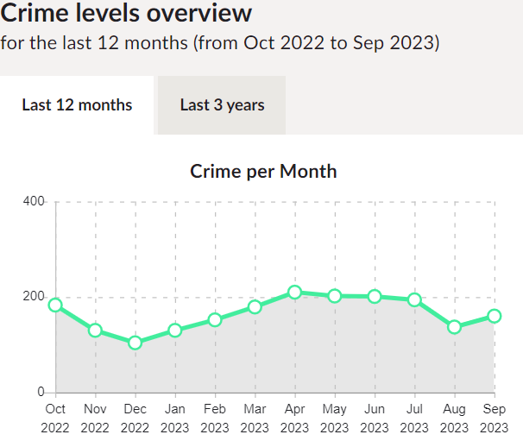

*Line graph showing the number of crimes over the last twelve (12) months for West Hampstead ward.*

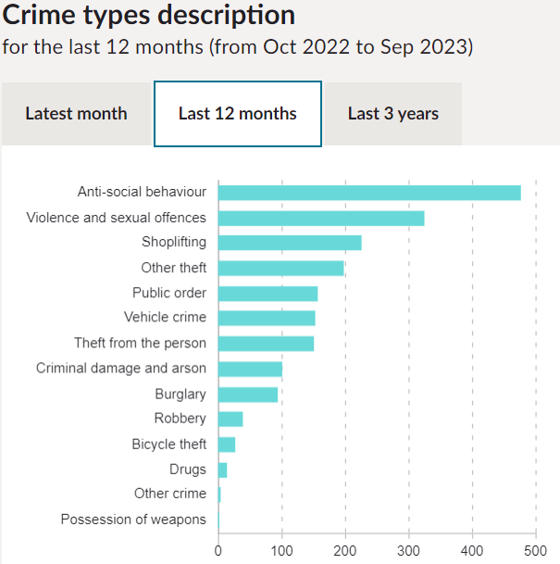

*Bar chart indicating the types of recorded crimes over the last twelve (12) months on West Hampstead ward*

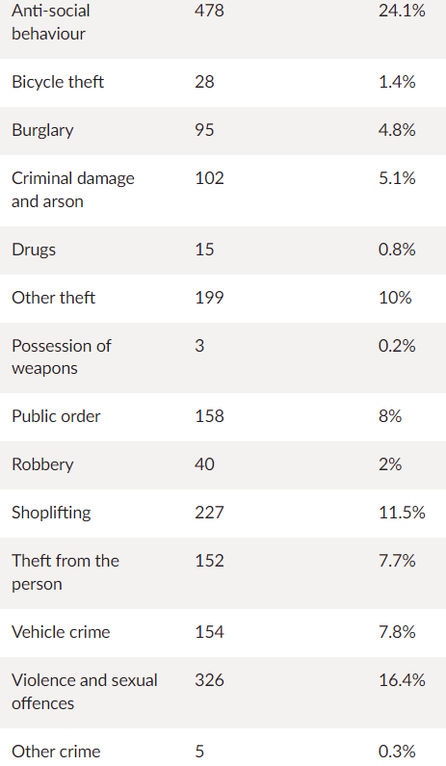

*Number of crimes on West Hampstead ward over the last twelve (12) months*

**The primary objective of an efficient Police Service is the prevention of crime**

Crime Prevention advice can be found on the Metropolitan Police Service Website –

http://content.met.police.uk/site/crimeprevention

(Crime figures obtained from www.police.uk and are as most recent as available)

*‘Crime prevention advice is given freely without the intention of creating a contract. Neither does the Metropolitan Police Service take any legal responsibility for the advice given. You must abide by the fire and safety regulations and if you are in any doubt consult the Fire Prevention Officer and the Council’s Building Control Officers.’*