Objection Letter and Planning Report Prepared in Relation to the Proposed Development at 31 Daleham Garden Under Planning Application 2023/4241/P (Subject to a Shadow Legal Agreement Executed Under 2020/2087/P).

Principle of development / land use

The application site previously contained a dwellinghouse in use as 14 self-contained bedsits. The redevelopment of the site for residential development is therefore considered acceptable in principle subject to compliance with other planning policies contained within NPPF, the London Plan, the Camden Local Plan (informed by Supplementary Planning Guidance as well as conservation area appraisals).

Nonetheless, the proposed quantum of development is considered inappropriate in the context of all relevant planning policies, taking into account site-specific characteristics, as outlined in this report.

Material planning considerations, including the scale, orientation, shape, and siting of the building, as well as its impact on the character and appearance of the conservation areas, the removal of mature trees, its effects on neighbouring amenity and the living conditions of future occupants, are systematically evaluated in this report. The comprehensive assessment indicates that, overall, the proposed development, primarily due to its substantial quantum rather than the principle of it, is deemed unacceptable in planning terms. Furthermore, it runs contrary to the planning policies outlined within the development plans.

The scheme's failure to address site constraints and align with the character of the conservation area, which the local authority has a statutory duty to protect under the Planning (Listed Buildings and Conservation Areas) Act 1990, seems to arise from a fixation on re-providing the 14 planning units from the pre-existing building. However, it overlooks the crucial fact that these were small, self-contained bedsits averaging 28 sq.m per flat, whereas the newly proposed flats have an average Gross Internal Area (GIA) of 70 sq.m, making them 2.5 times larger and requiring a much more substantial level of associated passageways, corridors, etc.

Consequently, the proposed development would lead to a doubling of the total Gross Internal Area (GIA) from the pre-existing building, which was already taller and more extended than most others on Daleham Gardens. The GIA is set to increase from 540 sq.m. to 1260 sq.m.

Crucially, however, the Camden Local Plan does not actually necessitate the re-provision of the number of existing residential units where a site is being redeveloped; rather, it requires the floorspace to be retained.

Indeed, Policy H3 (‘Protecting existing homes’) of the Camden Local Plan states that the local authority will “resist development that would involve a net loss of residential floorspace” whilst allowing the net loss of residential units where it would “enable sub-standard units to be enlarged to meet residential space standards”. Given the proposed doubling of the Gross Internal Area (GIA), resulting in an uncharacteristically large and potentially harmful building to visual and neighbouring amenity, both policy conditions could still be easily met even if the quantum of development were reduced to below 14 flats.

The concept of re-providing 14 units can also be traced back to the initial drawings from an early feasibility study conducted by Mary Duggan Architects. These drawings supported the Council's reconstruction plans for the site, where they acted as the land owner rather than the local planning authority. This initiative arose following a fire that had made the building unsafe for repairs.

The feasibility study indicated that the site could accommodate 14 self-contained flats, preserving a substantial portion of the rear garden (i.e., setback from the rear boundary) and maintaining alignment with the predominant front building line. Although these plans influenced the decision to demolish the building (approved under 2020/2087/P with reference to those plans), they do not seem to have formally been part of a statutory planning process. Instead, their purpose was to inform housing cabinet decisions rather than planning decisions. Consequently, the initial feasibility study plans, introducing the concept of re-providing 14 flats on-site, did not properly undergo the statutory planning process but still had a significant impact on the decision to demolish the building.

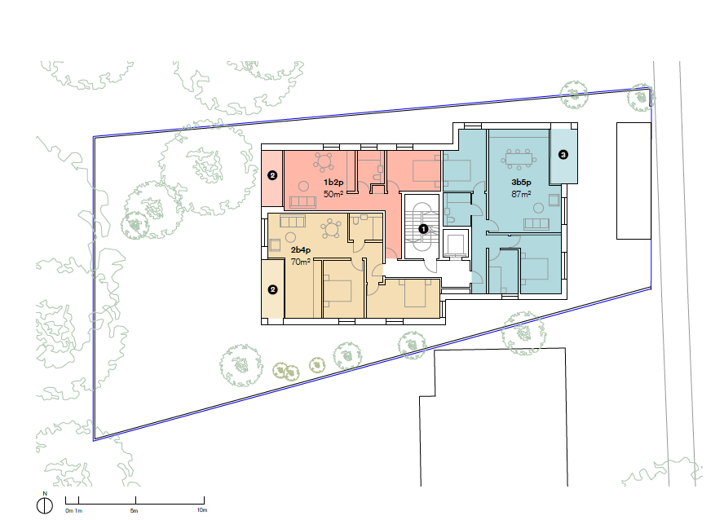

Scheme from feasibility study, showing front building line alignment and retention of characteristic rear garden

Despite this, the current scheme is considered materially different from the one proposed in the feasibility study, raising questions about the justification for demolishing a building within a conservation area. Not only does the development extend beyond the predominant front building line, but the rear garden has also been almost entirely eliminated from the plans. In its place, a building, comprising five and six storeys, now spans almost the entire depth of the previous garden. This creates a development that not only deviates significantly from the feasibility study but is also inconsistent with every other building on Daleham Gardens.

This departure from the designs included in the feasibility study seemed to have originated from pressures to achieve 14 units at the application site without proper consideration of whether or not the site could ever accommodate the proposed dwelling mix. Because the feasibility study plans were never duly assessed by officers as part of a statutory planning process (i.e., under the Town and Country Planning Act 1990), it was never possible to examine the shortcomings of the feasibility study scheme in planning terms. Yet, at the same time, the provision of 14 units proposed under the scheme was incorporated into future planning discussions without much scrutiny.

Consequently, it is evident that the proposed scheme is predominantly driven by capacity, where the desired output shapes the design, rather than being guided by design considerations that assess site constraints and opportunities to achieve an optimal capacity. Therefore, the proposed development is contrary to London Plan Policy D3 “Optimising site capacity through the design-led approach”.

Furthermore, officers are reminded that the planning permission to demolish the previous building was subject to a legal agreement. This agreement mandates the developer to secure a high-quality design, “taking into account the contribution of the previous building”. It also requires the replacement of all lost residential floorspace (rather than the number of units) and proposes a minimum of 50% affordable housing (calculated by floor space), including the re-provision of the lost social affordable floorspace.

On the other hand, the proposed development seems to have overlooked the built form of the pre-existing building while placing excessive emphasis on the re-provision of 14 planning units. Intrinsically, this task would have always been challenging as the bedsits within the previous building were 60% smaller than the flats currently proposed.

Concerns are also raised regarding the level of affordability. While six of the proposed units have been designated for sale at a discount to market values, given that they are newly-provided flats almost double the size of the pre-existing bedsits, it is unlikely that any of the previous occupants (or those of similar background) would be able to afford housing in the redeveloped property.

Additionally, the proposed development would necessitate the excavation of a substantial portion of the application site, essentially the entire depth once the light wells are included. Specifically, this includes the area of land that previously constituted the rear residential garden of the pre-existing building. Such excavation would be in conflict with Policy A5 of the Camden Local Plan (refer to the design section of this report for details).

The full-depth excavation of the application site, resulting in the loss of the former rear garden (a characteristic feature of the conservation area), also raises concerns about whether the proposals constitute an inappropriate form of back garden development. This would be contrary to national and regional planning policies.

Paragraph 124 of the National Planning Policy Framework (NPPF) sets out that “planning policies and decisions should support development that makes efficient use of land, taking into account the desirability of maintaining an area’s prevailing character and setting (including residential gardens)”. Furthermore, paragraph 71 mandates development plans to “consider the case for setting out policies to resist inappropriate development of residential gardens”.

In response, Policy H1 ('Increasing housing supply') of the London Plan aims to resist the redevelopment of residential gardens. It focuses London's 10-year housing delivery targets on "all suitable and available brownfield sites," commonly referred to as "previously developed land." Both the London Plan and the National Planning Policy Framework (NPPF) categorically exclude "residential gardens" from the definition of brownfield or previously developed land.

The rear portion of the application site is recognized as garden land, subject to protection under the NPPF and London Plan. Although the preceding structure has been demolished, this was sanctioned due to pertinent health and safety concerns, with the understanding that a development plan-compliant replacement building (informed by a feasibility study) would be erected in its place. This commitment is further solidified by a signed section 106 agreement, specifically intended to ensure that the relationship between demolition and redevelopment is not severed. If there were no urgent health and safety concerns, it is probable that the demolition and redevelopment of the site would have been evaluated under a single planning application.

The fact that, due to external circumstances (fire damage), the demolition and subsequent redevelopment were assessed separately, should not establish a borough-wide precedent for developers to use a two-step approach to redevelopment (involving a separate application for demolition) to circumvent basement and back garden development policies.

Lastly, if approved, the proposed development has the potential to undermine the development potential of adjacent land by constructing unreasonably close to the site boundaries, notably affecting 31a Daleham Gardens. This could effectively neutralize efforts to increase housing capacity (or the expansion of the neighbouring specialist school) in the long term.

Officers a reminded that planning decisions must, by law, be made in accordance with the relevant development plans, as required under Section 70 of the Town and Country Planning Act 1990, even if it is at the detrimental of the interests of landowners (who must accept a degree of risk in developing land).

Design, heritage and appearance

The pre-existing building, which had already been extended in the past, broadly followed the prevalent pattern of development in terms of height, scale, building lines, shape, orientation and footprint.

The property benefited from a large rear garden; a characteristic feature of this street as identified in the Council’s conservation area statement:

Daleham Gardens is one of the four parallel north-south planned Garden Avenues, with substantial sections of well-vegetated rear gardens. Most properties are set-back behind small front courts or gardens. […] Properties are predominantly detached, mainly three stories and demonstrate a mix of Queen Anne and Arts and Crafts influences. […] Daleham Gardens, Fitzjohn’s Avenue, Maresfield Gardens and Netherhall Gardens have a more formally planned layout, with straight and parallel streets. This layout includes large open areas to the rear of properties, comprising an amalgam of rear gardens.

The proposed development, by virtue of its height (part four storeys, part five storeys above raised ground level), footprint, unusual orientation and the elimination of the characteristic rear garden, would be in direct conflict with the attributes identified above.

In the assessment of the planning application permitting the demolition of the existing structure (2020/2087/P), planning and conservation officers determined that although the host building no longer made a positive aesthetic contribution to the conservation area, its built form — encompassing scale, orientation, and shape — was still deemed historically significant and a contributing element to the character of the conservation area.

For these reasons, the demolition was subject to a mandate to document the architectural and historical value of the building. This documentation was intended to be utilized "to inform future development on the site”.

Crucially, the planning permission granted for the demolition of the pre-existing building under 2020/2087/P was contingent upon the acceptance of legal terms outlined in Section 106 of the Town and Country Planning Act, ensuring the acceptability of the demolition in planning terms. This binding agreement mandates the developer to factor in the contribution of the previous building in any future application for planning permission.

The application to demolish the building was also informed by (and ultimately approved based on) a feasibility study conducted by Mary Duggan Architects in conjunction with the Council’s regeneration strategy for the site. This appraisal concluded that it was feasible to retain a significant amount of the rear garden, to adopt a building form not dissimilar to the existing one, and to position the structure behind the prevailing front building line:

Scheme from feasibility study, showing front building line alignment and retention of characteristic rear garden

Alarmingly, it seems that none of the benchmarks intended to preserve the residual historical interest and distinctive built form of the former building have been incorporated into the current application for planning permission. This oversight has resulted in a structure that significantly clashes with its surroundings. Had the current proposals been considered in the earlier application for demolition, it's plausible that they could have impacted the decision-making process. The design objectives of any replacement scheme, even if only indicative, would have held significant sway in that decision, considering their potential to impact the delicate balance between preserving the conservation area and achieving redevelopment goals.

The proposed building footprint has nearly doubled in comparison to the pre-existing footprint, and in relation to the original building, it has almost tripled. This expansion, coupled with the added height, will yield a distinctive form of development that significantly distorts the prevailing plot-to-building ratio. The outcome would be a structure taller and deeper than any other building on Daleham Gardens.

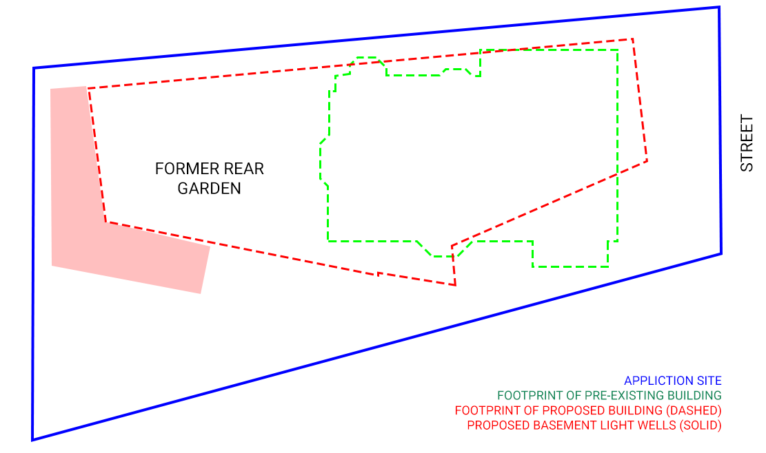
Footprint comparison between pre-existing and proposed

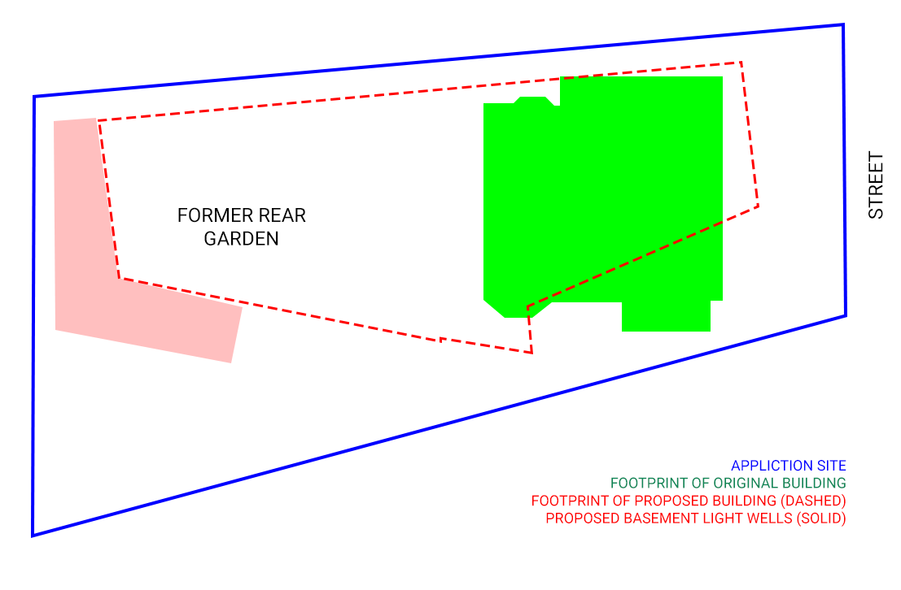

Footprint comparison between original and proposed

Furthermore, the proposals would run counter to Policy A5 ('Basements'), subsection (h) of the Camden Local Plan. This policy outlines that, concerning 'basement developments,' basements should not exceed 50% of each garden within the property as originally constructed. They should also be set back from neighbouring property boundaries when extending beyond the footprint of the host building, be less than 1.5 times the footprint of the host building in area, and extend into the garden no further than 50% of the depth of the original host building. The proposed development would violate each condition related to basement development. In contrast, the scheme from the feasibility study that informed the application to demolish the pre-existing building (2020/2087/P) did adhere to these criteria.

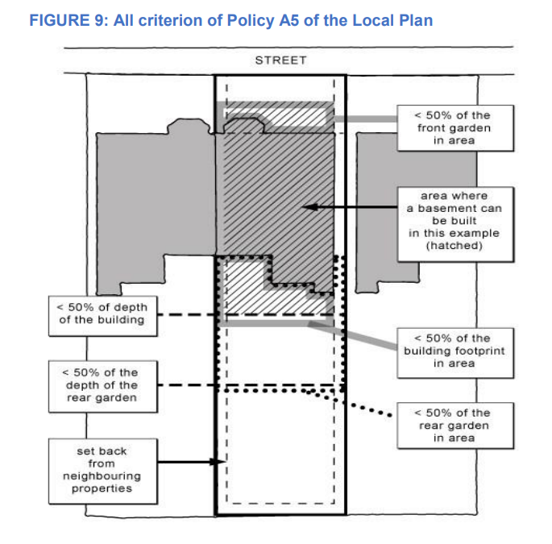

In addition to the significant expansion in footprint, the visual impact of the proposed development is exacerbated by the dominance of and over-reliance on light wells, paths, retaining walls, steps, bin stores, and comparable structures, indicative of the challenges the development faces in addressing site limitations. Importantly, these elements tend to dominate over the actual usable communal garden space. Compounding the issue, the building has been designed with occupancy levels accommodating 49 people, based on the number and size of bedrooms. This design translates to each occupant having access to less than 1 sqm of usable communal garden space.

Most, if not all, buildings along Daleham Gardens are comprised of either three storeys or two storeys with additional accommodation within the roof structure. The proposed development, ranging from five to six storeys in height, would lead to the establishment of a structure that not only exceeds the depth of any other property on the same road but is also notably taller. This situation is further compounded by the placement of the development atop a hill, where it will dominate views within the conservation area. The proposals will also dominate the comparatively modest infill development at 32a and 32b Daleham Gardens, situated directly opposite the site, as well as the single-storey school facilities immediately north of the application site.

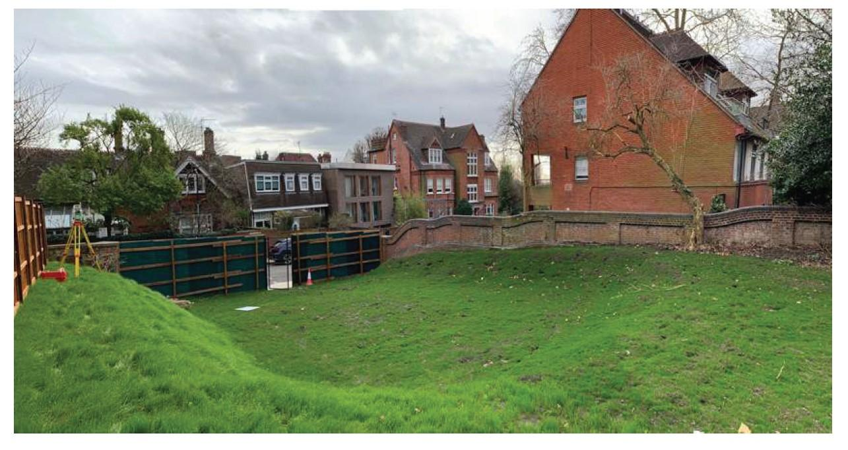

Photograph taken from inside application site towards neighbouring properties, all of which are of lesser height than the proposed development

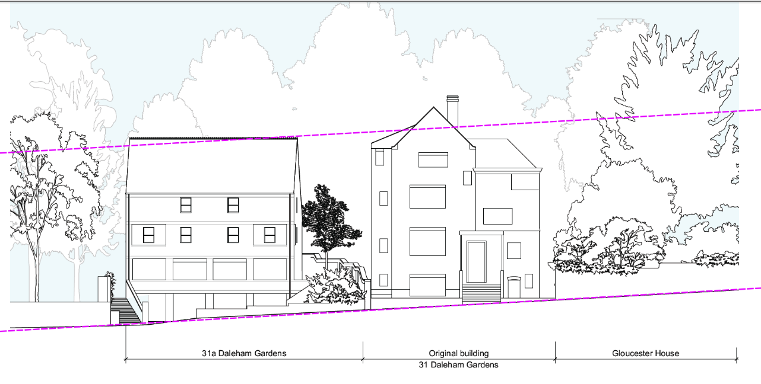

Streetscene elevation prior to the demolition of the previous building, noting how the building height responded to neighbouring development pattern and land gradient

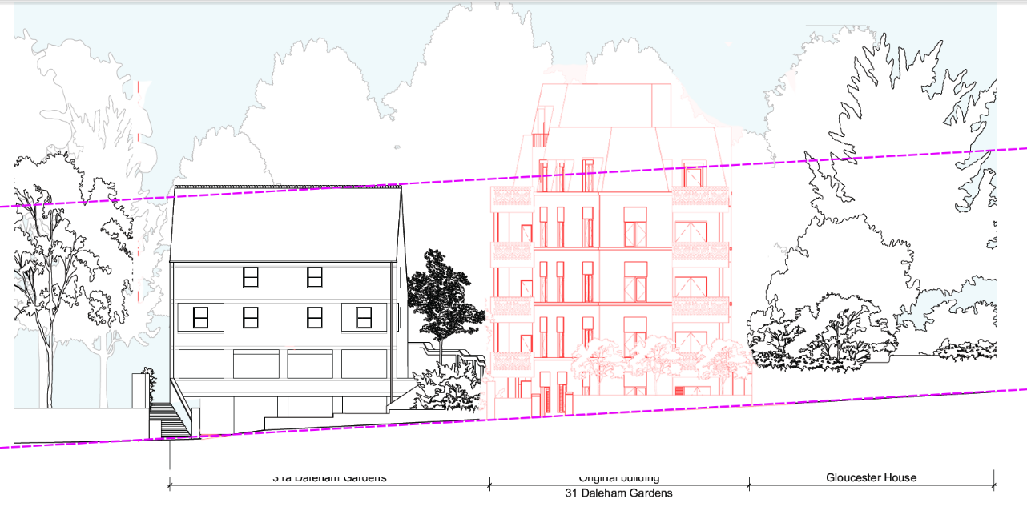

Streetscene elevation showing proposed development, projecting 0.5 to 2 storeys above the established pattern of development

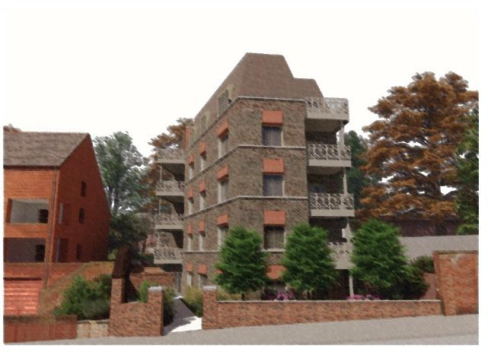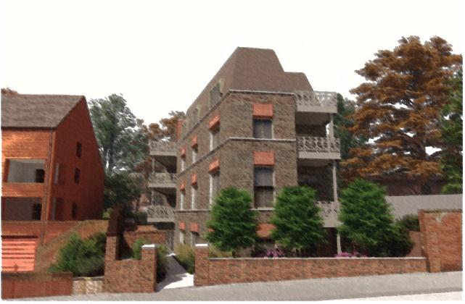

CGI showing the proposed development reduced by one storey to better reflect the height of neighbouring properties whilst taking in to account land gradients; note how the reduced height results in a less imposing, more humans scale

While the heightened elevation will be particularly conspicuous at the front, its impact at the rear will be even more profound. Here, the six-storey development will not only lead to the loss of a characteristic rear garden, but will also introduce essentially a form of back-garden development that surpasses the height of any other building in the neighbourhood.

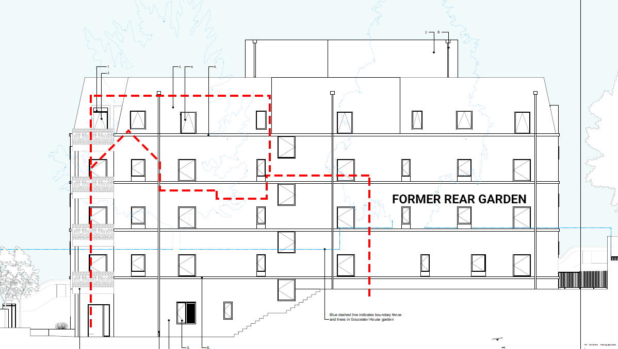

Within the rear garden the height of the building has increased from zero to six stories, virtually expanding along the entire depth of the application site.

Officer feedback from pre-application discussions has previously identified concerns over the height of the building: “The proposed height is 6 storeys and sits between a four-storey structure with pitched roof and a plot with a one storey building set away from the development boundary. Although the building steps away from its adjacent building, the height is considered tall in relation to its surroundings, especially in its current form, and would work better if reduced by at least one storey. Considering the proposed height and site occupation, the development appears to be greater than the site can accommodate”.

Contrary to officer feedback, the current design iteration has only been reduced by less than one storey (it remains a part six-storey building) rather than at least one storey as required.

Finally, it is considered that the boomerang shape and angled orientation of the building do not harmonize well with the prevailing building typology, which primarily consists of traditional built forms featuring prominent front and rear facades, expansive rear gardens, and flank elevation walls with windows limited to non-habitable rooms and only where absolutely necessary. In contrast, the proposed development incorporates its most prominent facade (housing the majority of windows, outdoor amenity areas, and even the entrance door) on the south elevation, directly facing a flank elevation wall and communal gardens of another plot, namely 31a Daleham Gardens. The introduction of overhanging balconies visible from every elevation is also considered at odds with the character and appearance of the conservation area.

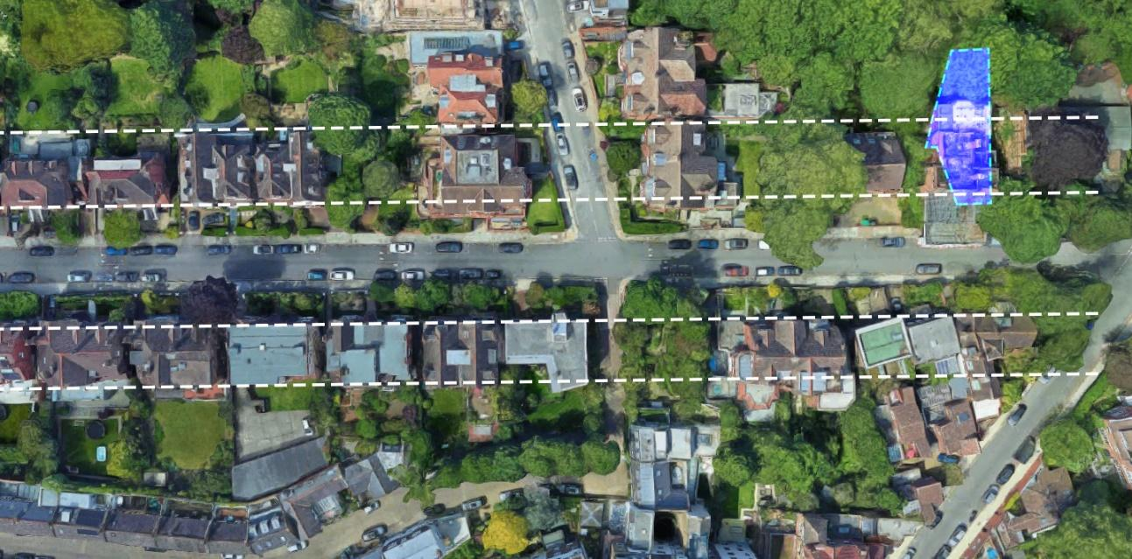

The proposed development is at completely odds with the pre-existing building as well as the prevalent pattern of prevalent

While the applicant asserts that the proposals will be mostly shielded from views by trees, no evidence has been provided regarding the removal of existing trees and how this will affect visual amenity when their removal is assessed in connection with the impact of the new building, rather than in isolation. Additionally, the photographs submitted as part of the submission were predominantly taken during the summer months when tree coverage is at its maximum.

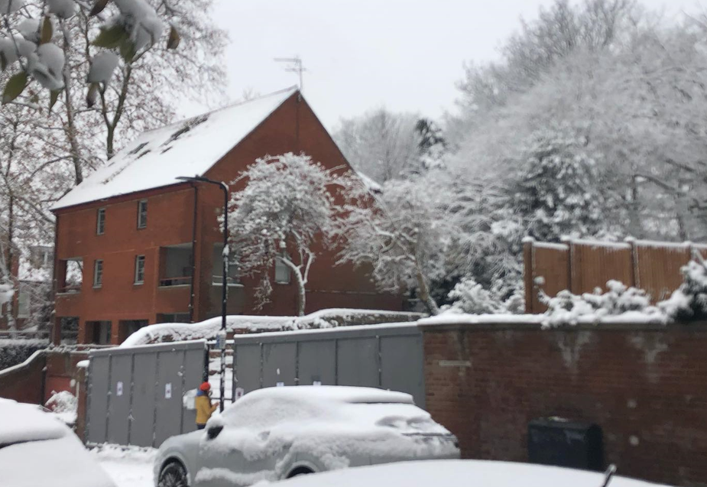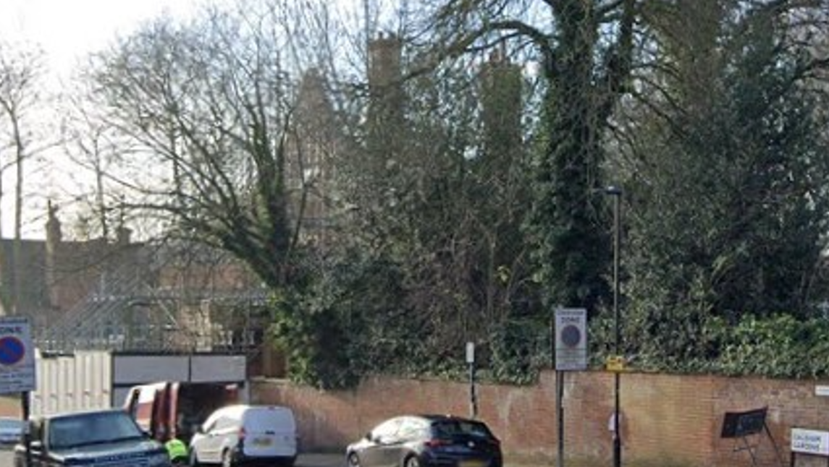

During the colder months of the year, the expansive part six-, part five-storey flank elevation wall of the proposed development would be highly visible from longer views, projecting higher than the pre-existing chimneys (right photograph)

Further assessments regarding the impact of the proposed development on the visual amenity enjoyed by neighbouring plots are addressed in the following section.

Impact on Neighbouring Amenity (incl. trees)

31a Daleham Gardens

31a Daleham Gardens is a block of six flats located immediately to the south of the application site. It benefits from a rear garden in use as a communal amenity area for the occupants of the block.

It is acknowledged that, prior to its demolition, there was a degree of overlooking between the side windows of 31 Daleham Gardens and the rear garden of 31a Daleham Garden. However, the opportunities for overlooking between the two sites were notably limited by mature trees, which served as a natural privacy screen and maintained the character of the rear garden setting.

Due to the extent of the proposed building footprint (significantly larger than pre-existing), the development will require the removal of several mature trees along the side boundary, notably the trees marked T1, T2 and T3 in the applicant’s Preliminary Arboricultural Report:

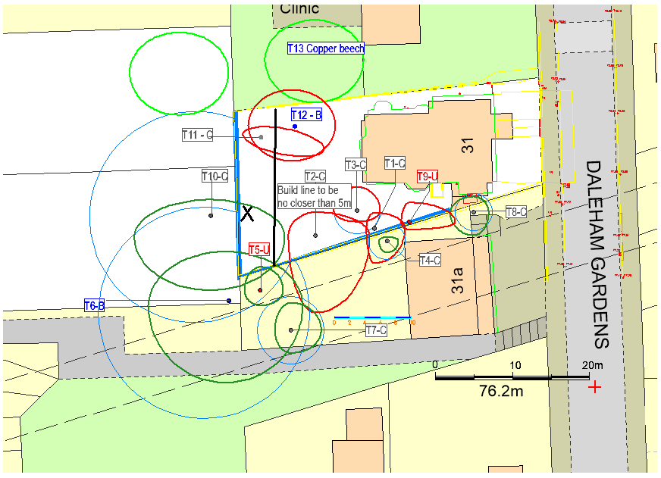

Concerningly, it is precisely these three trees that, until now, have kept overlooking opportunities between both sites to an absolute minimum, especially during the months when outdoor amenity areas are used most. The current tree cover, highlighted in the application’s own submission, serves as a privacy barrier:

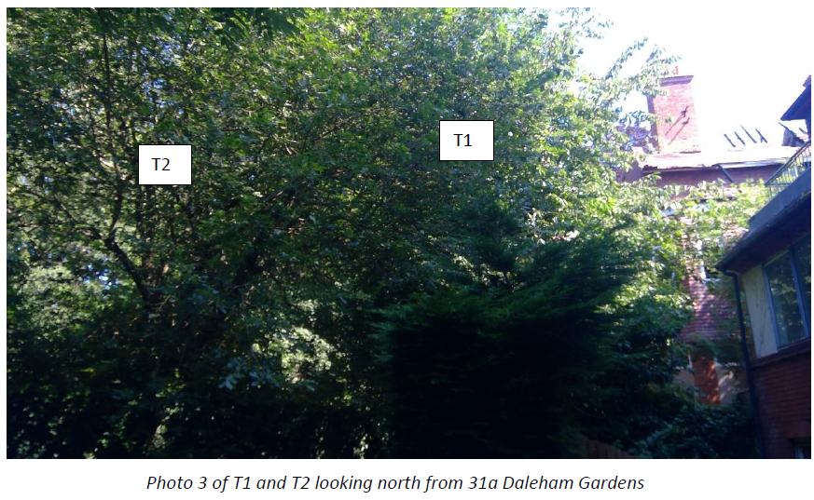

As a result, the removal of these trees will significantly increase overlooking opportunities between both sites. The uncharacteristically small gardens proposed on the periphery of the new development lack sufficient surface area for substantial tree growth. Even if it were possible to plant replacement trees with similar growth potential, it would take 20 to 30 years for them to reach the current coverage. This would adversely affect the outlook from the proposed flats in the future, highlighting an inherent conflict between two juxtaposed objectives: preserving privacy while creating acceptable outlook from the multitude of new windows on the southern elevation of the proposed development.

While the applicant argues that concerns about overlooking have been addressed by setting out the proposed building footprint at an angle, supposedly directing views towards the rear of the garden, in reality, this construction method fails to divert outlook away from the rear garden of 31b Daleham Gardens as intended: it is the rooms themselves that need to be angled internally. The angle of glass, as opposed to the orientation of rooms, does not impact human vision. This is demonstrated in the following illustration, confirming that every part of the rear garden of 31a Daleham Gardens will be overlooked by the new development:

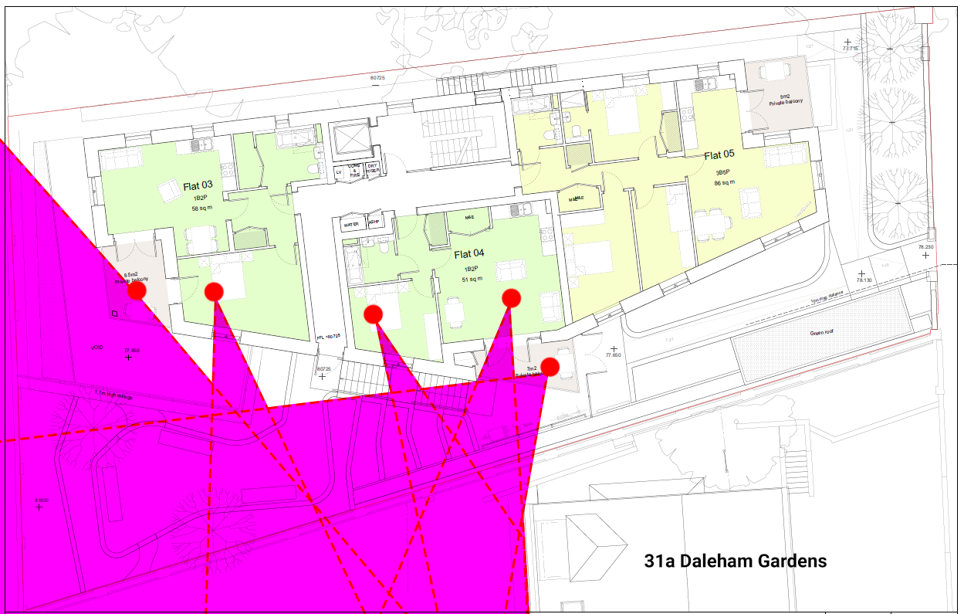

While it might be feasible to incorporate privacy screens around the rear-most balcony, all other windows/balconies serve as the exclusive openings to habitable rooms. Consequently, the addition of privacy screens or obscure-glazing would compromise the living conditions of future occupants of the development. This predicament arises from the scheme's overreliance on utilizing the southern perimeter to accommodate habitable rooms, whereas the pre-existing building largely managed to position only non-habitable rooms (or secondary windows) on this elevation.

Even with the installation of privacy screens around the rear-most balcony, which is currently overlooked by secondary windows from within the development, the rear gardens of 31a Daleham Gardens would still face complete overlooking:

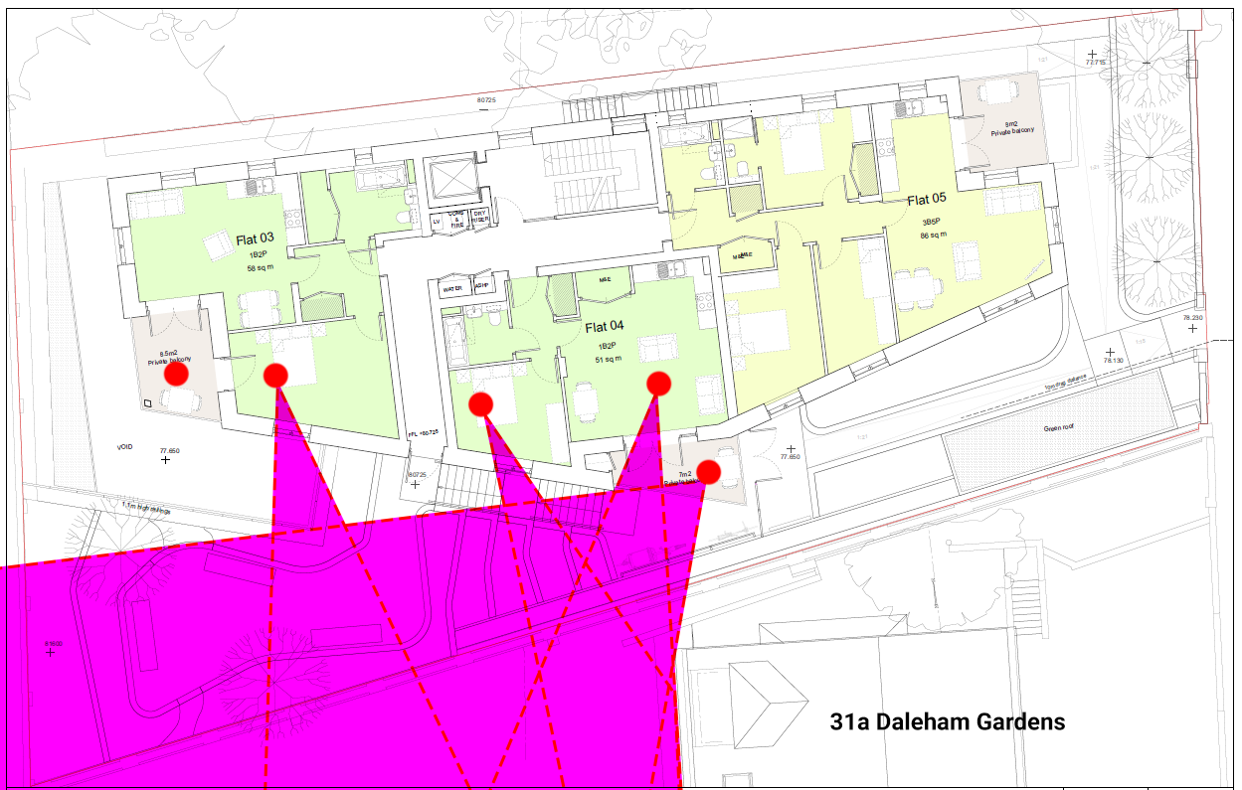

Crucially, while a degree of overlooking existed between both sites in the past (notwithstanding the proposed removal of mature trees), the proposed development will lead to a substantial intensification of the existing use. This, in turn, will cause severe overlooking and an unacceptable sense of enclosure when viewed from the rear shared amenity space of 31a Daleham Gardens.

Previously, as highlighted on the following plan, no more than 8 side-facing windows overlooked the rear garden of 31a Daleham Gardens:

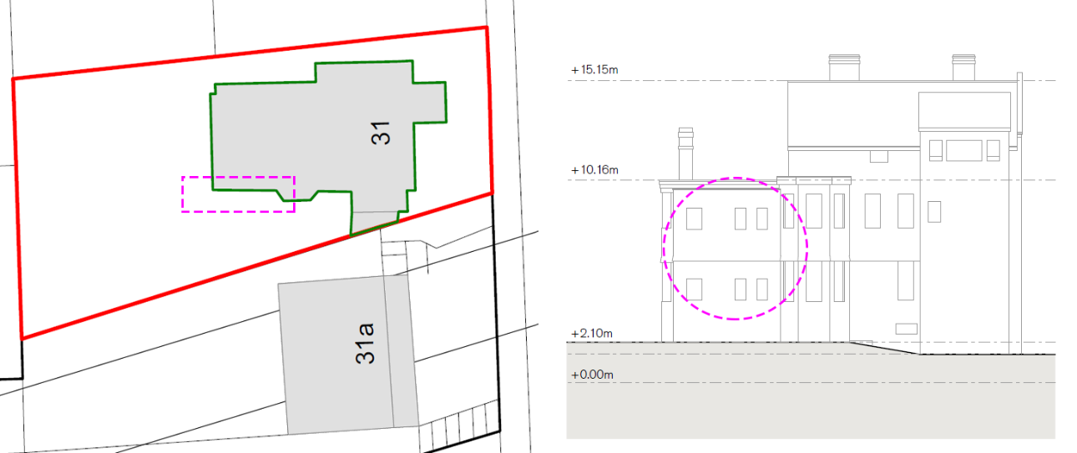

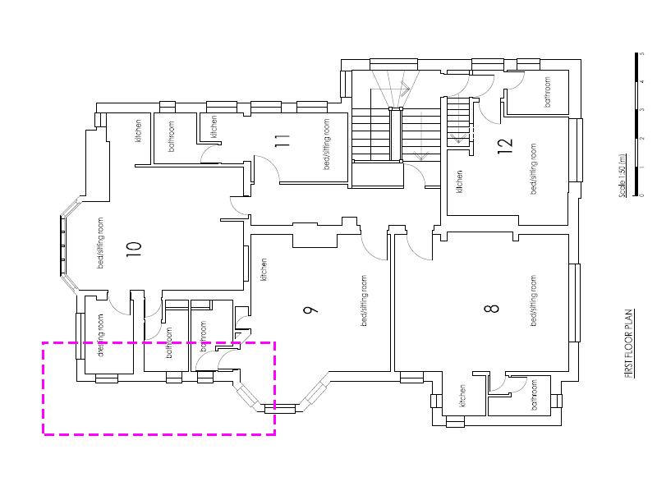

Furthermore, the majority of the windows highlighted above were openings to non-habitable rooms or secondary windows, often with the potential for or already equipped with obscured glazing, consistent with common practice for windows inserted into flank elevation walls. Simply put, the layout of the pre-existing building took into consideration the amenity of neighbouring properties. Additionally, there were no balconies situated on this elevation previously.

Moreover, the restricted count of habitable rooms with a view of the garden (just two in total) comprised small self-contained bedsits designed for a maximum occupancy of two occupants per unit. Consequently, no more than eight occupants would have had the chance to overlook the rear gardens of 31a Daleham Gardens, and this would be from no more than two habitable rooms in total.

In contrast, the new development will occupy nearly the entire depth of the application site, positioning the majority of windows along the southern elevation, directed towards 31a Daleham Gardens. With the added depth beyond the rear of the pre-existing building and the inclusion of four storeys above the ground level of accommodation, the count of windows serving as openings to habitable rooms overlooking the neighbouring garden (i.e. at first floor level or above) will surge from 2 to 18, marking an 800% increase. Additionally, the development will introduce eight balconies on the flank elevation wall, all positioned at the first-floor level or above, where previously there were none.

In contrast to the pre-existing building, the proposed scheme comprises bona-fide one-, two-, and three-bedroom apartments rather than self-contained bedsits. According to the proposed plans, seven of these flats, accounting for 50% of all units, will have views overlooking the rear garden of 31a Daleham Gardens. Three of them exclusively do so because they have not been designed to be dual aspect, contrary to London Plan requirements (a further indication that the quantum of development may be excessive). Based on the indicated occupancy levels, the number of occupants with views overlooking 31a Daleham Gardens would increase from the previous eight (confined to two habitable rooms) to 21, distributed across 17 habitable rooms.

As a consequence, the residents of the flats at 31a Daleham Gardens would face continuous overlooking, amplifying an unacceptable sense of enclosure, particularly notable as the flank elevation wall of the proposed development is treated as a principal elevation, a concerning departure from what site constraints would typically permit.

Paragraph 2.2 and 2.3 of the Council’s Supplementary Planning Guidance on ‘Amenity’ (SPG, 2021), itself referred to under Policy A1 ‘Managing the impact of development’ of the Camden Local Plan (2017) states in relation to overlooking and privacy:

(Par. 2.2) Interior and exterior spaces that are overlooked lack privacy, which can affect the quality of life of occupants. The Council will therefore expect development to be designed to protect the privacy of the occupants of both new and existing dwellings to a reasonable degree. Therefore, new buildings, extensions, roof terraces, balconies and the location of new windows should be carefully designed to avoid overlooking. The extent of overlooking will be assessed on a case-by-case basis.

(Par 2.3) The places most sensitive to overlooking are typically habitable rooms and gardens at the rear of residential buildings. For the purposes of this guidance, habitable rooms are considered to be residential living rooms; bedrooms and kitchens. The area of garden nearest to the window of a habitable room is most sensitive to overlooking.

Evidence has already been presented, confirming that the slightly-angled side windows of the rear part of the proposed development fail to redirect outlook away from the garden of 31a Daleham Gardens, attributable to the orientation and design of the internal layout. Furthermore, in contradiction to London Plan requirements, there are three flats situated at or above the first-floor level, and their windows exclusively overlook the rear garden of 31b Daleham Gardens, including areas closest to the habitable rooms at the rear of that property.

The SPG also confirms in paragraph 2.8 (in relation to possible mitigation measures) that “it will however not be acceptable for habitable rooms to have windows glazed exclusively with obscure glass however”.

The removal of trees from the side boundary will also cause harm to the visual amenity enjoyed by the occupants of 31a Daleham Gardens. This view is supported by the Council’s recently adopted Fitzjohns / Netherhall Conservation Area Character Appraisal & Management Plan (2022) which states:

(Par3.4) Daleham Gardens, Fitzjohn’s Avenue, Maresfield Gardens and Netherhall Gardens have a more formally planned layout, with straight and parallel streets. This layout includes large open areas to the rear of properties, comprising an amalgam of rear gardens. […] Throughout the Conservation Area the contribution of the streetscape is significant; the trees (public and private), the vegetation, the boundaries between private gardens and the street, the rear gardens. The general layout and landscape character create a green and leafy character. This is based on properties with front and rear gardens, with trees and hedges. Rear gardens are often very generously proportioned. The amalgam of rear gardens results in large open settings in many parts of the area, creating a semi-rural character. These amalgams of garden space are a very important characteristic of the area and, in the absence of public green space, have an important amenity value. A key characteristic is the range of mature trees, including formal avenues of street trees and also more informal garden trees.

Finally, it is noted that the proposed scheme would effectively, by virtue of the considerable depth of the building and the multitude of principal windows proposed on the flank elevation wall, severely compromise the development potential of 31a Daleham Gardens which, unlike the application site, has been identified as an aesthetically ‘negative’ building within the conservation area, indicating realistic redevelopment potential.

The risk of the current scheme harming the development potential of the adjoining plot (a material planning consideration, as confirmed in pre-application discussions) is further supported by the BRE’s guidance document Site layout planning for daylight and sunlight: a guide to good practice. Figure 21 of the guide provides a method to assess whether a proposed development, containing windows on its flank elevation, has the potential to impose itself on neighbouring land to the detriment of its future development potential, preventing future nearby developments from enjoying a similar access to daylight. Consequently, the quantum of development proposed at the development site may, in fact, impose or neutralize the long-term housing delivery potential of the street, while causing immediate and unjustifiable harm to neighbouring amenity.

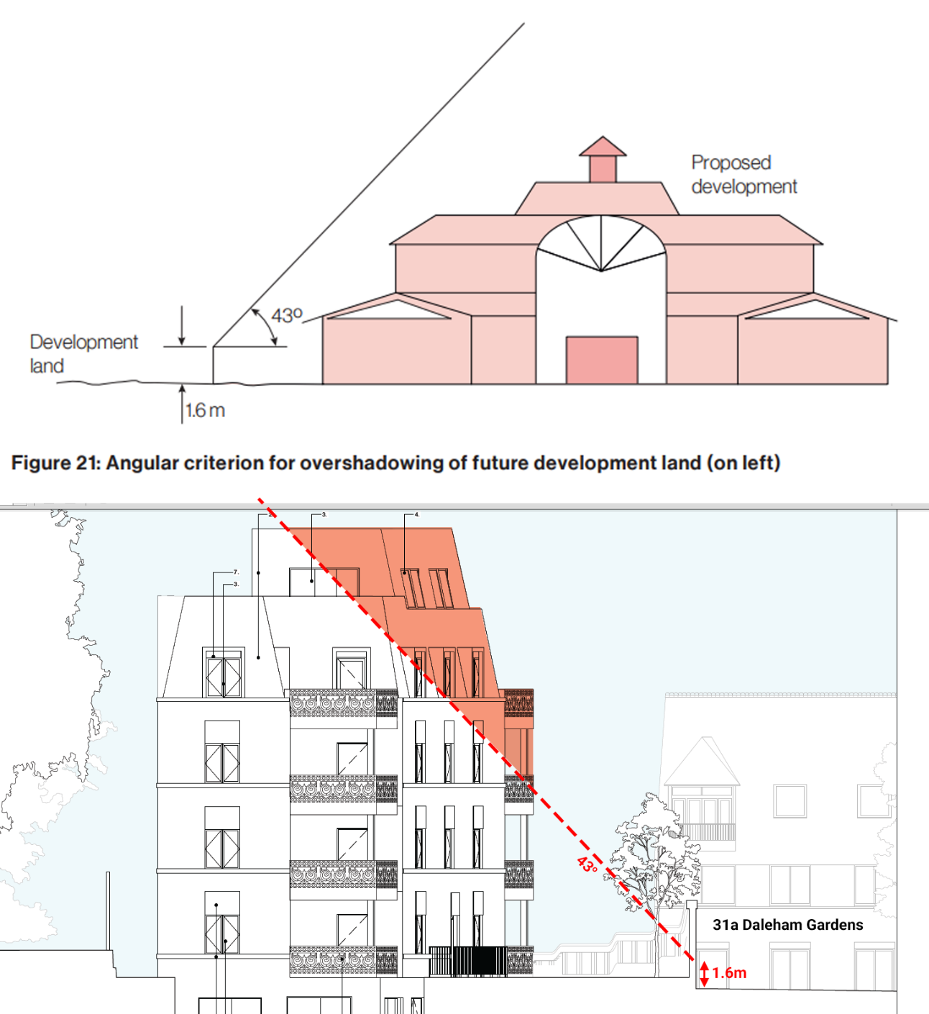

Note: the proposed development would also compromise the development / expansion potential of the adjoining school due to the positioning of its north-facing flank elevation wall just off the shared boundary for the entire depth of the application site (and former residential garden)

Tavistock Children’s Day Unit (33 Daleham Gardens)

A specialist school, known as Gloucester House School, catering to pupils aged 4 to 15 with Social, Emotional, and Mental Health Difficulties (SEMH), adjoins the application site to the north. More precisely, it’s the school’s outdoor recreation areas that flank the northern boundary of the application site.

While the pre-existing building contained a couple of windows on the northern (flank) elevation overlooking the school site, only three of these formed openings to a habitable room (a small bedsit, to be precise). All other windows generally formed part of corridors or constituted secondary windows that could be obscure glazed. Crucially, the pre-existing building did not encroach into the rear-most part of the garden, ensuring that the building did not overlook, overshadow or otherwise tower over the playground.

In addition to the above, until the pre-existing building was demolished, the school had installed a double-height (circa 4m high) fence to prevent any residual overlooking, clearly indicating that this was a concern.

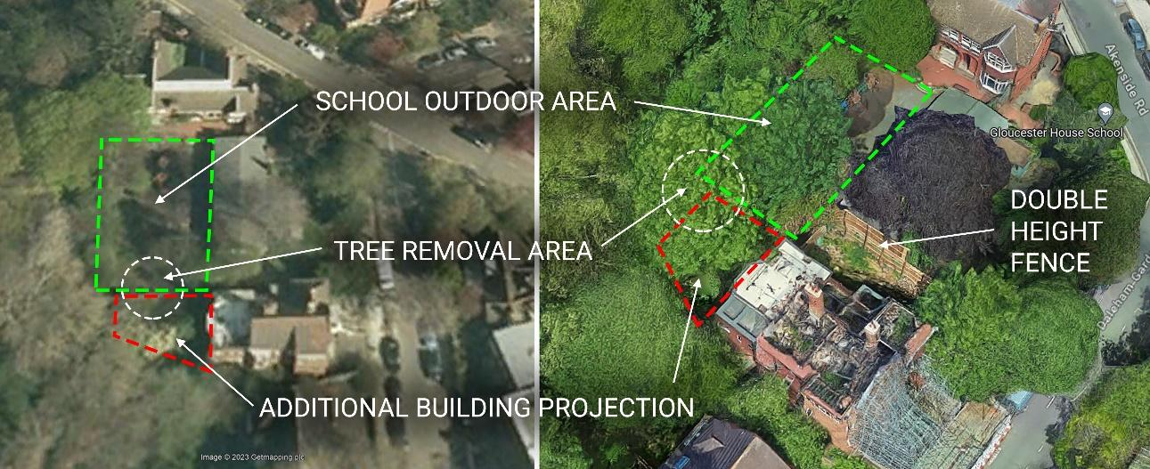

The currently proposed development, on the other hand, would create a 4-storey-high (above basement level) wall dominated by windows almost right up to the school perimeter and for almost the entire depth of the garden. As a result, overlooking opportunities that do not previously exist are being introduced between the application and the outdoor play area of a sensitive site. While some of these windows could be obscure glazed, there are windows on this elevation that constitute the sole windows of habitable rooms:

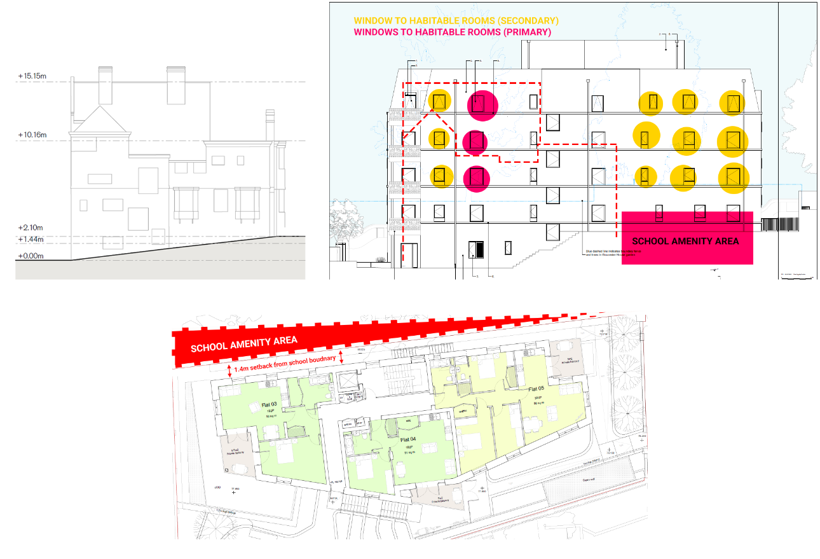

The situation will be further being exacerbated by the removal of two mature trees located between the specialist school playground and the application site (marked T11 and T12 on the tree reports). The proposed development, by virtue of its combined depth and height without notable setback from the school boundary, would also cause overshadowing, an overbearing sense of enclosure, and compromise the school's future redevelopment or expansion potential.

The matters outlined above could be addressed by reducing the quantum of development, for example, by retaining a greater amount of the existing rear garden (i.e., reducing the depth of the extension), lowering the height of the development, and positioning windows to habitable rooms away from the school

56 Fitzjohn's Avenue (Daphne Court)

The pre-existing building, distinguished by its characteristically large rear garden (as highlighted in the conservation area statement), was set back from the rear boundary with 56 Fitzjohn's Avenue by approximately 14 metres. This considerable distance provided high levels of privacy between the communal gardens of 56 Fitzjohn's Avenue and the rear windows of the pre-existing building. It is also noteworthy that the same separation distance was around 20 metres when measured from the original rear wall of 31 Daleham Gardens.

The proposed development, on the other hand, will stretch across almost the entire depth of the application site, projecting further out than any other building on the entire road. Consequently, the separation distance between the rear shared boundary and the proposed rear-facing windows and balconies will be reduced to 3.4 metres—less than the length of a car parking space. No evidence has been provided to demonstrate that the proposed development would not compromise the amenity enjoyed by the occupants of the communal gardens at 56 Fitzjohn's Avenue.

32, 32a and 32b Daleham Gardens

While overlooking between the application site and 32/32a/32b Daleham Gardens spans a public road where overlooking opportunities already exist(ed), it is crucial to note that the proposed development will be positioned closer to the public highway than the pre-existing building, deviating from the prevalent form of development. This reduced setback, along with the additional height at the front boundary, the introduction of balconies (for use by several flats with occupancy levels up to 5 people), and the bulkier mansard roof form, contributes to an increased intensity of overlooking that is deemed harmful. Specifically, this harm manifests as an augmented sense of enclosure, negatively impacting the privacy and outlook of the front-facing windows and gardens of 32, 32a and 32b Daleham Gardens. It's important to highlight that 32a and 32b Daleham Gardens lack a rear garden, making the front garden its private amenity area.

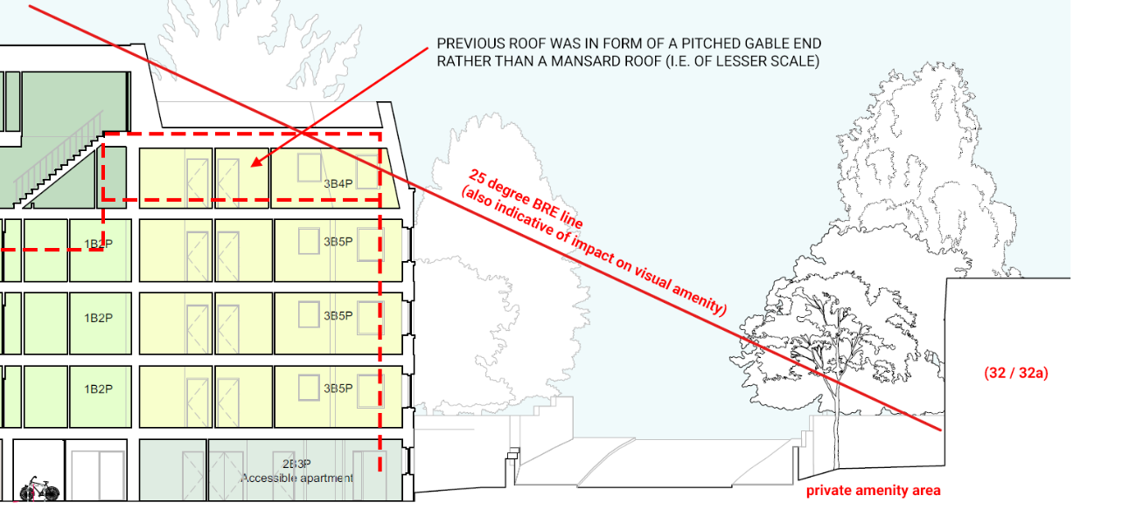

Accessibility and living conditions of future occupants

Policy D6 of the London Plan (2021) mandates that new dwellings must be dual-aspect, meaning they should have windows on at least two different elevations. Exceptions are only permitted when it can be demonstrated that the most optimal design has been achieved through a design-led approach, as opposed to a density-led or capacity-led approach. This aims to avoid single-aspect units that compromise privacy, fail to provide “a choice of views”, or are susceptible to overheating.

At the application site, three of the proposed dwellings (constituting over 20% of all units), namely Flats 4, 7, and 10, are single-aspect, contrary to the objectives of the London Plan. The windows of these flats are positioned within 5 metres of the shared boundary; as a result, outlook is directed exclusively into the rear garden of 31a Daleham Gardens, to the detriment of privacy between neighbours, an amenity which the dual-aspect policy of the London Plan aims to protect.

While an overheating assessment has been submitted in support of the planning application, it does not acknowledge or appear to assess the proposed removal of existing trees (i.e. shade) located on the southern perimeter of the application site. The application also fails to address the fact that by doubling the footprint of the pre-existing building, it contributes to urban overheating.

Also of concern is the unit shown as Flat 1 on the proposed plans, which is located wholly at basement level, relying exclusively on lightwells for daylight, sunlight, and outlook. From the drawings, it would appear that no part of the proposed flat would offer future occupants views of the sky; instead, the outlook will be limited to a 4-metre-high wall above which is a 2-metre fence and mature trees.

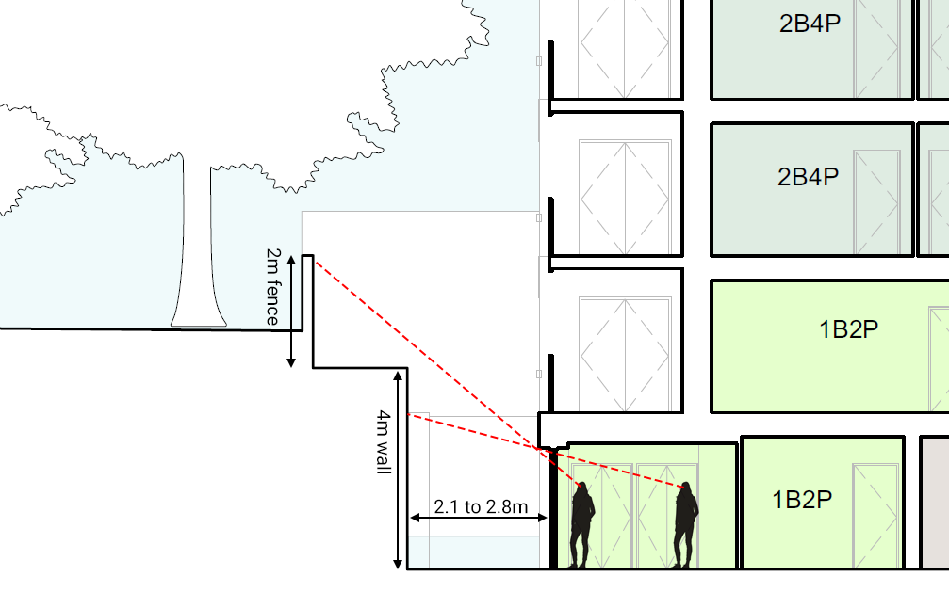

Regardless of positioning within the proposed basement flat, occupants would have no views of the sky and their sole outlook would be onto 4m+ tall walls

Contrary to Council requirements (c.f. Amenity SPD) and those of the BRE, the daylight and sunlight assessment submitted by the applicant fails to take into account the No Sky Line. It does not provide evidence of if and how the surrounding obstruction (e.g., wall-top fence and trees) has been modelled. As such, the developer should provide robust evidence that Flat 1 will benefit from acceptable degrees of daylight, sunlight, and outlook, taking the No Sky Line as well as internal daylighting into account.

In light of the above and as per the requirements of 3.16 of Camden’s Amenity SPD, the applicant should fund an independent verification report to assess the conclusions and robustness of the daylight and sunlight assessment with regards to Flat 1.

Generally, the proposed development poses challenges with regard to separation distances from each boundary. The outlook from the windows will either directly face adjoining communal gardens (or school premises), thus detrimentally impacting neighbouring amenity, or be obstructed by trees, adversely affecting the living conditions of future occupants of the development.

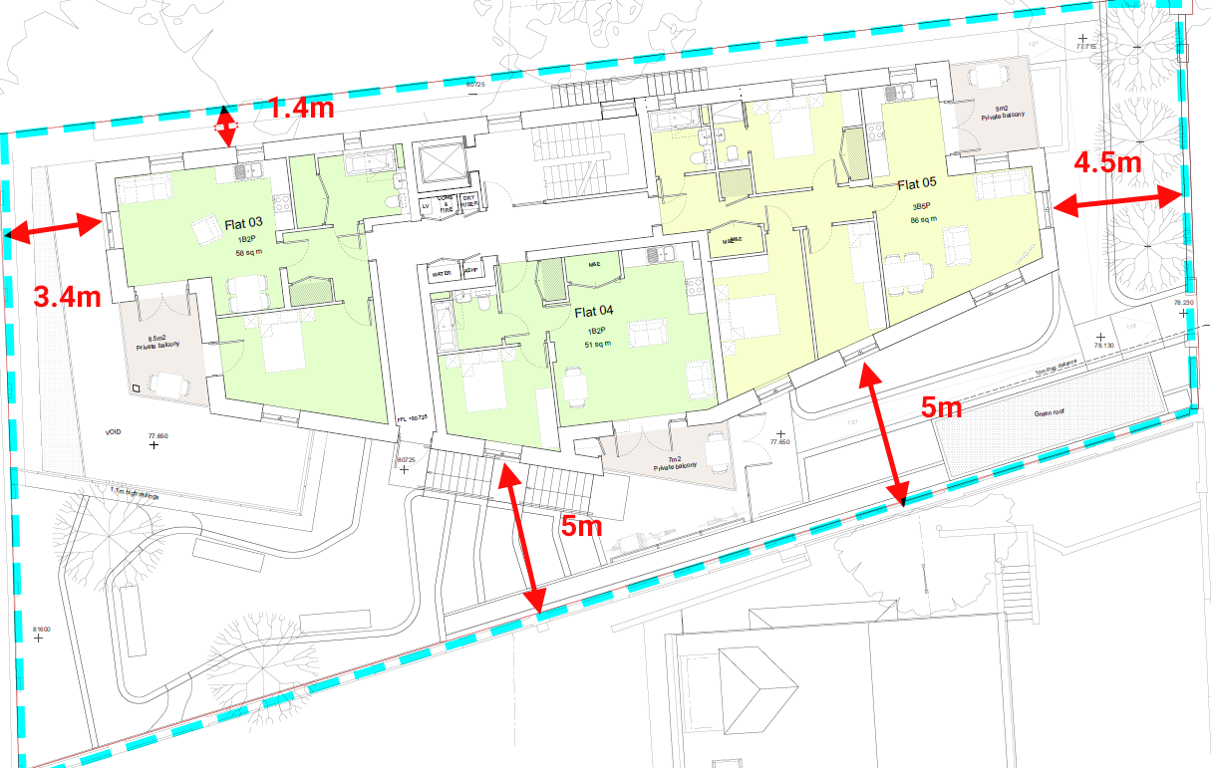

Overlooking from most windows would either be cut short by trees or directly into neighbouring amenity areas (including school premises), offering limited qualitative outlook and compromising privacy levels between plots

Finally, the Council has adopted technical guidance on waste and recycling storage in support of the SPD on Design (2021). This document stipulates, for all new development, a minimum width of 2 metres for all paths leading from the road to the bin storage area. However, the proposed path does not meet these requirements. Moreover, widening the path would further diminish the small amount of green space proposed at the front and side of the building, thereby compromising the privacy of Flat 2, whose windows are positioned along the communal side entrance path and bin store area. Overall, this indicates that the design of the proposed development is struggling to deal with site constraints adequately, primarily due to the quantum of development.

These concerns are substantiated by the prevalence of retaining walls, light wells, paths, and steps rather than actual usable communal gardens. Consequently, each occupant, including those with children or larger families, has access to less than 1 sqm of shared amenity space.

