**Materials Supplement**

Flat G, 10 Regent’s Park Road, NW1 7TX

The following supplement provides further details on the materials to be used in the renovation of Flat G, 10 Regent’s Park Road.

*Renovation:* Flooring

*Location:* Throughout

*Details:* The existing thermoplastic tiles will be replaced with Luxury Vinyl Tiles in both color and pattern to mimic the originals. The entirety of the flat, except for the bathroom, with have Ecru tiles from Harvey Maria (Figure 1) and the bathroom will have Venetian Red tiles from Harvey Maria (Figure 2). Note that the photos below are for reference only and include white tiles which will not be included in the renovation. The tiles are durable, waterproof, easy to maintain, and suitable to use with underfloor heating.

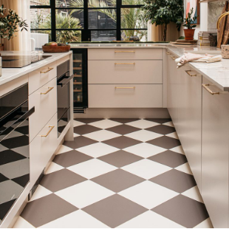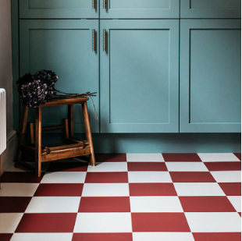

Figure  Figure 2

*Renovation:* Secondary glazing

*Location:* Throughout

*Details:* A slimline secondary glazing will be used, such as the one illustrated below (Figure 3) from Selectaglaze. The dining room and bedroom will use three pane horizontal sliders (Figure 4) and the living room will use four pane horizontal sliders (Figure 5). These options will match with the existing vertical mullions and provide a seamlessness between the original windows and the secondary glazing.

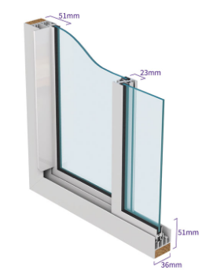

Figure

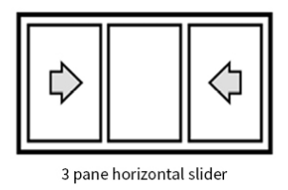

Figure

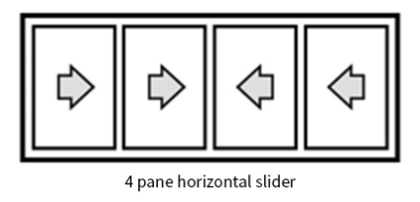

Figure

*Renovation:* Lower kitchen cabinets

*Location:* Kitchen

*Details:* The base cabinet doors will be comprised of FENIX NTM® bonded onto a solid plywood core; these are custom-made through Plykea. The color will be Bianco Kos, which is a white matt, and the handle will be semi-recessed with the same color backing. Figure 6 below is for illustrative purposes only as it does not reflect the color Bianco Kos, nor does it have the matching backing on the semi-recessed handle. A countertop with the same structure and color will also be used, as illustrated (in a different color) in Figure 7. Note also that the sink will be integrated and in the same material. The simplicity of these choices will marry nicely with the mahogany-veneered upper cabinets, creating a look that respects Goldfinger’s modernist design yet embraces an ergonomic and workable kitchen.

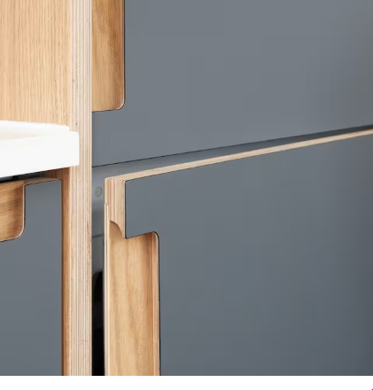

Figure

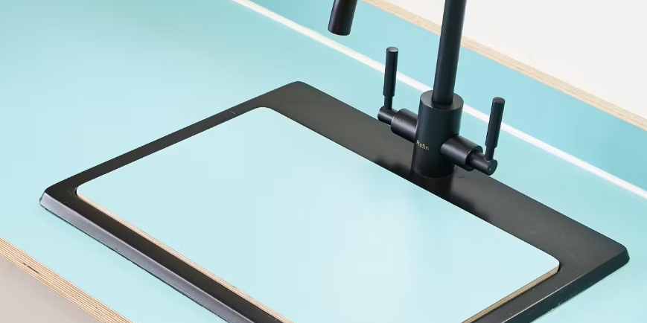

Figure

*Renovation:* Sinks and toilet

*Location:* WC and Bathroom

*Details:* Simple, matt white fixtures from Lusso will be used in the WC (Figure 7 and Figure 8) and Bathroom (Figure 9).

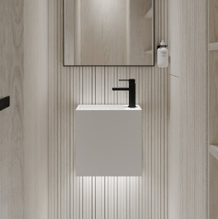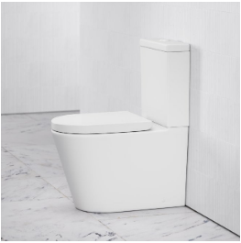

Figure  Figure 9

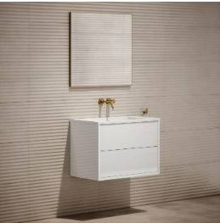

Figure