DESIGN & ACCESS STATEMENT

Project:

Proposed provision of security gates to main entrance steps at Rashleigh House, Thanet Street WC1H 9ES, a six-storey apartment block within the Bloomsbury conservation area. Suggested provision of security gates positioned on the existing 2 main entrance stairways to the property.

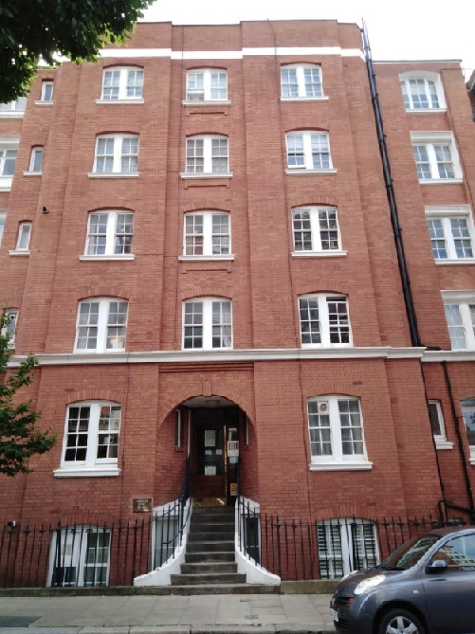

Rashleigh House main entrance to flats 31 -63

1

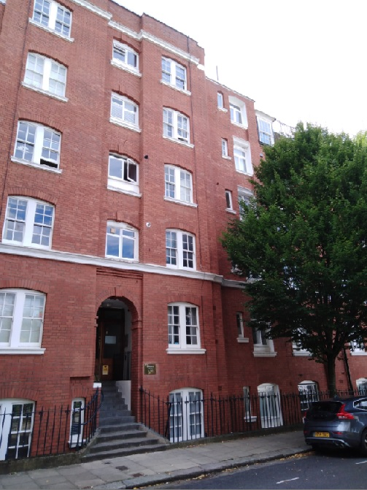

Rashleigh House main entrance to flats 1 – 30

2

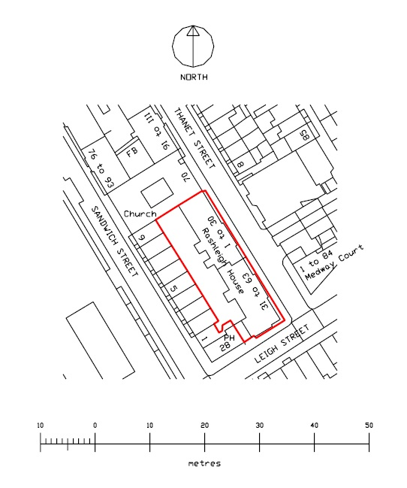

Position of existing apartment block – site boundary marked in red

3
Design:

The security gates have been designed to emulate & reflect various detail elements within the existing property’s stairway and light well protective railings.

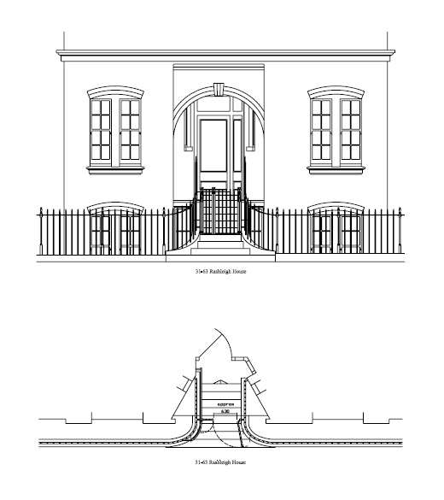
Rashleigh House proposed main entrance to flats 31 – 63

The proposal is to try and seamlessly integrate our new security gates onto the stairways between the existing property’s railings emulating current style, texture, finish & colour cloning architectural details from the existing building’s protective railings. In all we are proposing a sympathetic transformation for the stairways with a view to improving stairway security. Our client has given us a brief to construct the entrance gates from the highest quality locally sourced materials available that would complement the vernacular specific to the Bloomsbury conservation area. A brief consistent with their intended desire to specifically enhance all buildings within their portfolio.

4
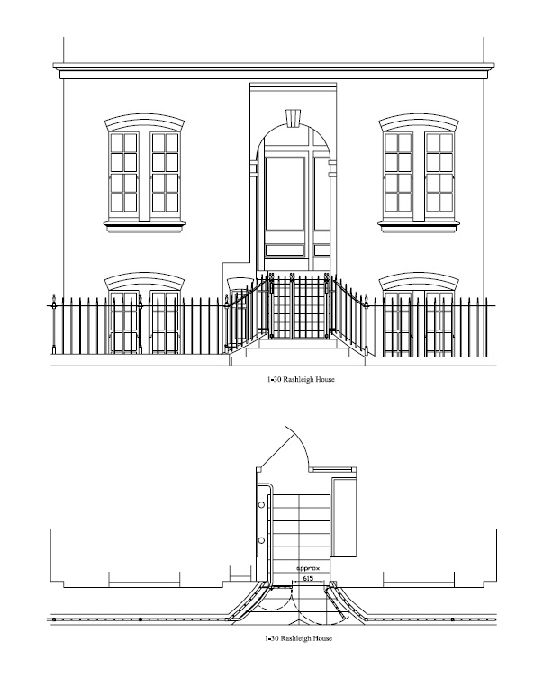
Rashleigh House proposed main entrance to flats 1 – 30

We are trusting that our considered thoroughly sympathetic creative scheme for the proposed entrance gates may go hand in hand and indeed our clients have suggested that they would be fully committed to addressing any beneficial content of any such Bloomsbury Conservation Area Appraisals / Management Proposals in keeping with the scale & nature of the immediate vicinity. Our clients would be delighted were the above proposals to be looked upon favourably.

5

