SUBJECT: Objection to Major Variation of Licence APP\PREMISES-VARY\116373
TO: licensing@camden.gov.uk

FOR THE ATTENTION OF THE LICENSING TEAM

REF: APP\PREMISES-VARY\116373

I am writing as a resident of Arlington Road to make a representation in objection to the major variation of licence application for the venue PREM-LIC\3021 (The Forge & Foundry/ Caponata Restaurant, 3-7 Delancey Street, London, NW1 7NL) in the application APP\PREMISES-VARY\116373.

Following a major variation of licence and decision to extend the The Forge’s operating hours, a number of conditions suggested by the police and other responsible authorities were placed on the premise’s licence on February 24th 2023, to ensure that even with the later proposed opening hours, the operation of the venue would cause as little disruption and nuisance as possible to the neighbouring residents. One such condition being condition no. 12. “There shall be no vertical drinking. Alcohol may only be sold by waiter/waitress service to customers seated at tables. Alcohol sales will be ancillary to a substantial table meal”. I join with many neighbours and especially those closest to The Forge to strongly urge against the removal of this condition, as this would subvert the stated intentions of the police and responsible authorities, and undoubtedly have a negative effect regarding the following licensing objectives:

- The prevention of crime and disorder
- Public safety
- The prevention of public nuisance

Over the past 10 months since the venue reopened and 7 months since a major variation of licence was implemented, we the residents have witnessed these licensing objectives being frequently disregarded by the venue’s operators and patrons. The removal of this condition would only serve to exacerbate the magnitude and frequency of the disruption that the venue causes, and heighten the existing hight levels of crime and disorder in our community.

The photos and video stills below show clearly where these licensing objectives have already been repeatedly disregarded by the venue’s operators and patrons. These are just a sample and not a complete list.

Saturday 18 March 2023 - Daytime event and night-time event
- The licencing objectives for prevention of crime and disorder, public safety and public nuisance were ignored.
- Windows of the venue were opened to allow ventilation into the building, already loud music became even louder due to the venue’s windows being open causing a public nuisance.
- The safety of the public was threatened as there was inadequate crowd control when patrons were entering and exiting the venue. The venue’s patrons took up the width of the pavement on Delancey Street, blocking passing pedestrians who then had to walk in the road.
- Drunken behaviour and acts of crime and disorder were witnessed when the venue’s patrons congregated long after closing time shouting in the street, fighting and congregating in the middle of the road blocking oncoming traffic including buses on Delancey Street and Camden High Street. See below photo evidence taken on 18/03/2023.

Saturday 20th May 2023 - Daytime event
- The licencing objectives for the prevention of crime and disorder, public safety were ignored.
- Patrons congregated in Delancey Passage, it was reported that patrons urinated and that there has been drug use by patrons of the venue in Delancey Passage. See below photo evidence from 20/05/2023.

Sunday 4th June 2023 - Night-time event
- The licencing objectives for the prevention of crime and disorder, public safety and public nuisance were ignored.
- Police attended the venue around 18:45 and detained a man. Following the departure of the police music blasted from the first floor of the venue. The level of noise coming from the venue was excessive with a thumping base. The windows were left open and music played loudly for the remainder of the evening causing public nuisance to the neighbourhood.

Sunday 11th June 2023 - Night-time event
- The licencing objectives for the prevention of crime and disorder, public safety and public nuisance were ignored.
- Windows of the venue were opened to allow ventilation into the building, already loud music became even louder due to the venue’s windows being opened causing a public nuisance.
- The safety of the public was threatened as there was inadequate crowd control when entering and exiting the venue. The venue’s patrons took up the width of the pavement on Delancey Street, blocking passing pedestrians who then had to walk in the road, including children and pedestrians with push chairs.
- Drunken behaviour and acts of crime and disorder were witnessed when the venue’s patrons congregated long after closing time shouting in the street, playing music from their cars, smoking marijuana outside our homes and congregating in the middle of the road blocking oncoming traffic including buses on Delancey Street. Below is photo evidence taken on 11/06/2023.

Sunday 30th July 2023 - Night-time event
- The licencing objectives for public nuisance were ignored on this date and on many other occasions. Music blasted from the first floor of the venue until closing time around 22:30. The level of noise coming from the venue was excessive with a thumping base when the venue’s windows were closed and with extremely loud music when windows were open causing disturbance to the neighbourhood.

Sunday 13th August 2023 - Night-time event
- The licencing objectives for the prevention of crime and disorder, public safety and public nuisance were ignored.
- Around 20:59 a fight broke out outside the venue. The fight took place on the road and on the pavement of Delancey Street. Patrons also congregated in Delancey Passage. The patrons were fighting and shouting in the middle of the road blocking oncoming traffic. See below photograph from 13/08/2023.

The examples listed above are just a very few of the disturbances over the last few months.

The removal of this condition will encourage ‘vertical’ drinking without food, regularly leading to drunkenness, irresponsible behaviour, crime, nuisance and risks to public safety that could extend until the early hours of the morning, all of which can only have a severely detrimental impact on our community. This is exactly what we expected when we made our original objections to the various licences and were only partially reassured when the various conditions were put in place. It is grossly unfair to the rest of resident community to allow these protections to be weakened.

Because that The Forge lies within Camden’s Cumulative Impact Policy Area and condition 12 was put in place specifically to protect the neighbourhood, I urge you most strongly to refuse the request to remove this condition in this major variation of licence.

Yours Sincerely,

Hillary Bauer
85 Arlington Rd

APPENDIX

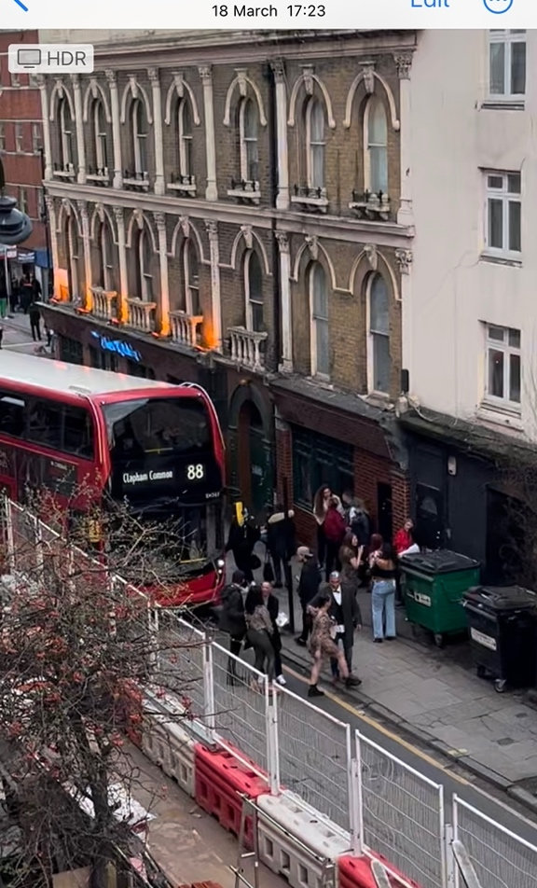

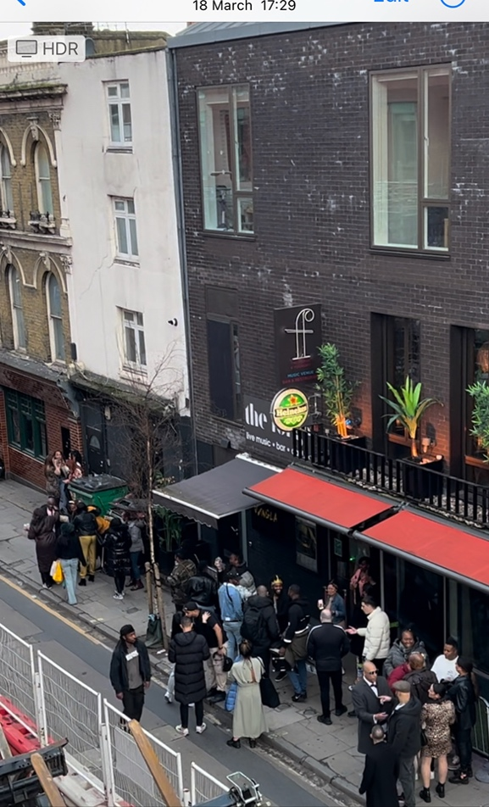

11th June 2023