planning@camden.gov.uk
Transport for London
Crossrail 2
Safeguarding Manager
5 Endeavour Square
LONDON
E20 1JN

Phone: 020 3054 7018
www.TfL.gov.uk
London Borough of Islington
Planning Applications Team
Planning and Development
PO Box 3333
222 Upper Street
London N1 1YA

18 August 2023
Crossrail 2 Ref: CR2-4777-2023

Dear Kate Henry,

2023/3265/P : Euston Tower, 286 Euston Road, London , NW1 3DP
Request for scoping opinion under Regulation 15 of the Town and Country Planning Environmental Impact Assessment (EIA) Regulations 2017, for proposed development involving the partial demolition of the existing building (retention of central core, basement and foundations) and erection of a 32 storey building (mixed use including office floorspace, lab-enabled floorspace and flexible retail floorspace), alterations to existing basement, improvements to public realm surrounding the building.

Transport for London administers the Crossrail 2 Safeguarding Direction made by the Secretary of State for Transport on 24 March 2015.
Regarding your letter dated 08 August 2023, requesting the views of the Crossrail 2 Project Team on the above application. I confirm that the application relates to land within the limits of land subject to consultation by the Crossrail 2 Safeguarding Direction.

The site falls with the Limits of Safeguarding for Crossrail 2.

TfL has no comment to make from a Crossrail 2 perspective in response to the EIA scoping request. In the event future applications for planning permission are submitted to the Local Planning Authority which propose or imply works more than 3 metres below ground level, an increase in height or floor area for this site consultation on that application must include Transport for London to prevent planning permission being granted for development that might be prejudicial to the subsequent delivery of Crossrail2.

The latest project developments can be found on the Crossrail 2 website www.crossrail2.co.uk .

I hope this information is helpful, but if you require any further information or assistance then please feel free to contact a member of the Safeguarding Team by email to crossrail2@tfl.gov.uk .
Yours sincerely,
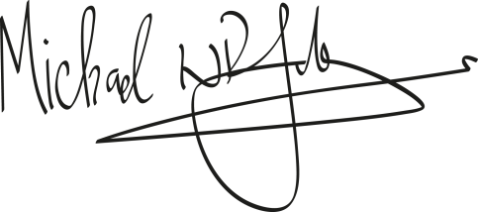
Michael Johnson
Safeguarding Manager

