DESIGN and ACCESS STATEMENT IN SUPPORT OF LISTED BUILDING CONSENT APPLICATION IN RELATION TO;

Rituals Cosmetics UK Limited

Unit 15, Kings Cross Station, London, N1 9AL

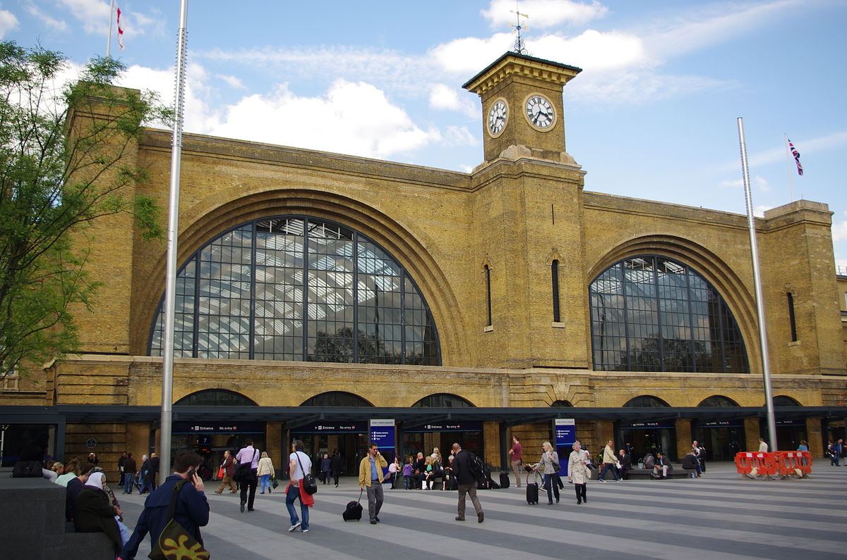

PROJECT DESCRIPTION

Unit 15, Kings Cross Station is a ground floor retail unit located in the Western Concourse of Kings Cross Station, designed by John McAslan & Partners, constructed between 2008-2012 as an addition to the original railway terminus designed by Lewis Cubitt, constructed between 1850-52. The entire station is Grade 1 Listed, the description of which follows;

*CAMDEN  
  
TQ3083SW EUSTON ROAD 798-1/85/420 (North side) 10/06/54 King's Cross Station  
  
GV I  
  
Railway terminus. 1850-52. By Lewis Cubitt (architect), and Sir William and Joseph Cubitt (engineers). Yellow stock brick. 2 train sheds (originally 1 for arrivals, the other for departure) closed by monumental plain brick screen of 2 glazed semicircular openings, framed with recessed arches (echoing the train sheds behind) with central and flanking towers; ground storey obscured by late C20 additions. Central tower with rectangular clock turret with pyramidical roof, eaves cornice and weather vane. To the west, 3 storey 3 window office block with booking hall and service rooms at rear; 1st floor with thin, debased Venetian windows, cornice at 2nd floor level, 2nd floor segmental-arched sashes (flanking bays tripartite), cornice. On east side, an extension with archway to the cab drive (now bricked up); rusticated surround to arch and quoins; cornice above which 3 tripartite sashes and parapet. INTERIOR: train sheds separated by round-arched brick colonnade. Originally, train shed roofs of laminated wood, inspired by the Crystal Palace, but these rapidly deteriorated and were replaced by the present iron-ribbed roofs to the eastern shed 1869-70, to the western 1886-7. (Laminated wood trusses successfully used at 26 Pancras Road (qv). HISTORICAL NOTE: when opened as the terminus of the Great Northern Railway, was the largest station in England and is the earliest great London terminus still intact. The contrast of its functional simplicity with St Pancras Station next door (qv) is powerful. (Hunter M and Thorne R: Change at King's Cross: London: -1990: 59-64).*

The proposed work comprises installation of a new fibre broadband line between Rituals shop unit in the western concourse and the station basement comms room in three stages, which are detailed in separate cable route documents submitted with this application and described below;

Route A (Document 43551-A)  
Approx 60m of internal 5x2 BFT .  
FROM:Ritual cosmetic ground floor wall mounted coms rack  
TO: Ground floor riser located to the rear of Pret next to lift.  
The engineers will start on the ground floor at the wall mounted cab located in the rear managers/stock room of Rituals cosmetics from here the  
internal BFT 5x2 will be installed following existing basket and traywork at height up and through the main shop floor exiting at height onto the  
main concourse in the false ceiling.The route will continue through the false ceiling using existing basket work to the riser located at the rear of  
Pret next to the lift.

Route B (Document 43551-B)

FROM:The ground floor riser located to the rear of Pret next to lifts(end of route A)  
TO: The mez floor +1 room 123/D1N Node 6 coms room.  
The engineers will start on the ground floor at riser located to the rear of Pret next to the lifts the route will then exit the riser at height into the  
ceiling void of Pret before continuing up to the riser above located on the mez floor next to the lift.The internal 5x7 BFT will then exit this riser into  
the false ceiling of the mezz floor before entering the mezz floor service corridor and the main cable run to one side .The route will continue in this  
area before following existing traywork out at height and up to the mez floor +1 where room M123/D1N can be located. The BFT will then proceed to  
the cab marked as NODE 6.

Route C (Document 43551-C)  
FROM:The mez floor +1 NODE 6 comms cab  
TO: The basement LB04 COMMS room.  
The engineers will start at the NODE 6 cab located in the mez floor+1 comms room from here the internal cof 950/48 will follow and use existing  
basket/traywork to exit this room and proceed down and through the mezz floor service corridor area before exiting at the end of the corridor in the  
white cupboard which inturn leads to the rear of the riser which is accessed via the front of house area at the end of the mezz area behind the  
escalator .Following the riser down to ground and then basement the route will then exit at height on to existing traywork and proceed through the  
basement to room LB04 where the route will end at the middle comms cab

The entirety of the cable route lies within the demise of the Western Concourse, which opened in 2012, and the route uses existing cable runs insofar as possible. The works will be completed outside of the station’s opening hours to remove any impact on accessibility of the station to the public.