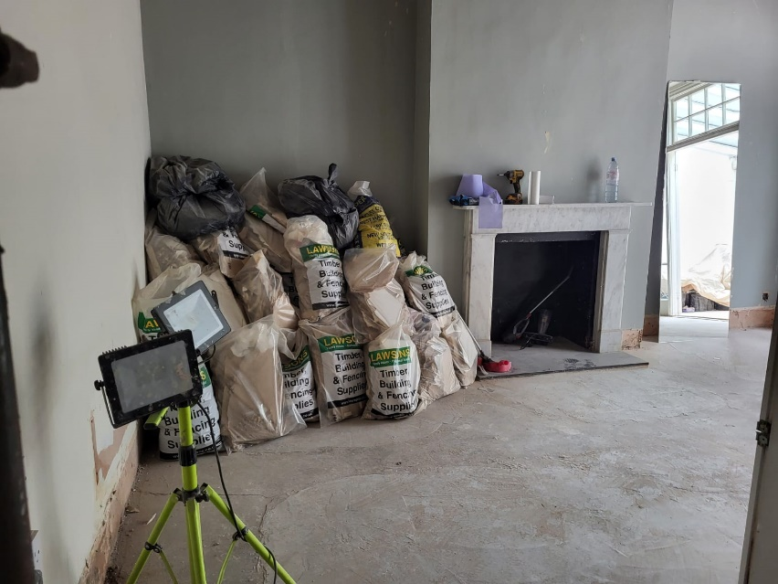
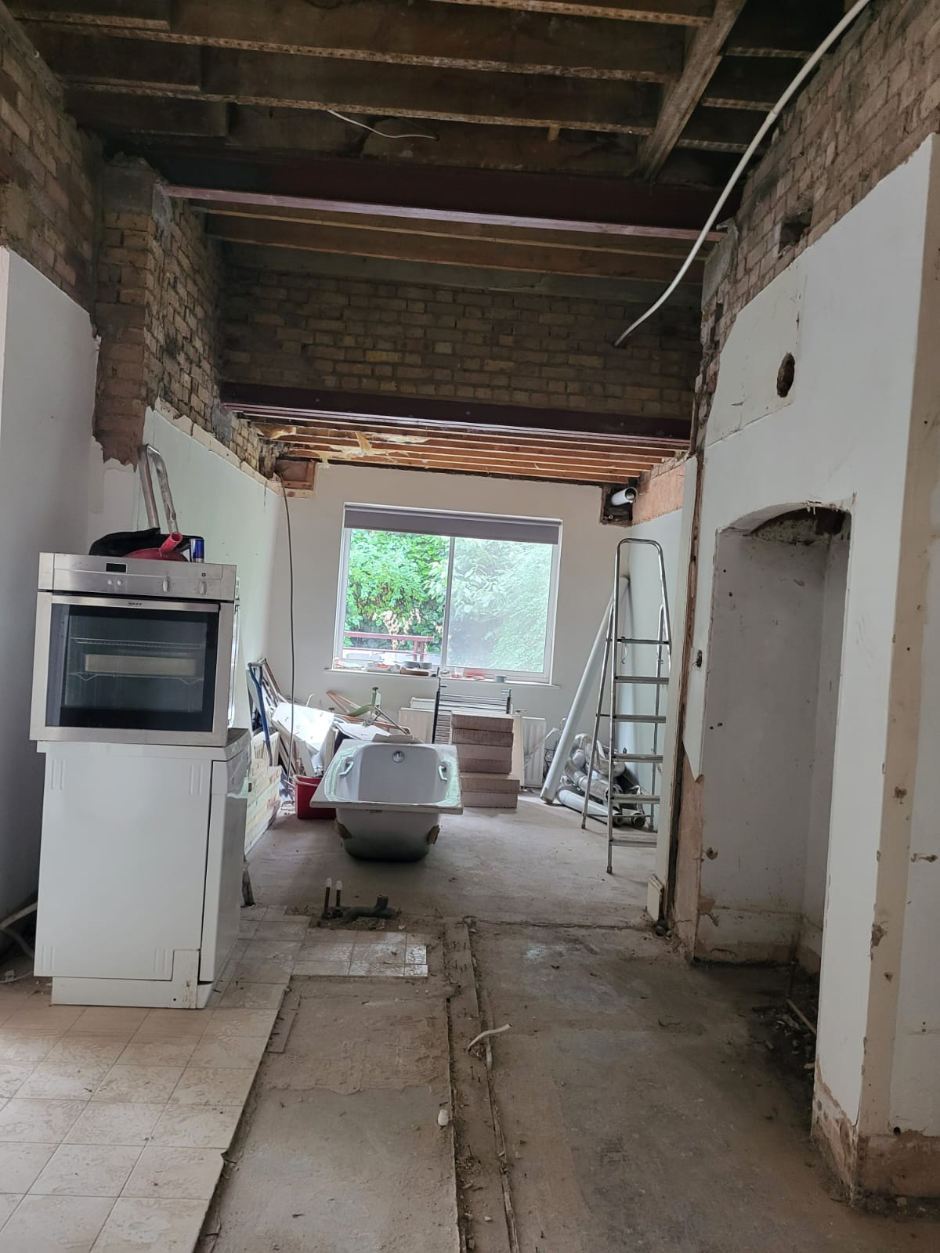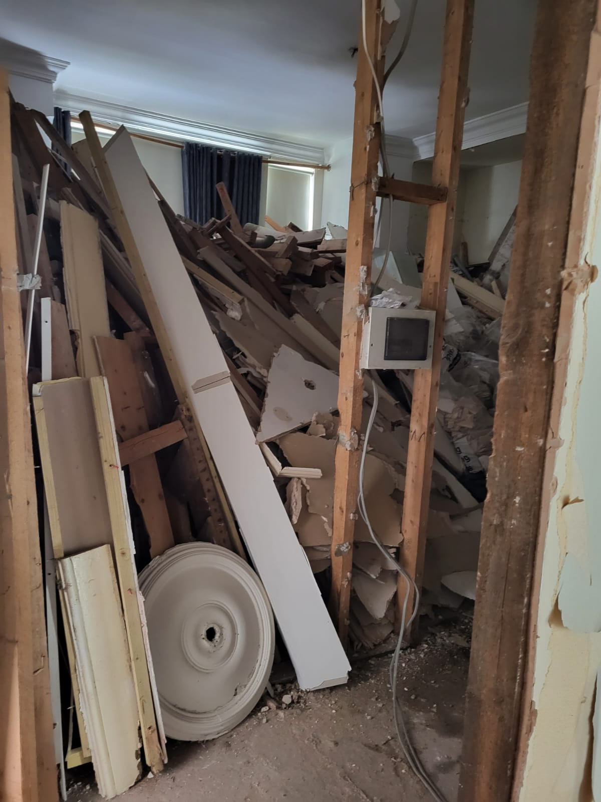

Photographs of stripping out of Flat 1 from 19 July 2021
By agreement with the other occupants of 41 Howitt Road, work was entirely outside and to the front of the main building prior to the lifting of Tier 4 Covid restrictions by central government after 19 July 2021. Following this date, stripping out of the flat began but stopped when

