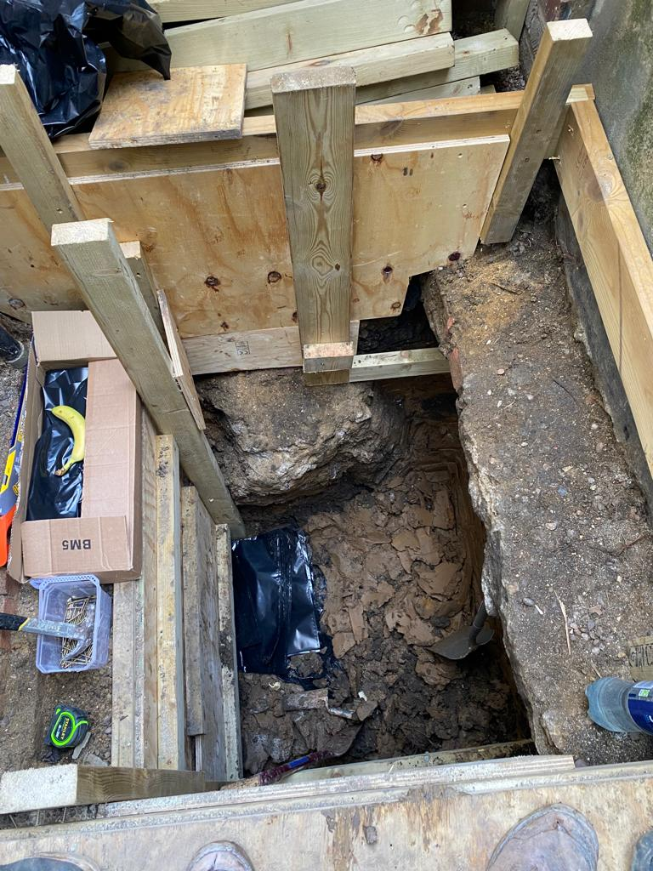
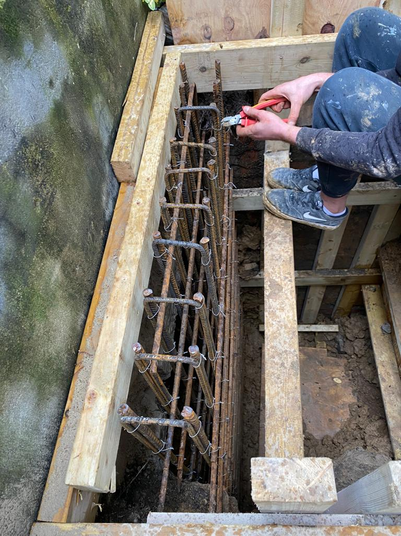
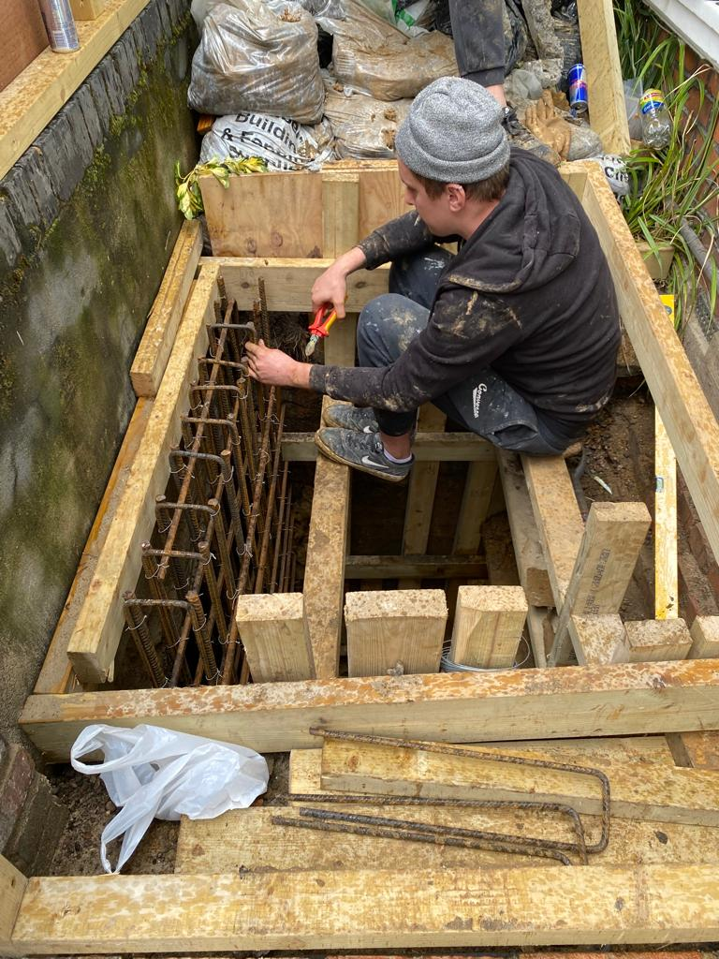

Photographs of work on site from 29 April 2021
By agreement with the other occupants of 41 Howitt Road, work was entirely outside and to the front of the main building prior to the lifting of Tier 4 Covid restrictions by central government after 19 July 2021. For this project, this meant hand excavation of the foundation of the front retaining wall by a single person (top left) followed by reinforcement for the underpin, which was completed to the satisfaction of London Building Control by Sept. 2021.

