Remy Kirk

Flat 8

20 Crediton Hill

West Hampstead

London, NW6 1HP.

Dear Sir/Madam)

**20 Crediton Hill, NW6 - The Property (2023/2258/P)**

As you may already know, a planning application has been submitted to build a three-storey dwelling (including basement) on the site of the single-storey outbuilding at 20 Crediton Hill, NW6. This has been allocated reference 2023/2258/P by the Council.

I write as the owner and therefore on behalf of Flat 8, 20 Crediton Hill. I am submitting an objection to the planning application and am opposing this damaging proposal.

The property lies within the Council’s West End Green Conservation Area, and is positioned directly adjacent to a designated area for local open space, which is used as a sports field by South Hampstead High School and Hampstead Cricket Club

Below are my key reasons for objecting to the planning application.

**Communal amenity space**

The Application has had no regard whatsoever to the following two points. It will represent a dominant and overbearing addition to the skyline and be highly visible from the back and front of the property and will overlook valuable communal amenity space and block out light of the garden. Plainly, the additional height will overlook the communal amenity space, as it will rise above the existing garages.

**Point 1.** Policy A1 of the Council’s Local Plan clearly states that the Council will seek to protect the quality of life of occupiers and neighbours, and will assess developments’ impact on neighbouring amenity, including privacy, outlook and enjoyment of amenity space. The Council’s Planning Guidance on Amenity (2021) states that “Developments should be designed to protect the privacy of occupiers of both existing and proposed dwellings; and Mitigation measures should be included to reduce overlooking”.

**Point 2.** The guidance also states that “Interior and exterior spaces that are overlooked lack privacy, which can affect the quality of life of occupants” and that “Developments should ensure that the proximity, size or cumulative effect of any structures avoids having an overbearing and/or dominating effect that is detrimental to the enjoyment of their properties by adjoining residential occupier”.

There is a small communal terrace next to a plain flank wall of the existing building which is available and used for quiet enjoyment and meals during the spring and summer months etc. The terrace currently acts as a secluded and peaceful private space.

There is currently an obscure-glass window close to the terrace but crucially the chairs and table cannot be viewed from the interior of the current building, so anyone using the terrace cannot view into or viewed from the current building.

However, the application proposes full length sliding doors immediately adjacent to, and looking out onto, the terrace, and also windows on the south elevation overlooking the terrace area.

This will make it uncomfortable for any user of the terrace other than the occupiers of the new building as they would be in full view of the building’s occupiers at both ground and first floor level. It will look and feel like the applicant’s de facto outdoor space This removal of a valuable communal amenity area is a clear breach of guidance and policy.

The above concerns are enhanced further with the proposed change of use from office space to residential dwelling. The property could be occupied not only during “office hours” but at all times of the day.

**Trees**

The whole rear of the garden is home to several exotic trees such as Chusan Palms and vines. These provide valuable shade and enhance the amenity space and the Conservation Area

The Applicant has submitted an arboricultural impact assessment, which disingenuously seeks to rely on a technicality to ignore the fact that a number of the Chusan Palm trees will need to be removed to allow for the development. The AIA states that these are technically herbs, so therefore does not undertake any meaningful assessment, though it does confirm that the Chusan Palm trees are healthy and have a life expectancy of over 40 years.

With respect, this seems to miss the point. The exotic planting is a valuable and intrinsic feature of the garden and Conservation Area – removing these trees would dramatically reduce both myself or any other residents’ enjoyment of the Property’s outdoor space, and this is in breach of the key messages in the Council’s Planning Guidance on trees, which include a requirement to retain and integrate existing significant trees during redevelopment.

The Council will note that (a) no replacement planting has been proposed, and (b) the applicant does not have the legal right to remove the trees or undertake any replanting (as this right rests with the freeholder), which are part of the communal garden. This latter point, coupled with the attempt to take over the terrace, would suggest that the applicant has no intention of being a good neighbour or considering other users of the garden area.

**Design and Heritage**

I understand that the council will have seen the heritage report prepared in conjunction with the objection made by the owners of 22 Crediton Hill and Flat 4 from 20 Crediton Hill. I endorse this report. The application will be entirely out of keeping with the Property and the Conservation Area and will appear as an incongruous and bulky addition. This is in contravention of Policies D1 and D2 of the Council’s Local Plan and sections 2 and 3 of the Council’s design guidance.

In terms of design generally, the Application is clearly an inappropriate addition to the local area and will represent a departure in design terms from the surrounding buildings (many of which are noted in the Conservation Area appraisal as positive contributors).

The structure will increase the mass of built development and will mean that the building (originally designed as an ancillary conservatory) will no longer be subservient to the Property but will be a new bulky and intrusive structure, adding significant height to the building. The materials proposed bear no resemblance to anything in the locality and cannot be said to be in keeping with the street or conservation area.

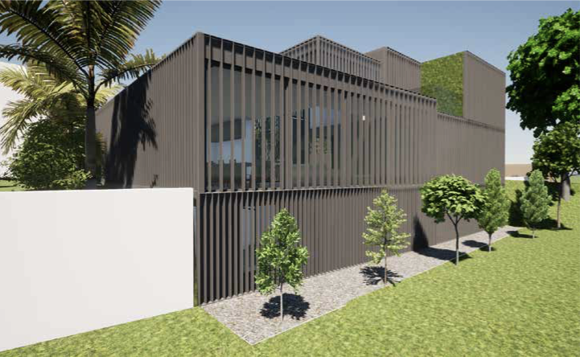

**Fire Appliance access**

At its narrowest point, the access to the rear of the Property is around 8ft. The entrance is itself is narrow and on a curve in the road. It is doubtful that any fire appliance would be able to access this easily in the event of an emergency.

In addition, parts of the proposed new building will be more than 45m away from the public highway. This means that there are very real safety issues associated with the Application.

**Refuse collection.**

I understand that the Design and Access Statement submitted with the Application notes that “Waste and recycling storage is strategically located (integrated into the northern façade)”. However, no further details are given, and this is not noted on the submitted drawings.

It is difficult to see how this would even be possible – the northern façade of the proposed building directly abuts the land owned by 22 Crediton Hill so there cannot be any waste facilities within that façade.

Assuming therefore that the new building will need to rely on communal waste facilities, the Council will note that the 9 existing flats at the Property should (under the Council’s residential offer) each be entitled to a 120L black bin. However, there are currently only five bins on site, and the area to store these bins is now full – there is no further space (even if all the residents at the Property were provided the bins to which they are entitled).

Any additional bins would either block the access road or the forecourt and would further detract from the Conservation Area, in contravention of paragraph 8.33 of the Council’s Planning Guidance on design.

**Construction**

This is clearly a constrained site, and it is difficult to see how any significant construction beyond that existing could take place safely and, in a policy-compliant manner.

Loss of on-site parking would be impossible should permission be granted. As a car owner access to the drive is required for loading. I do not wish to lose my right to park close to my property when need be.

Access to the garden from my property could potentially be obstructed and potentially dangerous especially for visiting childing and pet dogs. Construction needs to take place in a safe and secure manner.

**Conclusion**

For all these reasons, it is clear that the Application would be in clear breach of the Council’s policies and guidance, and permission should therefore be refused as it currently stands.

Kind regards,   
  
Remy Kirk

Flat 8, 20 Crediton Hill, NW6 1HP.