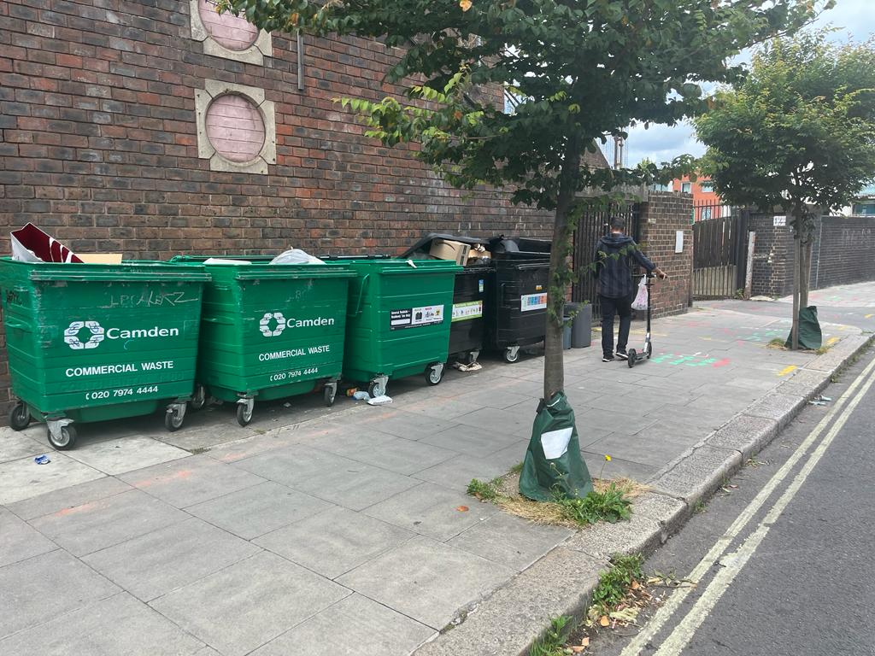 Loudoun Road
Raw of bins provided by the council for the residential building next to the shop / Wind blows rubbish all over the place and the rubbish end settling in front of our shot and if the shop front door is open the rubbish gets in affecting the appearance and the operation of the shop

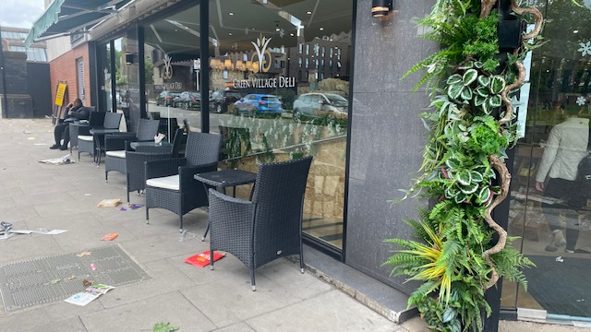

Before decking been installed
Large amount of rubbish parked in front of the shop
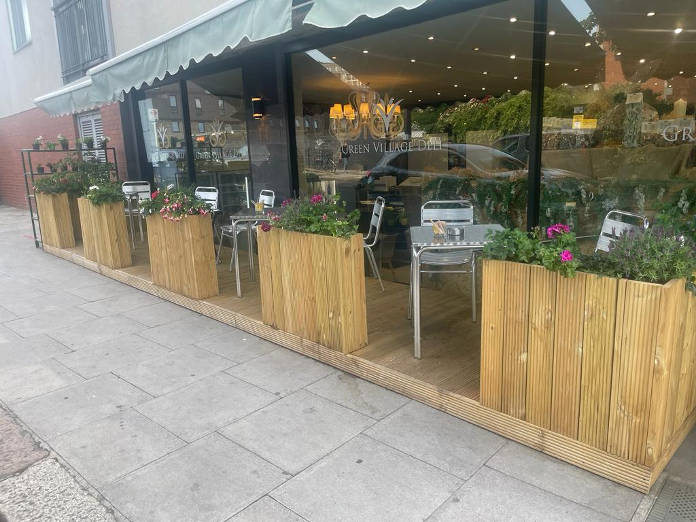
After building the decking

Actual picture of the decking proposal
Location: Loudoun Road front of the shop
1.5 m width
6 m length
20 cm heigh

