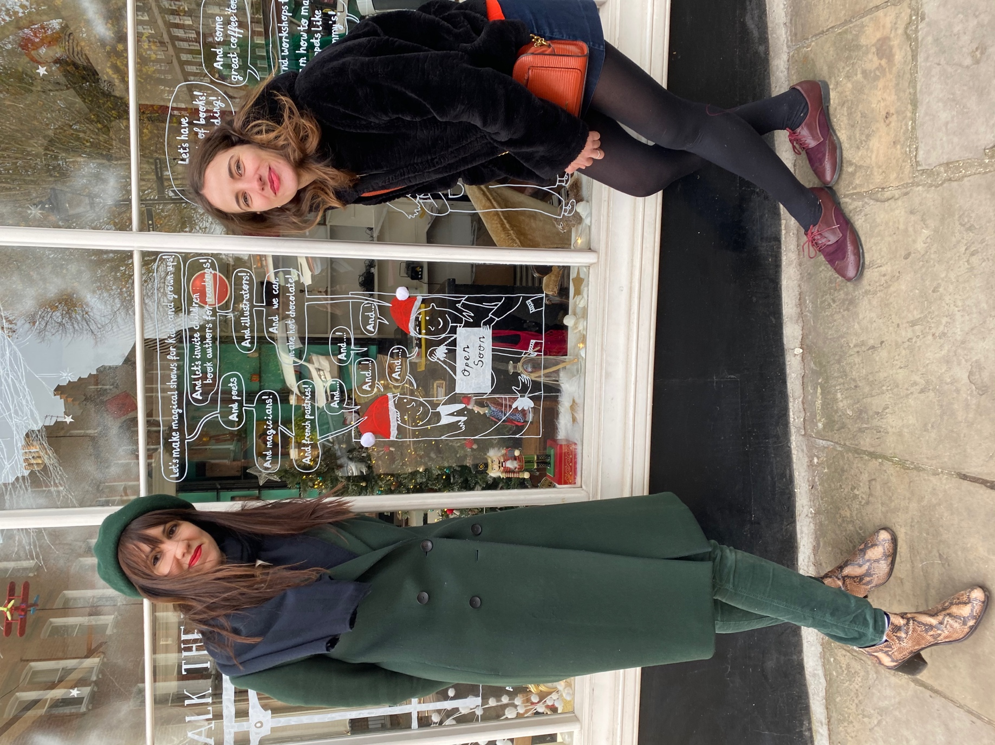

Photo 1

Photo 2

Photo 3

Photo 4

Photo 5

Photo 6

Photo 7