PAINT REMOVAL FROM BRICKWOR

METHOD STATEMENT

- CLIENT DETAILS
Stephen Stark

- SITE LOCATION ( include specific site)
3 Perrins Court, London, NW3 1QS

- BRIEF DESCRIPTION OF WORK TO BE CARRIED OUT (refer to job specification)
To remove paint from brickwork at front of property.

- TECHNIQUES /PROCEDURES TO BE USED (brief overview of practical aspects/tasks)
Use chemical – Tavec followed by steamcleaning with low pressure and high heat steam cleaning.

- SEQUENCE OF WORK ACTIVITIES
A – Ensure area is clear of any obstacles.
B – Apply Tavec with a roller or brush and leave to dwell for 24 hours according to manufacturers instructions.
C – Return the following day to remove chemical. Use hot water and low pressure so as not to damage the brickwork.
D – Ensure area is clear of debris before leaving.

- PLANT, MATERIALS & EQUIPMENT TO BE USED AT OPERATIVES DISCRETION(eg Generators, chemicals, scaffold)
14” rubber gauntlet First aid kit Eye wash Safety Boots Hi- viz PPE
Rollers & brush Tavec

Risk Assessment Form Number 43

Operation To remove paint from brickwork | Assessed By:  Andy Render | Date: 06/06/2023
Location 3 Perrins Court, London, NW3 1QS  Persons at Risk who will undertake work – James Warren (supervisor)  Gabriel De Freitas (operative) | Assessed By:  Andy Render | Review Date

 | Without Controls In Place |  |  |  |  |  | With Controls In Place
No | Activity/plant/ materials, etc | Hazard | Persons in Danger | Severity  1 - 5 | Likelihood  1 - 5 | Rate | Measures/Comment | Severity  1 - 5 | Likelihood  1 - 5 | Result
3 | Use of high pressure water jetting equipment  Below 2000 PSI  Water Jetting  Tavec | Hose splitting and jet of hot water.  Slips & trips  Injury or damage from water.  Irritation to skin & eyes | Operators  Persons in vicinity  Operators | 1  2  2 | 1  1  1 | Low  Low  Low | Check pipework before each job is undertaken to ensure no visible splits.  Be aware of trailing leads from steamcleaner. Work in progress signs either side of lead.  To ensure nobody enters area. Cease work if any person enters.  Staff to wear gloves when using and do not swallow or put in eys. | 1  1  1 | 1  1  1 | T  A  A
  1 | Use of high pressure water jetting equipment  Below 2000 PSI | Hose splitting and jet of hot water.  Slips & trips | Operators | 1 | 1 | Low | Check pipework before each job is undertaken to ensure no visible splits.  Be aware of trailing leads from jetwasher. Work in progress signs either side of lead. | 1 | 1 | T
  2 | Water jetting | Injury or damage from water. | Persons within vicinity | 2 | 1 | Low | To ensure nobody enters area. Cease work if any person enters. | 1 | 1 | A

 |  | Without Controls In Place |  |  |  |  |  |  |  |  |  | With Controls In Place
 |  | Activity/plant/ materials, etc | Hazard |  |  | Persons in Danger | Severity  1 - 5 | Likelihood  1 - 5 |  | Rate |  | Measures/Comment |  |  | Severity  1 - 5 | Likelihood  1 - 5 |  |  | Result

Operator’s Signature  Andy Render  Company Director | 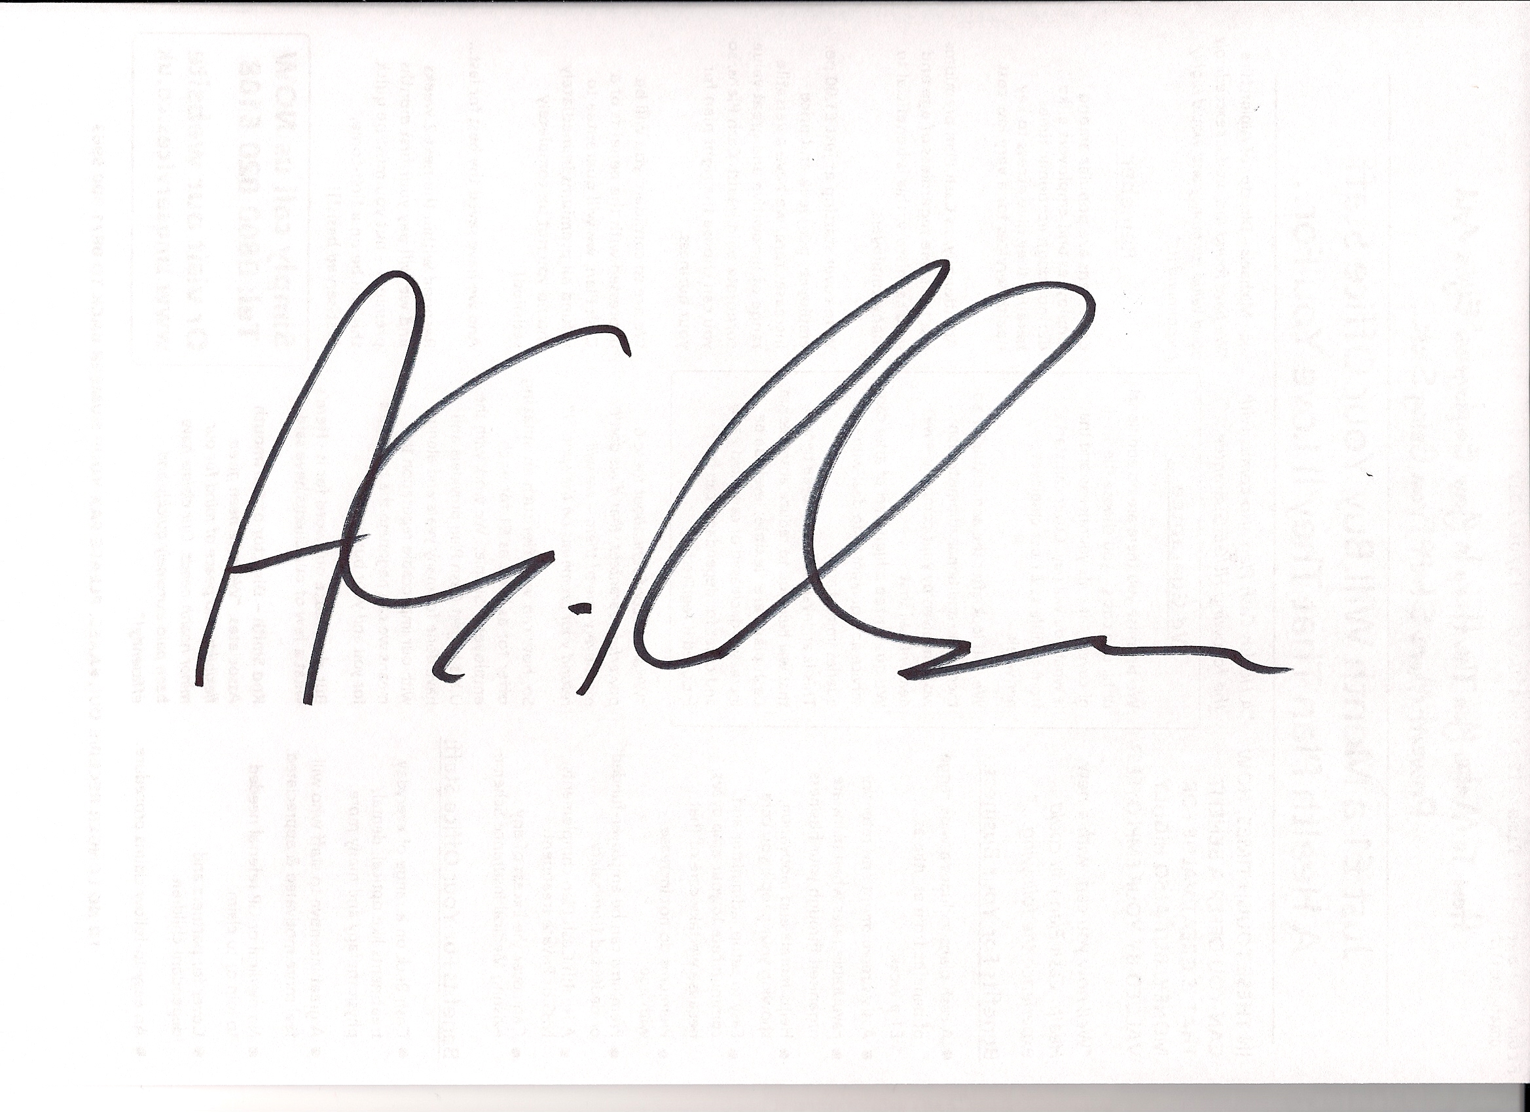 | Date:  6th June 2023

Key to severity - 1 = First Aid Only
2 = Injury causing time off work
3 = Disabling Injury
4 = Permanent disabling injury
5 = Fatal Injury

Key to likelihood - 1= Seldom
2 = Frequent
3 = Very Likely
4 = Near Certain
5 = Certain

Key to Result - T = Trivial Risk
A = Adequately controlled
N - Not adequately controlled
U = Unable to decide (decision deferred). Further information required.

