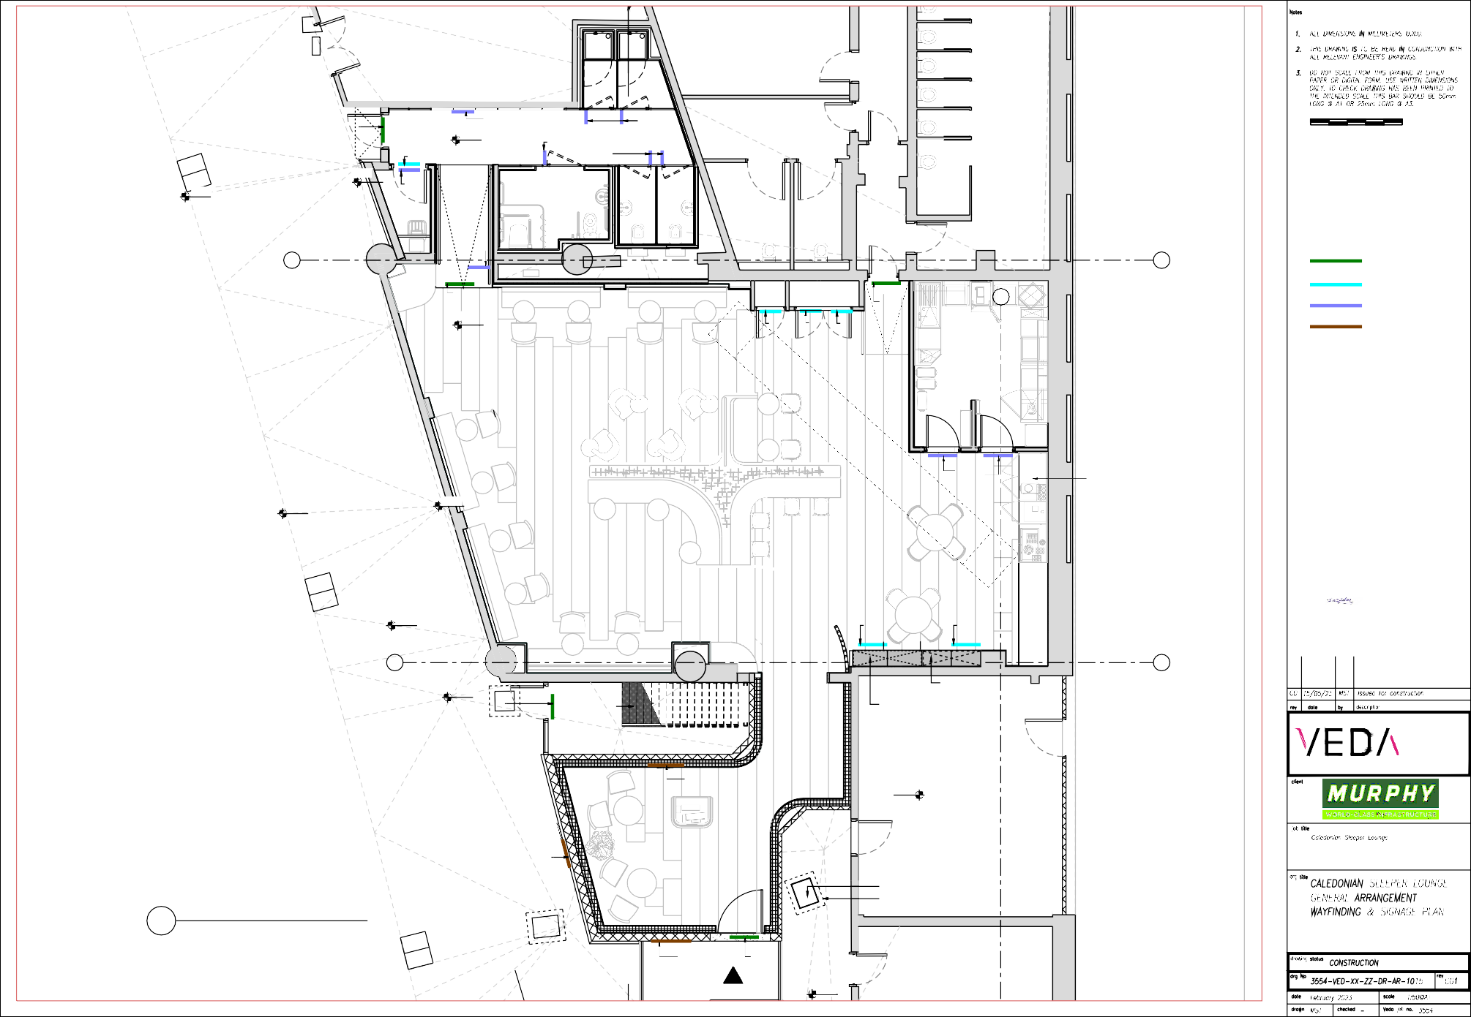

2

# Workshop

Store room

UNISEX SHOWER

UNISEX SHOWER

21180

New emergency exit

Exit sign1:12

21146

Do not enter

Cleaner's room sign

Cleaner's room

21205

Toilet sign

H2O

PRM toilet sign

PRM toilet & shower

Unisex toilet sign

Unisex shower sign

Unisex toilet Unisex toilet

# Ladies toilet

# Gents toilet

APPOINTED SIGNAGE SUPPLIER TO PROVIDE FULLY

CO-ORDINATED SHOP DRAWINGS FOR CLIENT APPROVAL,

INCLUDING ALL SIGNAGE

SIZE/TEXT/FIXING AND COLOURS IN LINE WITH NR SPECIFICATION

Toilet sign

# T

SIGNAGE TYPE

T STATUTORY

Exit sign

21345

Do not open

Hot water

Cylinder CPD

Do not open Do not open

Exit sign

# 150

INSTRUCTION WAY-FINDING

CLIENTS CSL LOGO

H2O

# Kitchen

CO2

H2O

Blanket

Kitchen

Do not enter

Food counter

21214

21171

# Lounge

21258

Do not open

Do not open

Digitally signed by Ian Spibey DN: cn=Ian Spibey, c=GB, o=J Murphy & Sons Ltd, email= [ianspibey@murphygroup.co.uk](mailto:ianspibey@murphygroup.co.uk) Date: 5/22/23 2:25:59 PM

# S S

21200

Exit sign

Emergency exit stairs

Electrical cabinet

Mechanical cabinet

1850mm wide x400mm deep. To match cupboard, all to Joinery specialist details

# Emergency exit core

LONDON OFFICE HIGHLAND HOUSE 165 THE BROADWAY LONDON SW19 1NE

T: +44 20 3214 5277

E: [info@veda.co.uk](mailto:info@veda.co.uk) [www.veda.co.uk](http://www.veda.co.uk/)

CSL Logo sign

21520

# Eversholt Street

CSL Logo sign

Reception

CO2

H2O

01 GA - WAYFINDING & SIGNAGE PLAN

Scale 1:50

Manhole

Critical dimension around manhole

CSL Logo sign Exit sign

Entrance

21279