4 Gainsborough Gardens NW3 1BJ

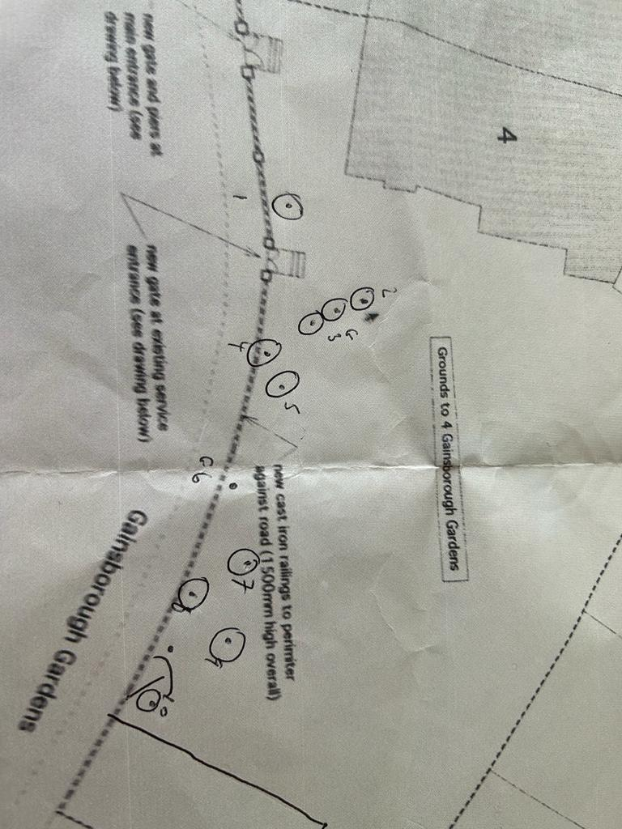

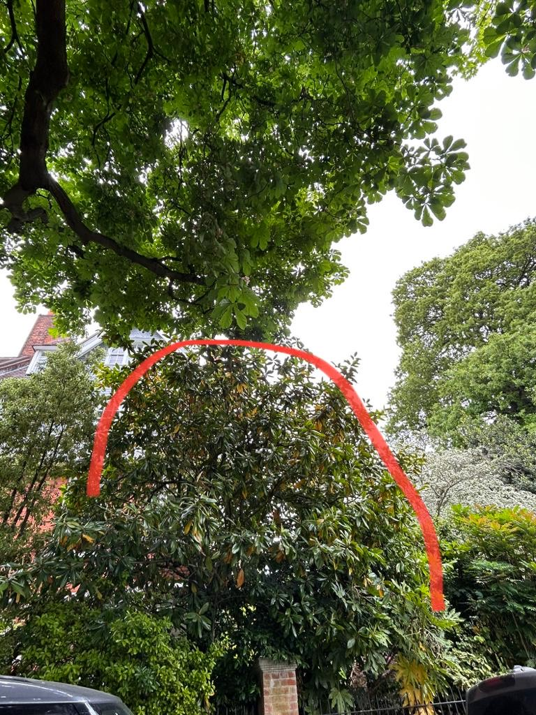

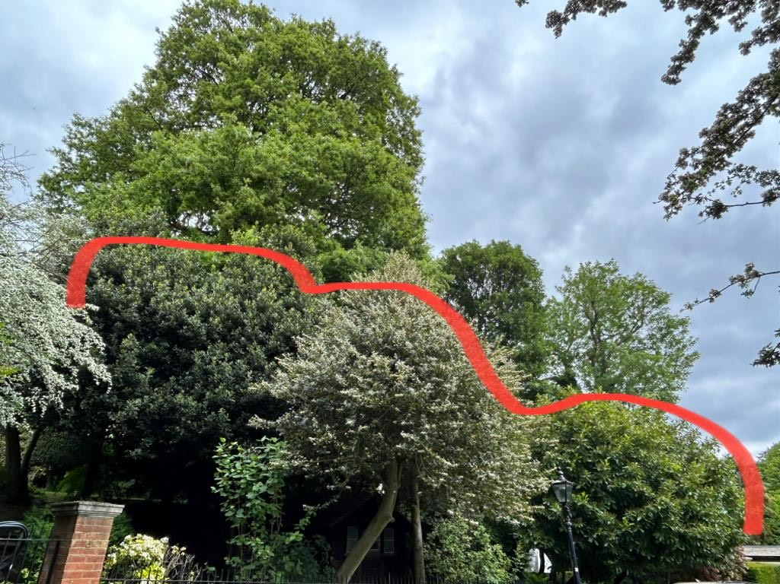

T1: Magnolia (8m): Crown reduce by 1m to keep at a size suitable for its location

T2: Holly (6m): Trim by 30cm to compact shape with hedge cutters to keep at a size suitable for its location

G3: Bay (6m): Trim by 30cm to compact shape with hedge cutters to keep at a size suitable for its location

T4: Holly (6m): Trim by 30cm to compact shape with hedge cutters to keep at a size suitable for its location

T5: Holly (6m): Trim by 30cm to compact shape with hedge cutters to keep at a size suitable for its location

G6: Laurel x 2 (6m): Reduce overhang by 2m to keep at a size suitable for its location

T7: Holly (6m): Trim by 30cm to compact shape with hedge cutters to keep at a size suitable for its location

G8: Holly x 2 (6m): Trim by 30cm to compact shape with hedge cutters to keep at a size suitable for its location

G9: Holly x 3 (6m): Trim by 30cm to compact shape with hedge cutters to keep at a size suitable for its location

T10: Holly (6m): Trim by 30cm to compact shape with hedge cutters to keep at a size suitable for its location