5 Redington Road NW3 7QX

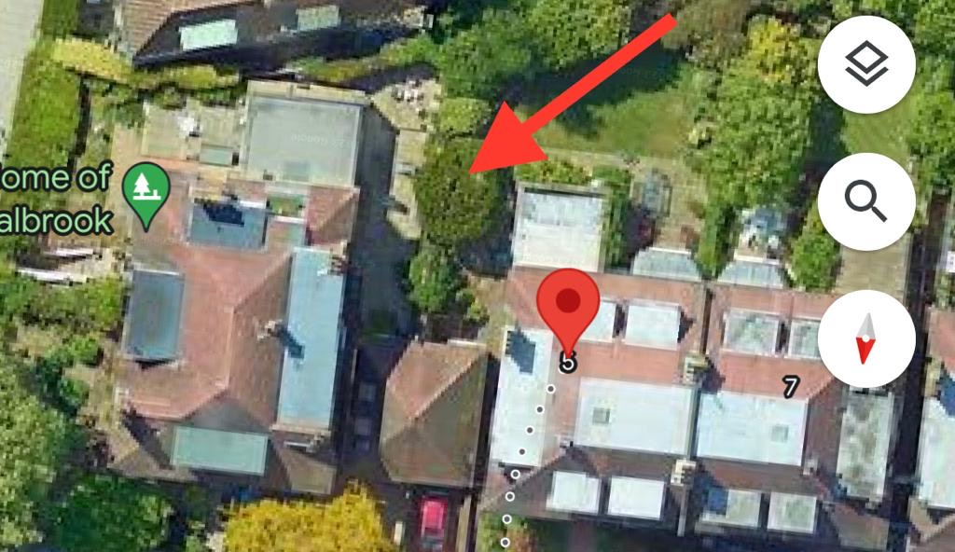

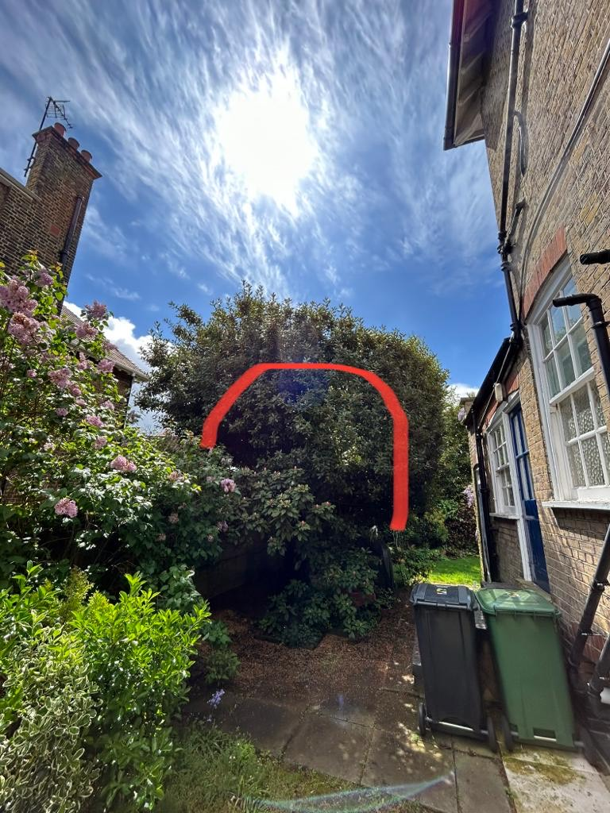

T1: Bay (9m): Pollard to 1m below previous points removing approximately 2m of growth of whole crown to keep tree at a size suitable for its location.