Background

29 Orde Hall Street is a residential property consisting of 3 flats over basement, ground and three upper floors.

The main building is of solid brickwork construction with a pitched tile covered roof of timber construction with suspended timber upper floors and solid basement floor. Windows to the Orde Hall and Great Ormond Street facing elevations are timber sliding sashes and to the rear are timber casement.

The attached photographs show the elevations of the main building as well as views of the roof.

Having completed a roof access risk assessment of the property, it has been proposed in accordance with the safety hierarchy that it will be necessary to eliminate the risk of falls from the main roof when access is required for maintenance of the roof structure by installing permanent edge protection. Due to the nature and layout of the roof structures, it will be necessary to install the edge protection into the perimeter parapet walls.

Relevant Policies & Guidance

National Planning Policy Framework (2021)
London Plan (2021)
LB Camden Local Plan (2017) D2 Heritage
Supplementary Guidance -Design (2021) & Bloomsbury Conservation Area Appraisal and Management Strategy (2011)
Camden Planning : Energy Efficiency and Adaptation

Pre- Application Advice

Several calls were made to Camden’s Planning Services using the ‘call back’ facility in order to establish whether Planning Permission was required in order to make the following alterations.

Proposals

The following outlines the proposed works requiring Planning Approval:

1. Installation of fall arrest edge protection to the main roof

Design

The edge protection will be a black powder coated steel handrail constructed from circular tube sections (approximately 40mm diameter) set at a height of 1100mm above the roof deck with a further additional intermediate guarding/rail set midpoint between the parapet coping and the top rail. The edge protection to the main roof is considered essential to allow the safe maintenance of the roof structure in order for health and safety legislation compliance. The design of the railings are simple and unobtrusive and as such to meet Building Regulation standards in respect of the height of the railings and the spacing of the additional rail. The railings will be powder coated black to enhance their appearance.

At the time of re-covering of the roof, the external elevations will be repaired and repainted as necessary.

The edge protection to the main roof is considered essential to allow the safe maintenance of the roof structure in order for health and safety legislation compliance.

Access Assessment

The proposals do not change the access into or within the property in any way.

Summary

The proposals described are not considered to have any detrimental impact to the character and architectural significance of the property and outbuilding or the surrounding properties and Conservation Area and will allow The Governing Body of Rugby School to provide a safe working environment at roof level.

Photos

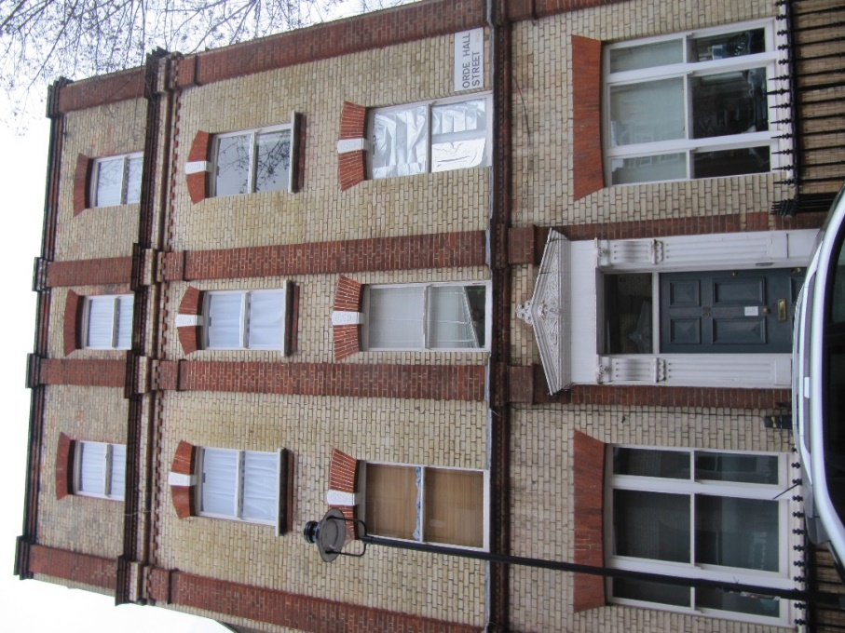
Orde Hall Street facing elevation
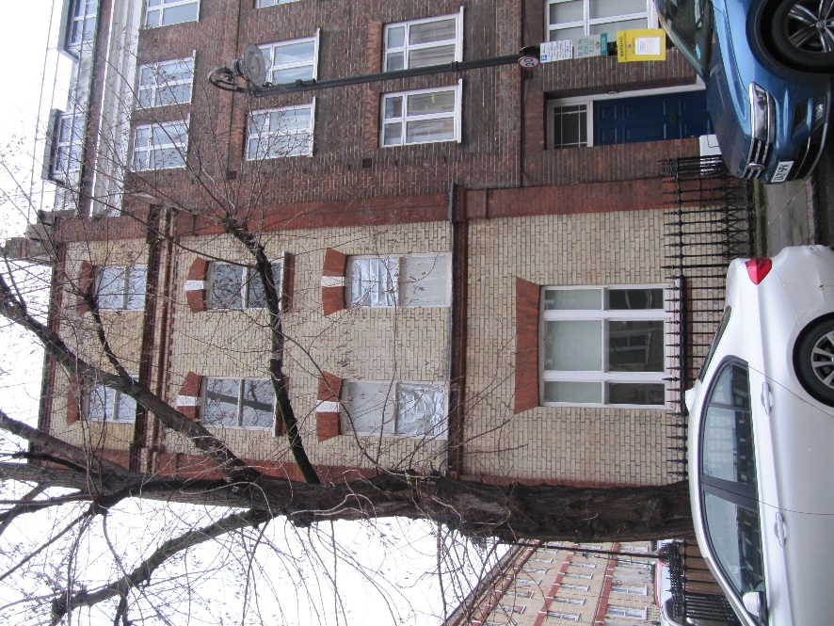
Great Ormond Street facing elevation

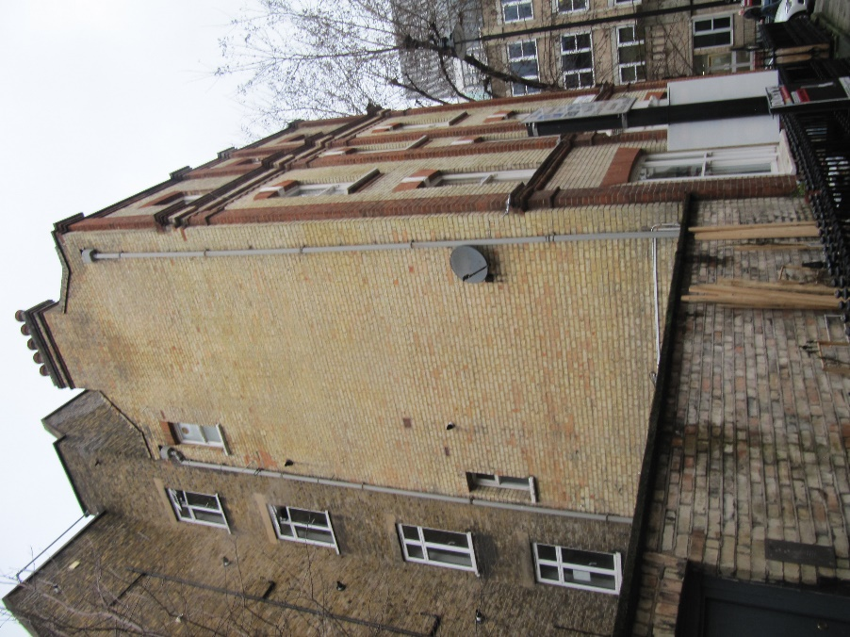
Rear elevation
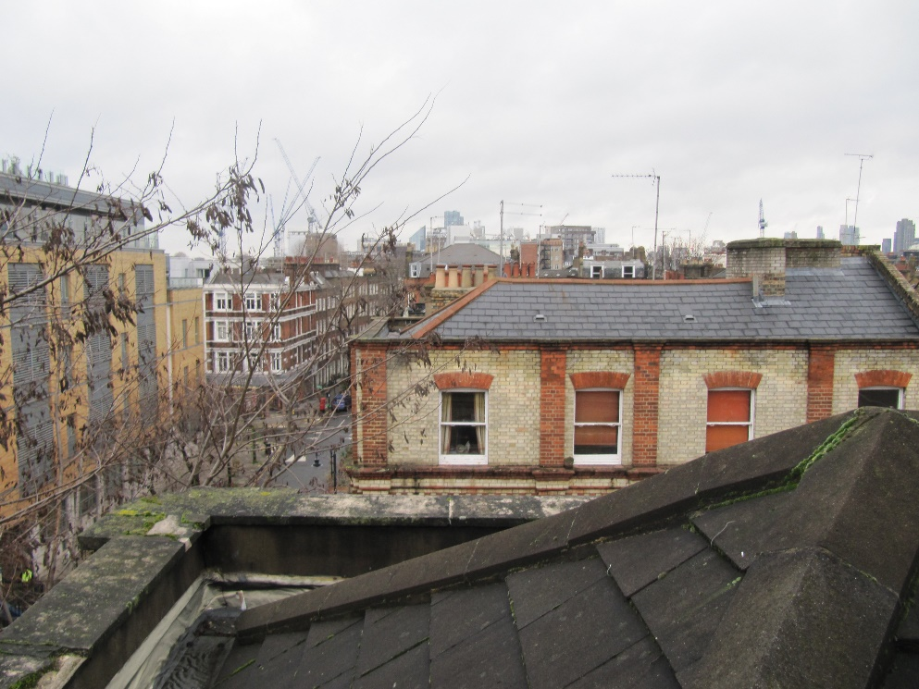
Roof

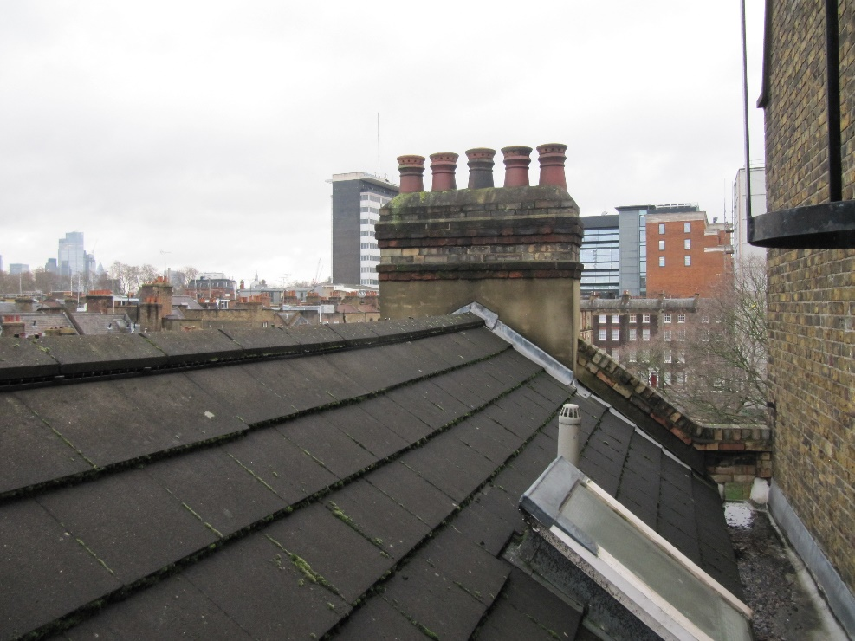
Roof

