138 Abbey Road NW6 4SR

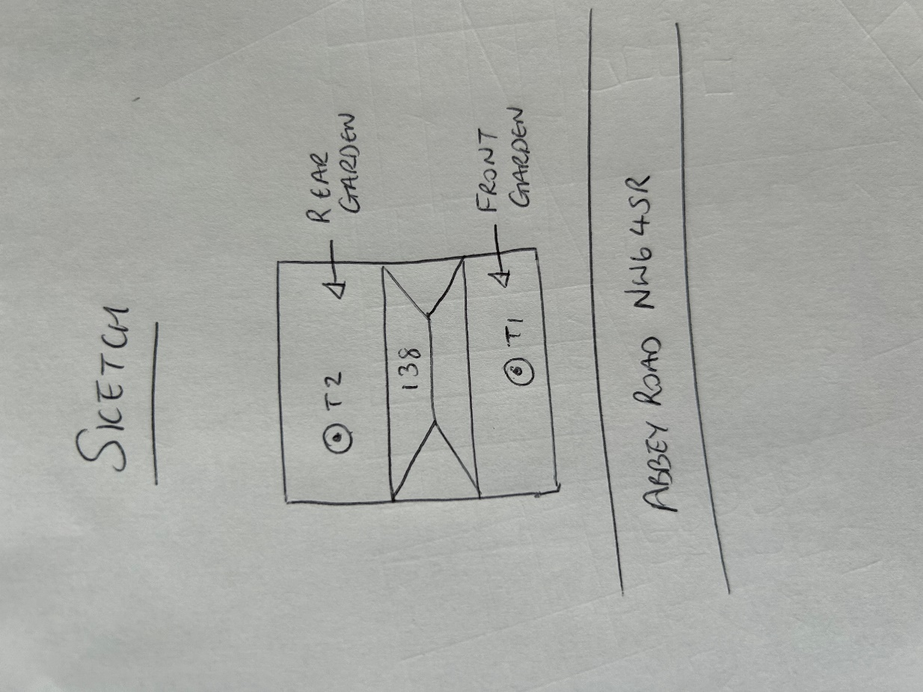

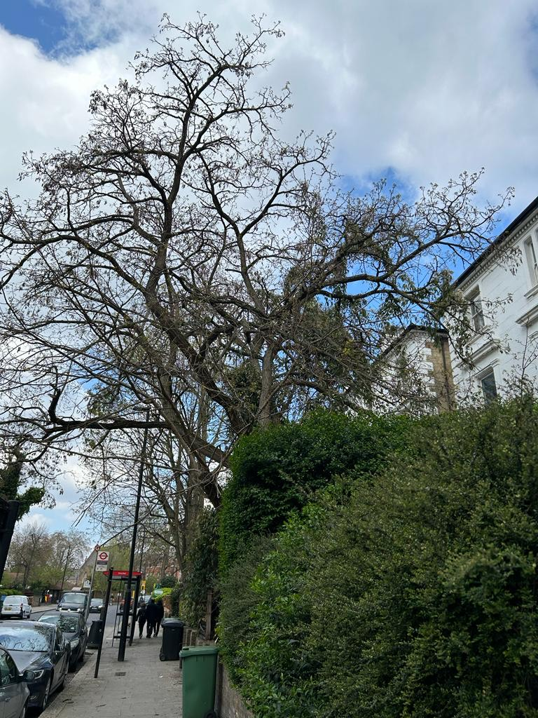 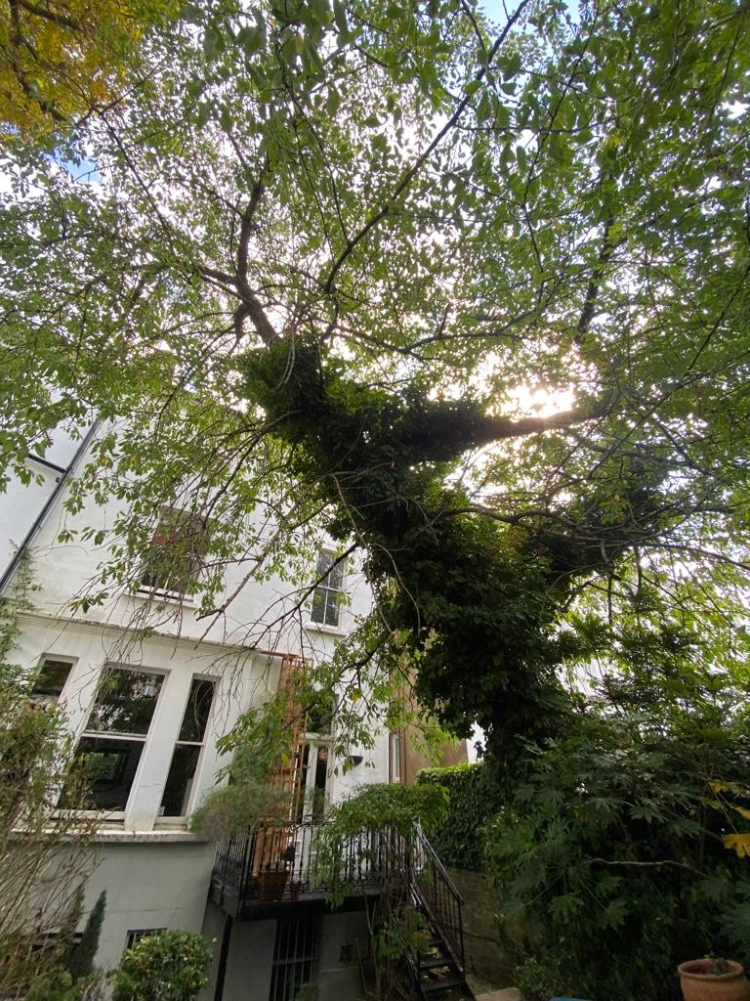

T1: Robinia (12m): Crown reduce by 2m to reduce the risk of failure in overextending branches and to keep tree at a size suitable for its location

T2: Cherry (15m): Crown reduce by 2m to keep tree at a size suitable for its location