**Background**

18 Great Ormond Street (also known as 70 Lambs Conduit Street) is a residential property consisting of 3 flats over first second and third floors above a basement and ground floor commercial premises.

The property is of solid brickwork construction with a pitched artificial slate covered roof of timber construction. There is a small section of flat roof to the rear which cannot be seen from adjacent properties or at street level due to its position behind the adjacent property Spens House flank wall which extends beyond that of 18 Great Ormond Street. Windows to the front street facing elevations are a mixture of timber sliding sashes, timber casement and to the curved corner bay, steel crittall style. To the rear the windows are timber sliding sashes other than the third floor where the bathroom window is a timber casement (non-original) window.

Our Client (The Governing Body of Rugby School) is in the process of making Energy Efficiency adaptations improving the thermal efficiency of their properties by taking natural “passive” measures to reduce energy usage. This approach follows the recommendations in Camden’s Planning Guidance “Energy Efficiency and Adaptation” and forms part of an ongoing cycle of Planned Preventative Maintenance Works over the School’s Estate, carried out on an annual basis at which point the properties are repaired and redecorated. Externally energy efficiency measures including insulating roofs and replacing windows will be completed as part of these works. It is understood that as window replacement will either be replacement of the individual sashes and not the entire box frames or if required for replacement in their entirety will essentially be on a like for like replacement basis in matching materials and arrangement, then Planning Permission will not be required and for this reason has not been referred to within the application other than the individual third floor bathroom window that is referred to above and that will be replaced with a sliding sash window to match those adjacent and to reinstate it to what would have originally been found in this location.

It is also our understanding that Planning Permission would not be required for the installation of mechanical extract fan grilles sited to the rear elevation. Where possible mechanical ventilation with heat recovery will be installed as again recommended in Camden’s Guidance Notes referred to above.

The attached photographs show the elevations of the main building as well as the area of flat roof adjacent to Spens House.

**Relevant Policies & Guidance**

National Planning Policy Framework (2021)

London Plan (2021)

LB Camden Local Plan (2017) D2 Heritage

Supplementary Guidance -Design (2021) & Bloomsbury Conservation Area Appraisal and Management Strategy (2011)

Camden Planning : Energy Efficiency and Adaptation

**Pre- Application Advice**

Several calls were made to Camden’s Planning Services using the ‘call back’ facility in order to establish whether Planning Permission was required in order to make the following alterations.

**Proposals**

The following outlines the proposed works requiring Planning Approval:

1. Raising the flat roof level over the third floor bathroom (area approx. 1.5 x 4m) by approximately 200mm as a result of the addition of insulation above the existing roof coverings.

2. Replacement third floor east elevation window with original matching double glazed sash (currently casement)

3. Installation of fall arrest edge protection to the roof.

**Design**

The area of flat roof as noted above is in a concealed area of the roof that is not visible either from adjacent properties or ground level. As demonstrated in the attached drawings by raising the level of the roof by approximately 200mm the new level can be accommodated without altering the height of the external parapet walls or altering the pitch roof adjacent. To the leading edge where there is no parapet and the roof coverings discharge into the horizontal gutter affixed to a timber fascia board, the vertical face of this roof edge will be increased to cover the insulation. The changes to the roof level are insignificant and do not alter the shape or form of the main pitched section of the roof and are not visible from any adjacent or below vantage points.

Having completed a roof access risk assessment of the property it has been proposed in accordance with the safety hierarchy that it will be necessary to eliminate the risk of falls from the main roof when access is required for maintenance of the roof structure by installing permanent edge protection. Due to the nature and layout of the roof structures, it will be necessary to install the edge protection into the perimeter parapet walls to the street facing elevations. The edge protection will be a black powder coated steel handrail constructed from circular tube sections (approximately 40mm diameter) set at a height of 1100mm above the roof deck with a further additional intermediate guarding/rail set midpoint between the parapet coping and the top rail. The edge protection to the main roof is considered essential to allow the safe maintenance of the roof structure in order for health and safety legislation compliance. The design of the railings are simple and unobtrusive and as such to meet Building Regulation standards in respect of the height of the railings and the spacing of the additional rail.

An additional roof access hatch of zinc covering will be set into the front street facing roof slope so safer access can be provided to the perimeter box gutter.

At the time of re-covering of the roof, the external elevations will be repaired and repainted as necessary.

**Access Assessment**

The proposals do not change the access into or within the property in any way. The proposed works are of repair, safety and energy efficiency improvement only.

**Summary**

The proposals described are not considered to have any detrimental impact to the character and architectural significance of the property or the surrounding properties and Conservation Area and will allow The Governing Body of Rugby School to improve the energy efficiency of this property as well as provide a safe working environment at roof level for future maintenance of the roof structure. The window replacement to its original form is seen to have a positive visual impact.

Photos

Flat roof over 3rd floor bathroom and adjacent Spens House to rear.

Pitched roof facing Great Ormond Street

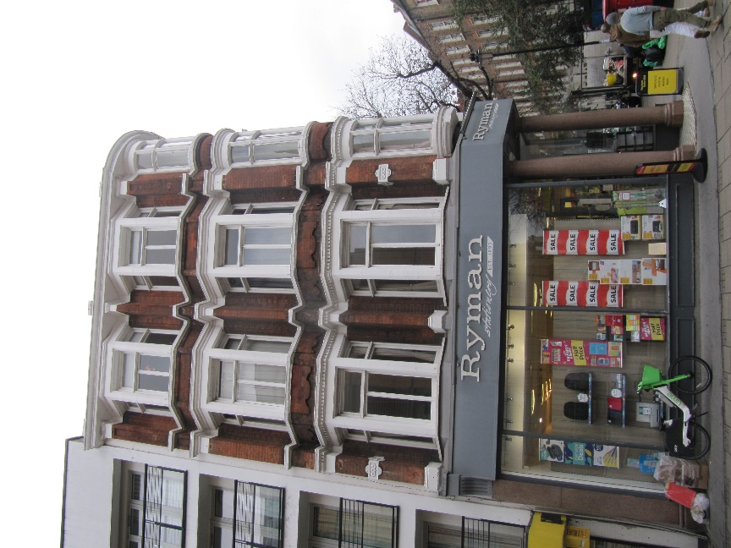

Lambs Conduit Street facing elevation

Great Ormond Street facing elevation

Great Ormond Street facing elevation

Rear elevation (Spens House on right side, 20 Great Ormond Street on left side of property)