**Background**

3/5 Rugby Street is a residential property consisting of 5 flats over basement, ground and three upper floors.

The main building is of solid brickwork construction with an inverted pitched slate covered roof of timber construction with suspended timber upper floors and solid basement floor. Windows to the front elevation are timber sliding sashes and to the rear are similarly timber sliding sashes to basement and ground level with crittall style steel single glazed windows to the upper floors including the communal areas.

To the rear of the property is an outbuilding currently let as an Artist’s Studio which is single storey and consists of solid brick external walls with an asphalt covered concrete flat roof with a glazed lantern above the roof deck. Access to the studio is through the communal parts of the flats only from Rugby Street.

Our Client (The Governing Body of Rugby School) is in the process of making Energy Efficiency adaptations improving the thermal efficiency of their properties by taking natural “passive” measures to reduce energy usage. This approach follows the recommendations in Camden’s Planning Guidance “Energy Efficiency and Adaptation” as part of an ongoing cycle of Planned Preventative Maintenance Works over the Estate carried out on an annual basis at which point the properties are repaired and redecorated. Externally energy efficiency measures including insulating roofs and replacing windows will be completed as part of these works. It is understood that as window replacement will either be replacement of the individual sashes and not the entire box frames or if required for replacement in their entirety will essentially be on a like for like replacement basis in matching materials and arrangement, then Planning Permission will not be required and for this reason has not been referred to within the application.

It is also our understanding that Planning Permission would not be required for the installation of mechanical extract fan grilles sited to the rear elevation. Where possible mechanical ventilation with heat recovery will be installed as again recommended in Camden’s Guidance Notes referred to above.

The attached photographs show the elevations of the main building as well as views of the artist’s studio to the rear.

**Relevant Policies & Guidance**

National Planning Policy Framework (2021)

London Plan (2021)

LB Camden Local Plan (2017) D2 Heritage

Supplementary Guidance -Design (2021) & Bloomsbury Conservation Area Appraisal and Management Strategy (2011)

Camden Planning : Energy Efficiency and Adaptation

**Pre- Application Advice**

Several calls were made to Camden’s Planning Services using the ‘call back’ facility in order to establish whether Planning Permission was required in order to make the following alterations.

**Proposals**

The following outlines the proposed works requiring Planning Approval:

1. Raising the flat level roof over the Artist’s Studio as a result of the addition of insulation above the existing roof coverings.

2. Replacement of dilapidated glazed lantern with a powder coated aluminium framed double glazed lantern.

3. Installation of fall arrest edge protection to the main roof

**Design**

On three of the four sides of the Artist’s Studio are raised parapet brick walls. As demonstrated in the attached drawings by raising the level of the roof by approximately 200mm the new level can be accommodated without altering the height of the external parapet walls on these three elevations.

To the front entrance elevation of the Studio where there is no parapet and the roof coverings discharge into the horizontal gutter affixed to a timber fascia board, the vertical face of this roof edge will be increased to cover the insulation.

The glazed lantern will replace the dilapidated existing lantern with the arrangement of glazing bars and opening lights following the same arrangement as to the existing.

Having completed a roof access risk assessment of the property, it has been proposed in accordance with the safety hierarchy that it will be necessary to eliminate the risk of falls from the main roof when access is required for maintenance of the roof structure by installing permanent edge protection. Due to the nature and layout of the roof structures, it will be necessary to install the edge protection into the perimeter parapet walls. The edge protection will be a black powder coated steel handrail constructed from circular tube sections (approximately 40mm diameter) set at a height of 1100mm above the roof deck with a further additional intermediate guarding/rail set midpoint between the parapet coping and the top rail. The edge protection to the main roof is considered essential to allow the safe maintenance of the roof structure in order for health and safety legislation compliance. The design of the railings are simple and unobtrusive and as such to meet Building Regulation standards in respect of the height of the railings and the spacing of the additional rail. The railings will be powder coated black to enhance their appearance.

The changes to the artist studio are considered subtle and follow the form and lines of the existing roof arrangements enhancing the overall appearance of this currently dilapidated outbuilding. At the time of re-covering of the roof, the external elevations will be repaired and repainted as necessary.

The edge protection to the main roof is considered essential to allow the safe maintenance of the roof structure in order for health and safety legislation compliance.

**Access Assessment**

The proposals do not change the access into or within the property in any way. The proposed works are of repair, safety and energy efficiency improvement only.

**Summary**

The proposals described are not considered to have any detrimental impact to the character and architectural significance of the property and outbuilding or the surrounding properties and Conservation Area and will allow The Governing Body of Rugby School to improve the energy efficiency of this property as well as provide a safe working environment at roof level. The works proposed to the Artist Studio will revive and enhance the visual appearance of this currently dilapidated building.

Photos

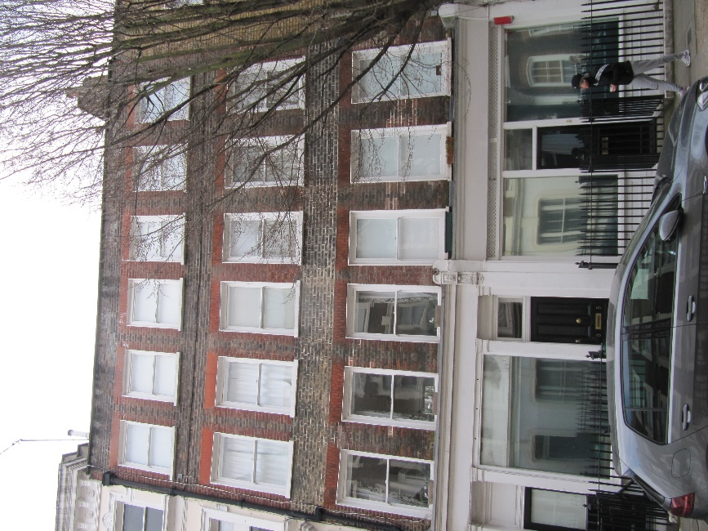

Front

Main roof

Rear

Rear

Rear

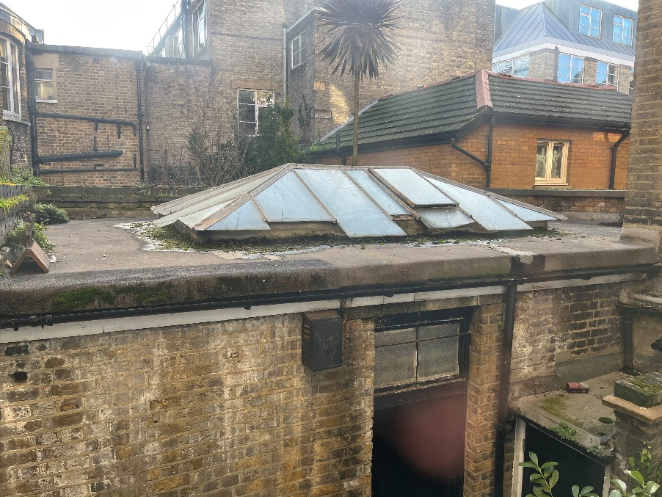

Artist Studio

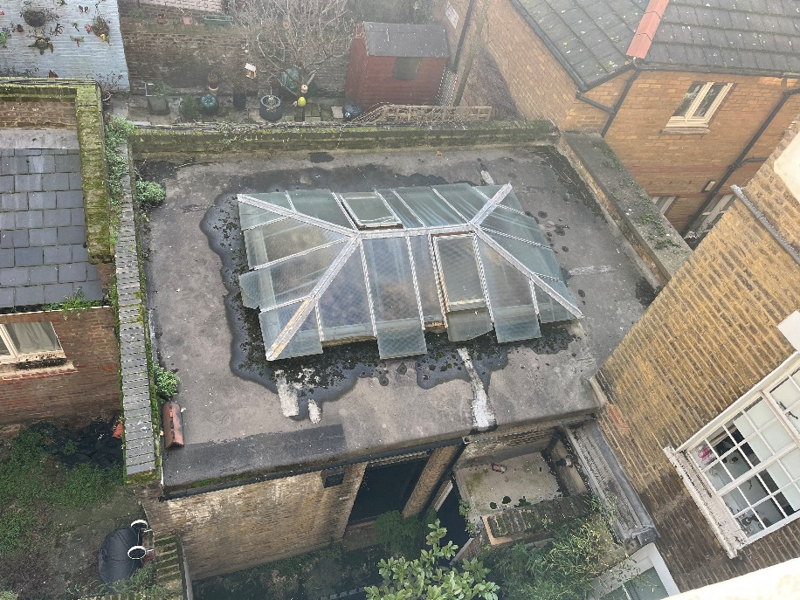

Artist Studio roof