**Response to application 2023-0358P**

23 Mar 2023

The house was built in the 1840s within Camden Town estate as a single family house. It was approved for 3- floor residential flats in 1988.

An application for ground floor extension and conversion of the ground floor into a 3-bedroomed flat was approved in December 2021.

The new plans are for further additional living / shed building within the garden.

Conservation Area Statement

“R22 Rear extensions will not be acceptable where they ... would encroach significantly on the rear garden space”.

The extension of 2021 built out to the limit of the building line of neighbouring houses, almost doubling the floor space of the flat and widening the existing extension, which itself was an extension of the original building:

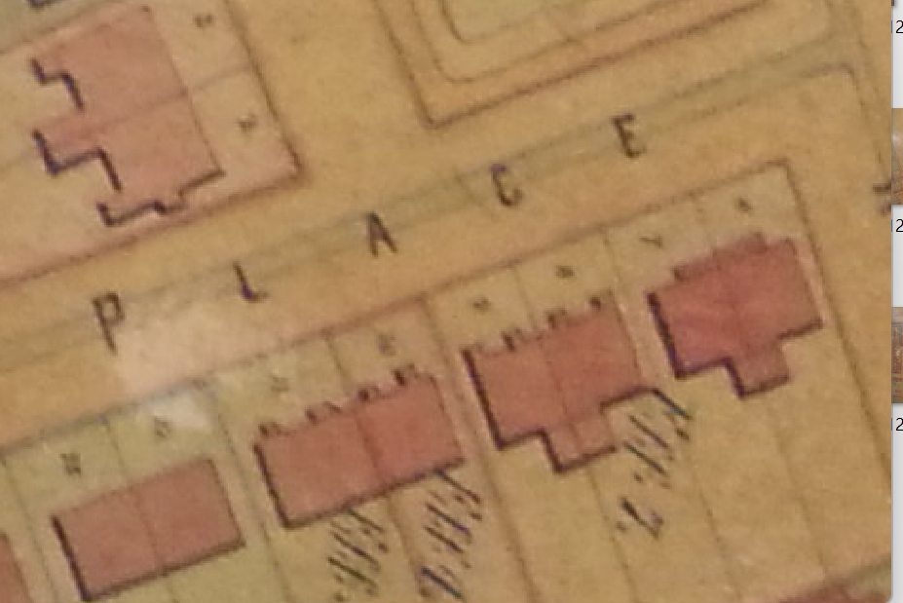

Camden Town Estate map 1875

The proposal shows a ‘patio’ has been built around the extension which was not agreed in the 2021 application, with further loss of ground. The total area *already* ‘taken’ from the original back garden is around 45%:

Given the existing impermeable area now, the proposed buildings would remove *approximately 30% more* of the permeable grassed area.

Camden Planning Guidance says

4.23 Large garden buildings ... if used for purposes other than storage or gardening, may  
intensify the use of garden spaces.

*The proposal will ‘intensify the use of garden spaces’ for habitation*

4.24 Rear gardens should

• ensure the development has a minimal visual impact on the host garden

*The proposal will take 30% of the grassed space and is formed across the whole back wall*

• ensure building heights will retain visibility over garden walls and fences

*The proposal is higher than the back and side garden walls*

The application requires permission if a proposal

* will include a veranda, balcony or raised platform.

*The proposal includes a raised platform*