18 Lyndhurst Gardens NW3 5NR

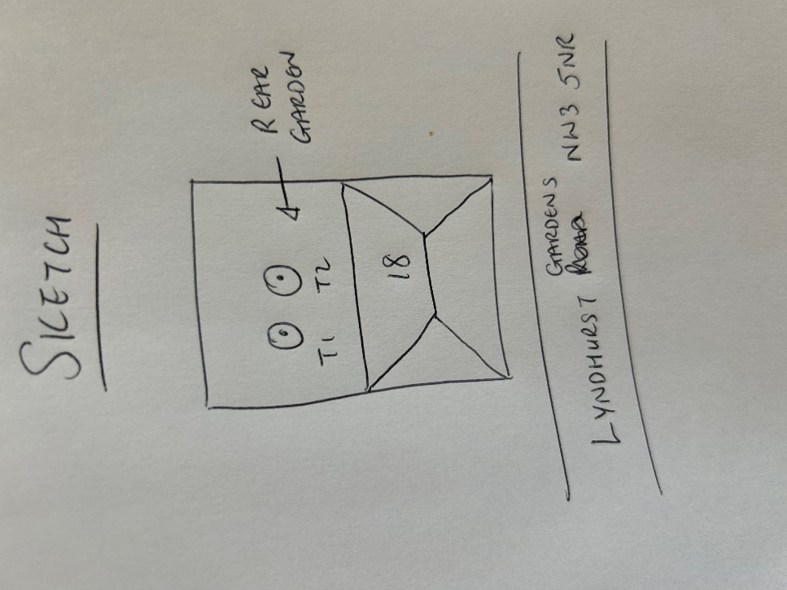

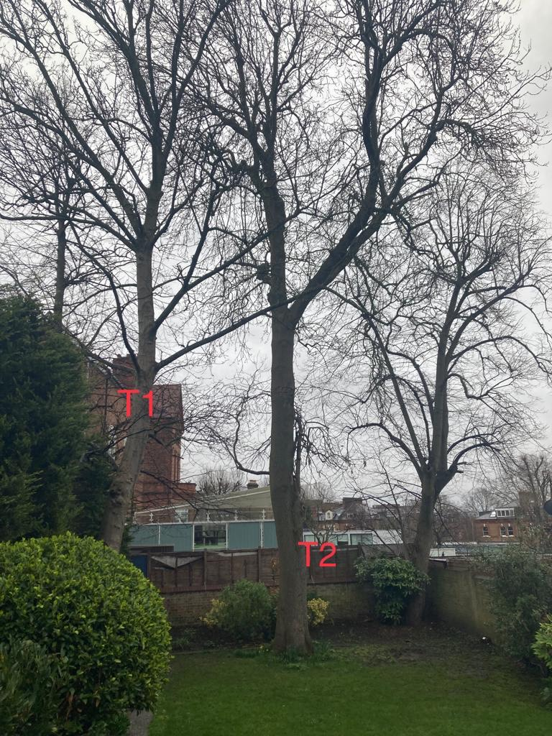

T1: Sycamore (14m): Crown reduce by 1.5m and remove major dead wood to keep tree at a size suitable for its location and as part of regular maintenance

T2: Ash (18m): Crown reduce by 2m and remove major dead wood to keep tree at a size suitable for its location and as part of regular maintenance