

The Society examines all Planning Applications and Notices of Intent for tree work relating to Hampstead and Hampstead Heath Fringes, and assesses them for their impact on the Conservation Areas, the local environment and building stability.

To London Borough of Camden, Tree Preservation Team

Planning Ref: 2022/5583/P
Address: 14 Greenaway Gardens, London NW3 7DH
Case Officer: Geri Gohin
Date: 28th March 2023

I am writing these comments on 2022/5583/P particularly mindful that the oak tree T29, stated by Landscape Trees to be ‘over mature’ and described as ‘a standout high quality specimen’ is registered with the Ancient Tree Inventory (ATI) no. 241111. This was submitted by Dr Liz Wright who leads the veteran tree survey of Hampstead town for the Heath & Hampstead Society. At a height of 1.5 metres this oak tree’s trunk has a girth of 4.524 metres (based on Landmark Tree’s own measurements of 25th September 2020), and it has many signs of veteranisation, not least the central rot noted by Landmark Trees, sufficient to deem it a veteran. It is also marked as being a significant tree on the 1866 OS map.

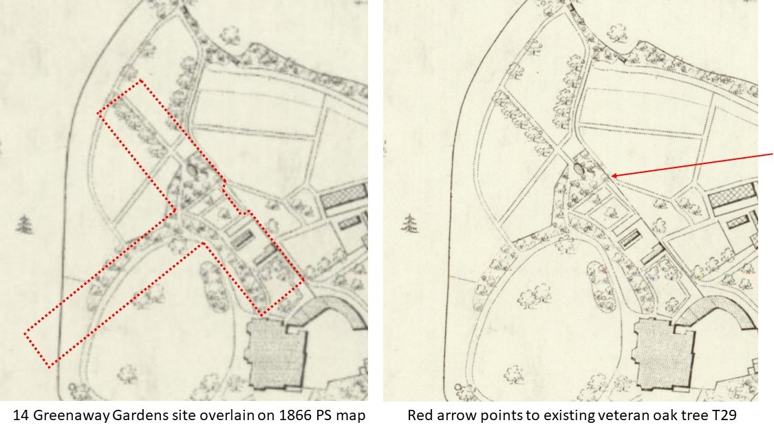

Since its current status is pending validation as a veteran (we have noticed that validations of the veteran trees submitted to the ATI by us have been held up by the pandemic) it does not appear on the ATI map yet, so a screen capture of its front page to verify the current situation is provided below. It is quite likely that Landmark Trees used this map to check the tree’s status and thus would be unaware of this.
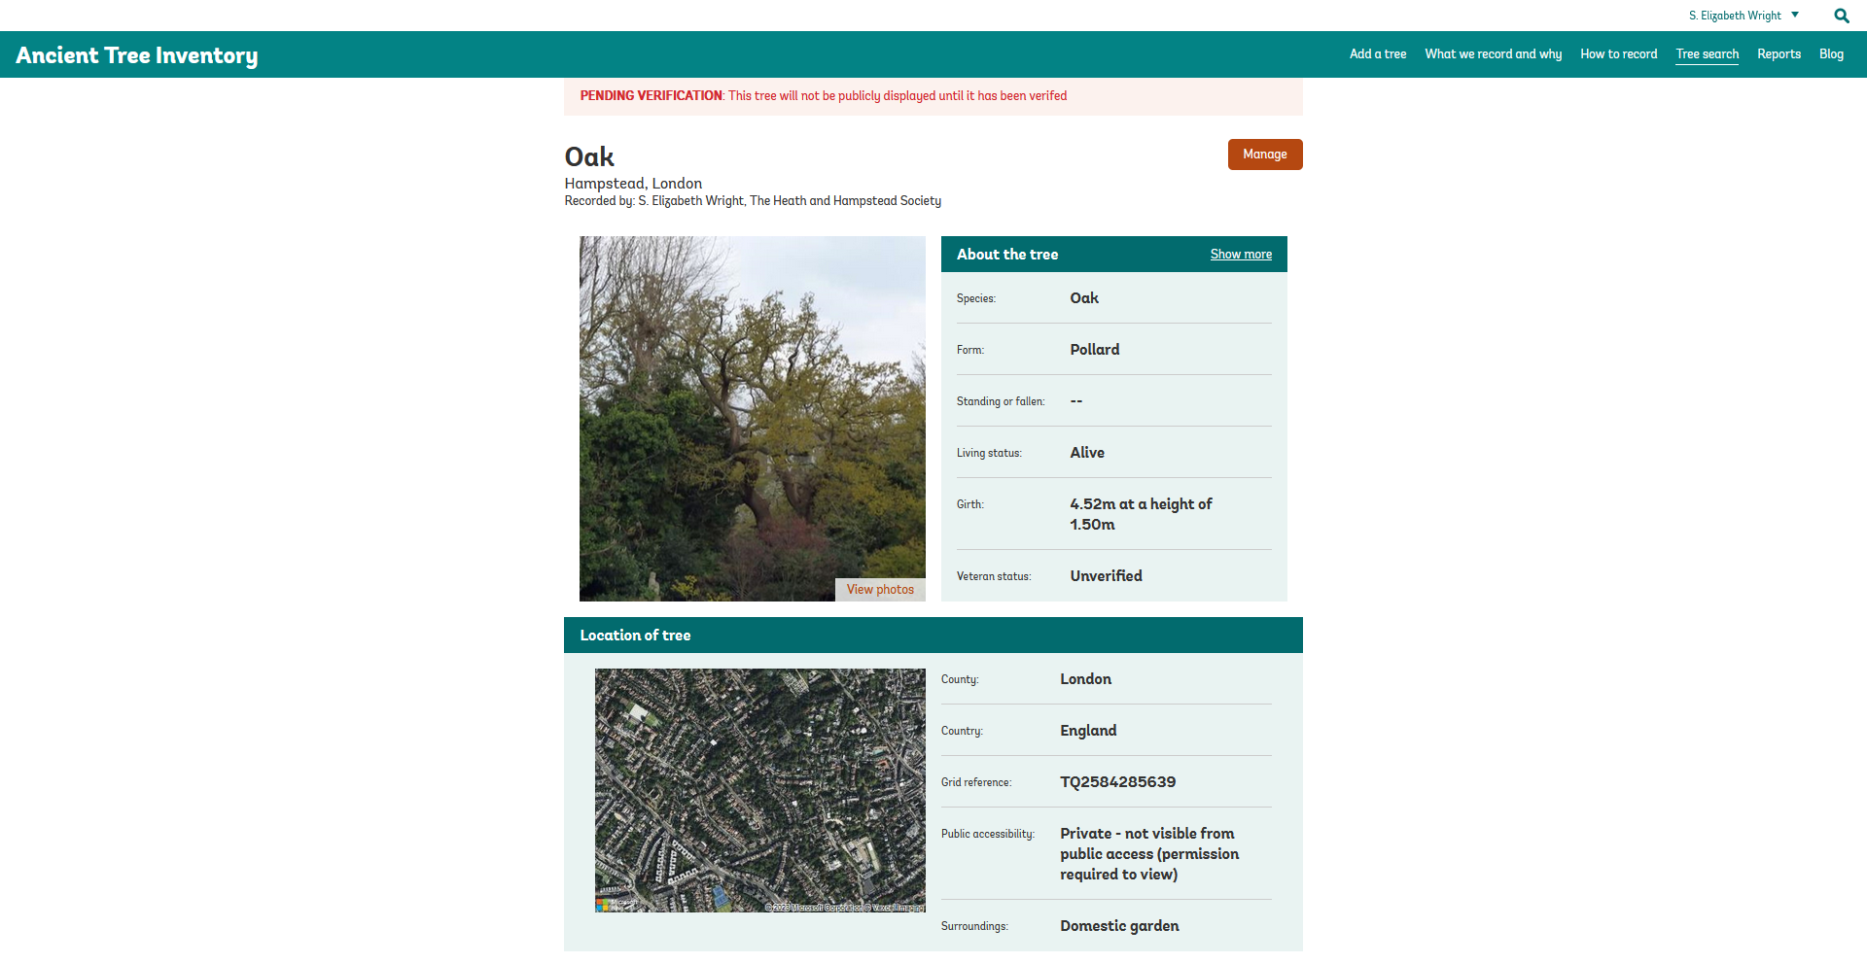

There are several factors that relate to this.

Firstly, that T29’s veteran status should change its RPA calculations in line with Natural England and the Forestry Commission’s ‘Ancient woodland, ancient trees and veteran trees: advice for making planning decisions’. I believe T29’s RPA radius should be considered to be at least 17.28 metres and not limited to 15 metres as is usual for non-veteran trees according to BS: 5837, 2012.

In any case this project is now more than 2 years beyond the original ‘Arboricultural Impact Assessment report & Outline Method Statement’ (AIA&OMS) of 2021/0984/P, and the 4th May 2022 revision only used the original proposed plans for 2021/5768/P and the tree survey data obtained on 25th September 2020.

Secondly, I note there is no Aboricultural Method Statement for this application which would be building over the roots of the veteran oak. The original AIA&OMS for 2021/0984/P was done on 4th March 2021, up-dated 21st November 2021 for 2021/5709/P, 2021/5768/P and 2021/6257/P, and only the Arboricultural Impact Assessment (AIA) was included and revised for 2021/6257/P on 4th May 2022.

Landmark Trees does much work for developments in Hampstead, and I recognise its arboriculturalists as being meticulous in their surveys and reports. For the May 4th 2022 AIA (I repeat, without a Method Statement) it is stated that the plans supplied to them included: ‘Existing site survey: 37915_01-07_PES’ and ‘Proposals: (0942)0401_PL02 Basement Floor Plan & (0942)_PL02 Ground Floor Plan’, that is to say the plans consistent with the original swimming pool removal, post-pool house removal plans and landscaping plans associated with these proposals.

I am concerned that these projects would not encroach quite so much onto T29 as the proposed five buildings of 2022/5583/P would do. Without an accurate AIA&MS and oversite by Landmark Trees and Camden Tree Officers, I do not believe it is possible to assess the impact of this new proposal on the veteran oak tree – particularly as it is registered with the ATI. Landscape designers do not have the professional expertise to do this.

Incidentally, I note 2023/0324/T and Landmark Trees’ recent study with a resistograph of the extent of T29’s main cavities. They proposed what appeared to me to be appropriate canopy reduction in line with honey fungus infestation to reduce the weight on each of the main branches, which would also mimic the natural canopy retrenchment of a veteran tree. This appears to have been carried out well and only after Camden’s agreement with this Notice of Intent was obtained.
However, I am reluctant to fully support their assessment of the tree’s future life expectancy and possibly its requirements in the light of it being a veteran. None of the three arbs involved in this site (Adam Hollis, David Gardner and Kim Dear) have had VetCert training according to https://www.vetcert.eu/certified-specialists as of today 28th March 2023, and I think it would be useful if both Landmark Trees and David Humphries could work together on supporting this tree’s best management, particularly if planning application 2022/5883/P were to be granted.

David Humphries (david.humphries@cityoflondon.gov.uk) is Trees Management Officer for Hampstead Heath in the Open Spaces Department, City of London Corporation, overseeing all management of the approximately 500 veteran trees on the Heath. He has had VetCert training and is a VetCert trainer, was the London Tree & Woodland award winner 2020, and is one of the country’s main experts on veteran tree fungi. I personally know he has experience in successfully supporting veteran oak trees with serious honey fungus infestation, including one I myself surveyed for veteran features in my section Area 5 of the 2003-5 survey of all Hampstead Heath’s trees marked on the 1866 OS map and still existing.

He has in the past stated that he and the Corporation of London are keen to support veteran tree owners within Hampstead Town with advice on veteran tree management, as these trees with their special and rare invertebrates and fungi are part of the network of veteran trees in the wider region associated with Hampstead Heath. There are approximately 70 trees marked on the 1866 OS map as significant that still exist within Hampstead’s gardens, though we are discovering more as time goes by. Both RedFrog and Hampstead Neighbourhood Forums are, with the help of Camden Conservation Officer beginning to review their original Neighbourhood Plans to include more of the veterans being discovered and verified by the ATI, and put into action plans for veteran tree wood piles - when these are supported by residents for inclusion within their gardens - to strengthen the ecological value of the historic tree lines and networks extending from areas such as Hampstead Heath and being developed in Camden’s Local Plan.

Thirdly, and following on from this last point, the 4th May 2022 Revised Arb Impact Assessment v2, states that the mitigation measures for encroaching into RPAs include
‘6.1: Soft ground within the unaffected parts of these RPAs will be treated with a 75mm layer of mulch to be maintained in place throughout the duration of construction activities.’
It also states that
‘1.2: T29 is a standout high quality specimen although investigation of decay in its stem / roots is recommended. All trees are material constraints on development, but this latter (subject to the decay detection findings) requires particular consideration’ (my italics.)
I contend that the RPA mitigation measures proposed are good according to BS: 58737, 2012 but may not be sufficient for a veteran tree and further advice should be welcomed. There are measures which could be taken to further support T29 in reducing the impact of both the honey fungus and other fungi on it and the assaults that building work naturally has to some extent on trees. Veterans are particularly susceptible to such work which is why English Nature originally produced their Standing Advice on veteran tree management to help protect them.

Fourthly, while I will leave it to others to comment on the appropriateness of applying for a Certificate of Lawfulness for this enormous project where buildings have already been demolished, and on its design features, I would like to state that by not informing Landmark Trees of the 5 new proposed buildings, this has meant that the owner has possibly not been advised on the effect of the swimming pool building placed in front of the veteran oak tree and its view from the house. This is not easily determined with the plans submitted so far.

The owner himself has stated that the tree is one of the main reasons he bought the house. I am also concerned that the owner might be assuming too early – without full veteran tree expert advice – that the tree’s life expectancy is only 10 years. This would naturally lead him to believe that blocking its view by a 4-metre-high swimming pool building in front of it, already in a section of the garden significantly higher than the house would not matter if it is about to die.

I consider this situation has not been sufficiently verified, particularly without a non-invasive picus test of the tree to more clearly visualise the extent of hollowing, and without an expert of David Humphries’ standing to comment on the thickness and quality of the tree’s remaining trunk walls, estimate its likely survival and its best management.

I also believe some future-proofing of the views from this important house is worth doing.

Fifthly, there has been quite a lot of tree removal on this site. While all this has been notified appropriately and permission obtained, this will have a cumulative effect not only on the garden’s visual features, but also on its ecology. I have counted 33 trees and a mixed hedge as already removed or shortly to be removed.

I note the latest Landscape Design allows for an acid garden to the left side of the old tennis court, including rhododendrons. The trees chosen are mainly likely to withstand the bogginess of this area. This is fortunate considering past trial pits have shown the water table is close to the surface beneath the tennis court.
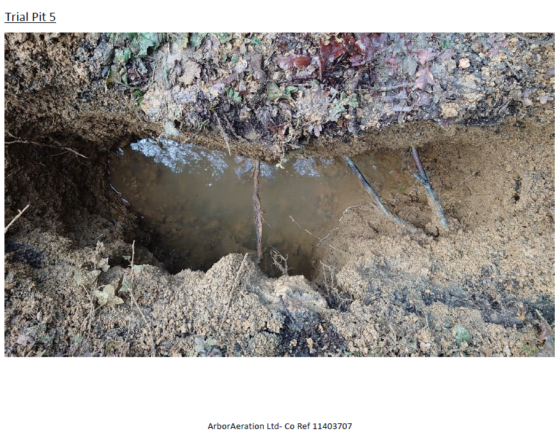
The newly passed Environment Bill includes a section requiring positive ecological uplift for development sites from September 2023.

I should therefore like to see:
- An ecological appraisal of the whole site as it was before the planning applications since 2021 so that it can be determined that the acid garden and the new woodland on the old pool house site are indeed providing a positive ecological uplift, not just an additional number of trees. Quite a few of which are non-indigenous and likely to support less wildlife in the bigger picture.

- A statement from the Landscape Designers on how they intend to shield the soil of the acid garden and rhododendrons so we can be reassured that they will not impact on the more indigenous trees close to the site’s boundary in the surrounding gardens.

Dr Vicki Harding, Society Tree Officer, Heath & Hampstead Society

