Summer of Sport.
Screen June 2023

EVENT MANAGEMENT PLAN
For Regent’s Place

Version – 1
Date – March 2023
Author – Jamie Turner

Contents
Event summary
Event contacts
Event detailed schedule
Site operations
Production & build
Security & crowd management
Medical provision
Event running order
Roles & responsibilities
Events schedule
Social media

Introduction
With a drive towards more experiential and activation-led campuses, requirement for thorough health and safety documentation and the increased security risks from external factors, it is imperative to deliver a robust event safety management process which can be shared with the business.

The purpose of an Event Safety Management Plan (EMP) is to ensure the thorough planning, safety management and clear communication of the activation’s management, to all key stakeholders.

Event overview & background
The temporary screen is part of the plaza activation and to support the return to the office plan for the campus and wider community.

The screen will run from June to October and will be supported by a sporting event, news, advertisements, and documentaries.

The screen will run from 8am to 9pm.

Contacts
In the below table are all the key contacts for the estate.
Agency & Supplier contacts
Full Name | Brand | Responsibility | Mobile No. | Email
Internal / Management contacts
Security Control Room | Security Team | Estate wide security, monitor the CCTV of all public domain spaces , co-ordinate a security response to any incident | 020 7380 6047 | securitycontrol@regentsplace.com
Kate Trzecieska | Estate  Manager | Lead point for  estate enquiries | 07977 279 398 | Kate.trzecieska@britishland.com
Claudia Augusto | Assistant Estate  Manager | Lead point for  estate enquiries | 07790 778 655 | claudia.augusto@britishland.com
Sean Hibbard | Technical Services Manager | Site event  manager and point of contact across all aspects | 07702 733 266 | shaun.hibbard@britishland.com
Lucy Greene | Consumer  Experience  Executive | Site event  manager and point of contact across all aspects | 07989 755 570 | lucy.greene@britishland.com
John Reynolds | Head of Security | Lead point for security enquiries | 07909 500 437 | John.reynolds@regentsplace.com
Kenny Willis | Cleaning Contract Manager | Lead point for cleaning enquiries | 07738 409 610 | kennywillis@regentsplace.com
Simon Bannon | Estate M&E Manager | Lead point for M&E enquiries | 07398 930 274 | Simin.bannon@regentsplace.com
Other

Overarching key dates & event running order
The live dates for the screen are June to October 2023

The below table will be completed once all the program schedule is confirmed

Time | Activity | Where | Contact | Notes
INSERT DATE
INSERT DATE
INSERT DATE

General Campus Procedures, Health & Safety Management

Local Authorities/Licence Requirements:
- Planning application with Camden Council is being manged by Guy Smith at British Land.
- The event will operate under the Regent’s Place PRS/PPL licences for music.
- Regent’s Place Premises License:
Number: PREM-LIC\3126
Permitted times for films are Mon-Friday, 08.00 – 21.00

House rules & regs:
The house rules and regulations will be provided as required.
EMERGENCY EVACUATION
Regent’s Place site assembly points is Munster Square.

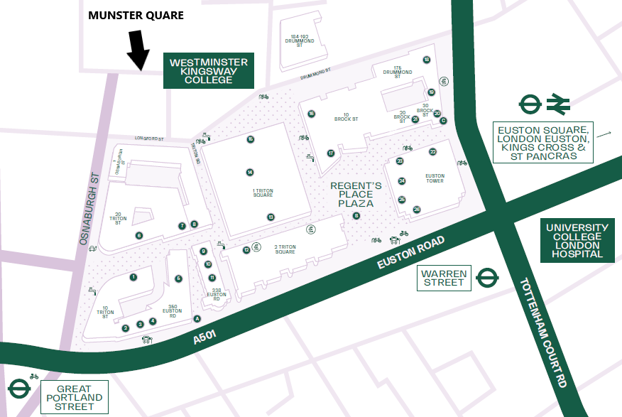

Incident report form
Security manages our incident reports and send out as required to the wider British Land Property Management team.

Major incident guidelines
Major incident guidelines are held in our grab bags, security control room and Management Office

First Aid

First aid kits are held in every reception on campus and also within the emergency grab bags. Security will direct and/or provide first aid in the first instance.

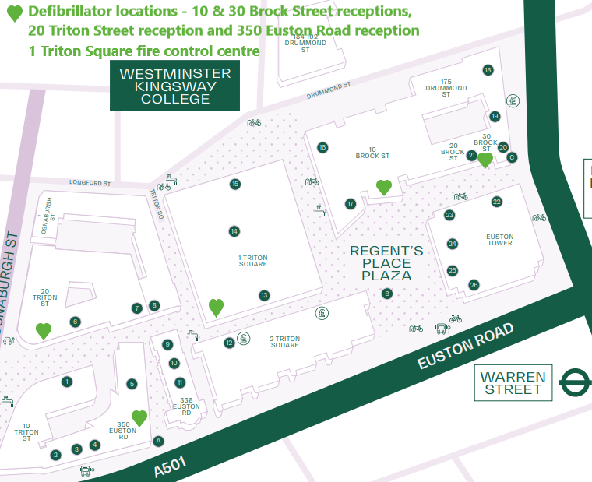

ACID ATTACK GRAB BAGS
Acid attack grab bags are located in the following buildings:
- 10 Brock Street
- Sierra 6
- Control room
- 20 Triton
Hospital Provision
Estate security will contact the emergency services if required or if phoned by a member of the general public will escort them to the site. The nearest hospital and emergency room I UCL 235 Euston Rd, Bloomsbury, London NW1 2BU which is located on Euston Road five minutes away from campus

Blue Route
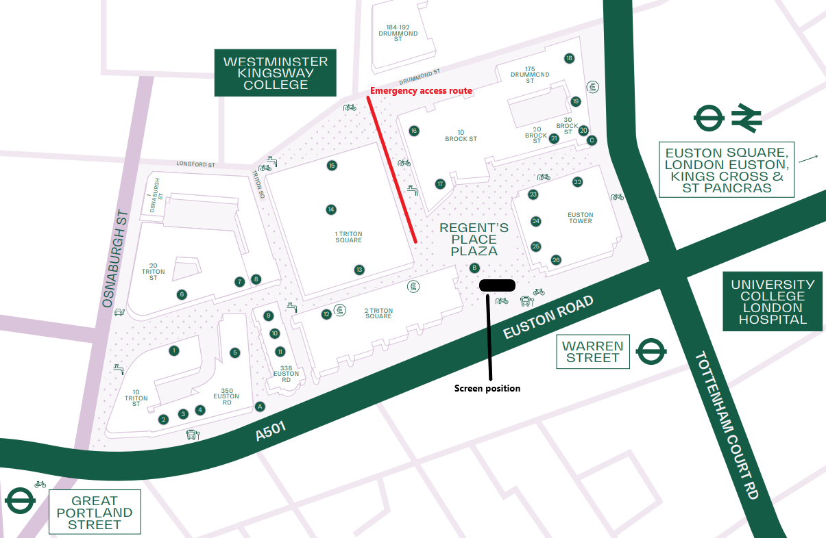

Key

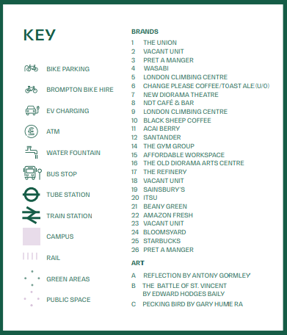

Deliveries

Daily Deliveries to Regent’s Place - All deliveries to Sierra 6

All vehicles must be booked in by a member of the Events & Communication team (see contact page for details) this needs to include registration numbers and driver’s details provided.
For any late changes or additions then all vehicles registration numbers, make and model must be notified to Regent’s Place Security a minimum of 48 hours in advance by contacting the Events & Communications team.

- Route: Vehicles should make their approach to Regent’s Place via Sierra 6 on Drummond St.
- Access to site: 7 days per week
- Size: Vehicles no bigger than large wheelbase vans
- Times: Can come on site but offload before 0700hrs, then between 0930 -1130hrs. From 1900hrs – this is subject to numbers on the campus.

Saturday & Sunday:
Deliveries can access the campus at the weekends. As per above drivers must book their details in with events & Communications team include registration numbers and driver’s details provided.

Crowd profile, dynamics & size
- All persons entering Regent’s Place campus are captured by CCTV this is monitored 24hours a day by the Regent’s Place Estate Security team.

Security, stewarding & crowd management plan
- Estate security are there to assist the event team and will escort persons off the estate if needed, they will conduct regular patrols of the event as part of the normal duties. The security team are on site 24/7.
- The number of people permitted on the plaza is shown in the capacity section above, should look near to exceeding, additional security, cleaning and barriers will be put in place by the Events, Estate and Security teams to ensure safe crowd management

Policing Plan
The EMSP will be shared with a senior member of your security team, or the lead contact who deals with police enquiries. They will then review contents and send it to the police if required/requested.

Crowd control & barriers
Crash barriers are available across the Regent’s Place campus and can be provided whenever necessary at prior agreement with the site management team.

Poor weather
In the event of poor weather conditions, the deck chairs and bean bags will not be placed out in position.

Missing persons
Any lost person/child identified will be brought to the attention of Chilled front of house staff and Regent’s Place Security team. A member of the security team will remain with the child/person on site and radio through to control to co-ordinate the contacting of the parent/guardian/group they were with.
Lost Property and suspicious packages
All lost property will be managed by security who are available on site 24/7. Please contact them on 020 7380 6047

Water Supply
See map in appendix. There are four locations around the campus for the supply of free water.

Toilets Provision
There are no public toilets available outside of the buildings. Toilets can be found in the
reception areas of 10 Brock Street, 20 Triton Square and in certain retail stores.

Disabled Provision
Disabled access is available via all major access points on Euston Road, Drummond Street, N Gower Street or Hampstead Road. Disable toilet facilities can also be found within the ground floor of, 350 & 338 Euston Road,10 Brock Street and 20 Triton Street.

Site Cleaning
- Mon – Fri: Full Team 5am-8pm
- Saturday & Sunday: Reduced Team (x2 Estate) 5am-8pm
Review of general cleaning will continue throughout the installation live dates and appropriate action will be taken as to whether we need to increase regularity personnel throughout.

Waste management

Recycling and waste receptacles are provided on the Plaza for the use by the general public.

All contractors working on site must remove their own waste and rubbish from the campus daily and should follow a sustainable route for disposal. Waste must be disposed of using a licensed waste carrier.

Designated Hazardous Waste (for example cooking oil) must be collected by a specialist waste contractor and Regent’s Place reserve the right to ask contractors for the Waste Transfer Note to demonstrate compliance.

Where there is an agreement in place for a specific event to use the campus facilities,
arrangements will be made with the individual company who will be required at all times to adhere to the Regent’s Place Waste & Recycling Strategy and Policy.

Noise

No noisy works before 9am and after 9pm.

Management Plan Identification of sources of noise and acceptable levels SOURCE – LIVE AND RECORDED SOUND
- Big Screen Speakers
- Live Events
- Spectators

ACCEPTABLE LEVELS
- Ambient noise levels onsite have been measured at 64 dB (A).
- In line with the Code of Practice from Environmental Noise Control at Concerts issued by The Noise Council the music or playback noise level shall not exceed the existing ambient noise by more the 15dB over a 15 minute period. Resulting in a maximum external acceptable level of 79dB.
- Indoor ambient noise levels not to exceed 35dB (A) during the hours of 07.00 and 23.00.
- The closest residential noise sensitive receiver is located approximately 100m away from speaker source. There is no access for noise measurement of indoor ambient levels, so this is estimated using adjustments of -34dB to account for 100m distance from noise source and -10dB for partially open window. Therefore the maximum external acceptable level is 79dB.

PROGRAMME OF NOISE CONTROL
- To ensure compliance the external noise level will be maintained at 70dB Lmax
- The noise sources will be located at the bottom of the amphitheatre, where possible, in order to ensure that sound does not carry across Sheldon Square to the nearest residential receiver.
- A trained member of the Regents Place team will use a noise monitoring device in order to ensure compliance

Event & Site Specific RAMS
All agencies/event suppliers are required to supply their own RAMS and PLI. These must be produced by themselves and be site and event specific. Also note these will form their individual permits and held on file.
Incident messaging / business continuity
In the event of a serious incident, all scheduled posts on Hootsuite will be paused by BL and access suspended for all users. The British Land internal communications team and appointed agencies will manage communications.

Appendix.

