Flitcroft House at 113-116 Charing Cross Road is located on the corner of Charing Cross Road and Flitcroft Street. The building was constructed as an office block on the upper floors with commercial use at ground floor in 1888. The building is five storeys. When originally built, the ground floor was in commercial use with rusticated pillars and an entrance facing Charing Cross Road with the pillar detailing turning the corner to Flitcroft Street. The ground floor has now been altered, with a modern shopfront facing Charing Cross Road and a recessed corner entrance. The ground floor detailing to Flitcroft Street remains. The upper storeys are constructed from London stock brick, with five bays to Charing Cross Road and a corner bay. The windows from first to third floor are arched with a simple surround. The top storey was built with less detail and with horizontally orientated rectangular windows, these have since changed and are now larger and vertically proportioned. The whole building has been painted, to its detriment, as the detailing and texture of the building can no longer be fully appreciated.

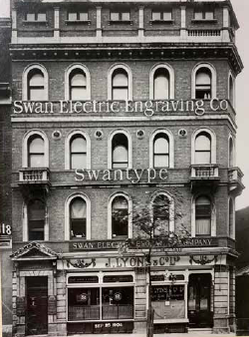 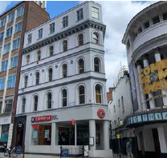

Figure The site 1904 Figure 2 The site 2021

The building is situated within the Denmark Street conservation area and is noted as making a positive contribution to its character and appearance. The Denmark Street conservation area lies within the ancient parish of St Giles, which has been developed since at least 1117. The historic heart of the conservation area is St Giles Church (Henry Flitcroft, 1734) and churchyard. The historic street pattern and network of narrow passageways which remains in much of the southern part of the area lends an intimate character. The surrounding architecture is a varied mix of former residential, industrial and commercial, dating from the late C17 to the early C20, but which has a consistency of materials and scale.

There are a number of listed buildings in close proximity to the site, a map of the listed buildings is shown below:

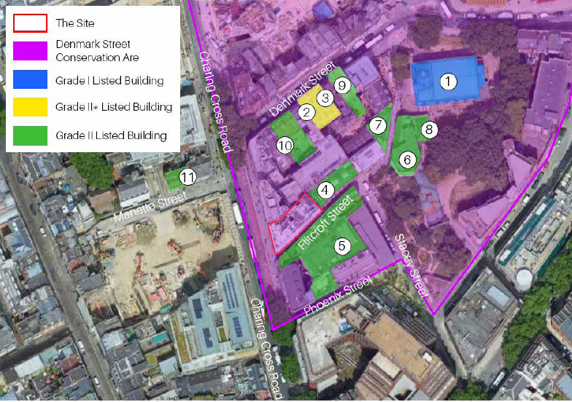

Figure 3 Map showing heritage assets.

The grade II listed Pheonix Theatre is immediately adjacent to the site facing Charing Cross Road. The theatre was constructed in 1929-30 and designed by Sir Giles Gilbert Scott, Cecil Masey and Bertie Crew. The theatre is relatively low scale compared to its neighbours, however due to its detailed and eclectic elevations is a prominent part of the street.

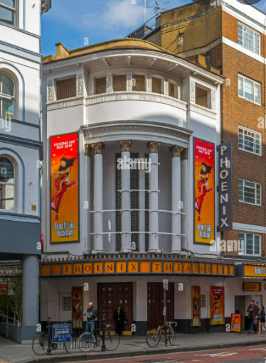

Figure 4 Phoenix Theatre

To the rear of the site 12 Flitcroft Street which is a grade II listed warehouse, now open plan offices. The building was constructed in 1878 from yellow stock bricks, it is four storeys and has eight bays. The entrance is arched with red brick pilasters.

At the end of Flitcroft Street is St Giles church which is grade I listed. The church was constructed in 1731-33 by Henry Flitcroft and was later restored in 1896 and 1952. The church is of Portland stone with a copper roof and is in a classical style. The building has a rectangular plan, a nave of five bays and a vestibule at its west end with a tower.

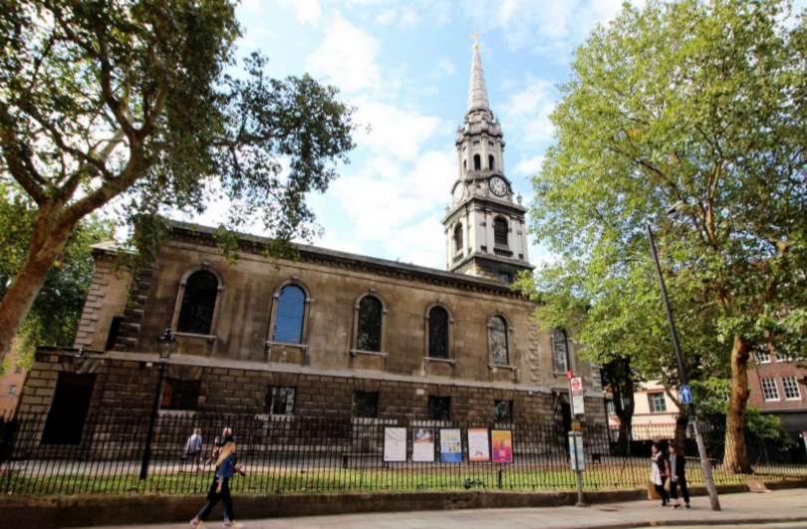

Figure 5 St Giles Church

There are a number of grade II and grade II\* listed buildings to Denmark Street and the grade II listed Elms Lester Painting Rooms on Flitcroft Street.

Proposals

The proposals are to erect a two storey roof extension and to remodel the ground floor shop front with improvements to Flitcroft Street.

Evaluation

The proposed extension is set in very slightly at fifth floor level and sets in slightly more at the sixth floor. This reduces the visual impact of the massing and creates variation within the roof form which is a characteristic of this part of Tottenham Court Road. The sculptured form of the extension at both levels also creates depth and interest which enhances the varied and detailed streetscape.

The fenestration to some degree mimics the fenestration of the host building, with rectangular windows at fifth floor level and arched windows to the sixth floor. The sculpting and panels around the windows create a sense a window hierarchy whilst also allowing light spaces within.

The materiality, which is sandstone, has been chosen based on the paint being removed from the host building and the original brick work being revealed. Once the paint has been removed, or at least a sample patch has been prepared, the colour of the sandstone will be chosen. The sandstone will be darker than the revealed brick work to ensure the extension is a visually recessive element to the building. Not sure how we can condition this, ideas?

It would be helpful to understand how visible the roof terrace railing will be – this should be set back and should not be visible if possible.

The shopfront will be mostly restored back to its historic form. Detailed drawings of the new shopfront should be submitted as a condition ensuring the surviving historic elements are used to inform the design.

The removal of the paintwork is welcome, however a gentle conservation approach should be taken and a sample patch should be prepared on site for approval.

Overall, the roof extension is well designed and is an attractive addition to the building. The reinstatement of the shopfront and the removal of the paint will also enhance the appearance of the building. The character and appearance of the conservation area will be preserved as a result of the development and the setting of the nearby listed buildings will be unharmed.

Conditions:

Details of windows.

Samples of all materials – sandstone to be approved based on relationship with exposed brickwork.

Detailed drawings of the shopfront.

Sample patch pf removed paintwork.