30 Ornan Road NW3 4QB

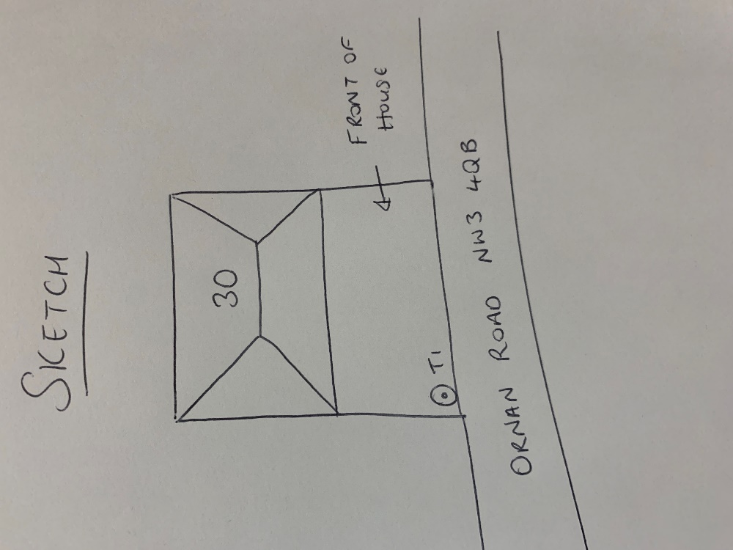

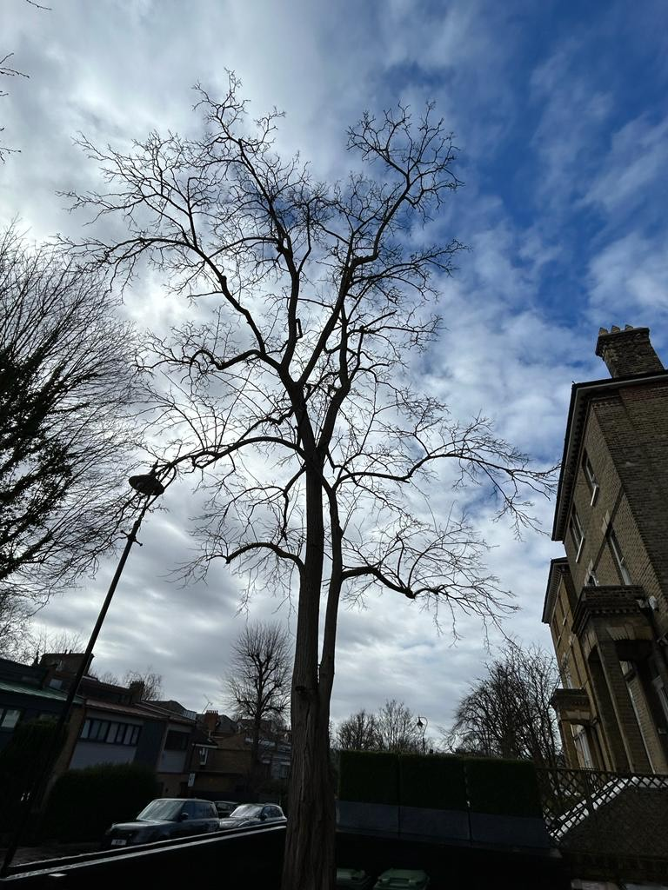

T1: Robinia (10m): Crown reduce by 1.5m to keep tree at a size suitable for its location and as part of regular maintenance